Contents

1. Lidar Obstacle Detection 4

1.1 Introduction to Lidar and Point Clouds 4

1.1.1 Lidar Sensors 4

1.1.2 Point Clouds 6

1.1.3 The PCL Library 7

1.1.4 The Course Starter Code 7

1.1.5 Compiling the Lidar Simulator 8

1.1.6 Running the Simulator 8

1.1.7 The PCL Viewer 9

1.1.8 Creating the Lidar Object 9

1.1.9 Using the Lidar Object 10

1.1.10 Templates and Different Point Cloud Data 11

1.1.11 Adjusting Lidar Parameters 12

1.1.12 Examining the Point Cloud 13

1.2 Point Cloud Segmentation 13

1.2.1 Segmentation 13

1.2.2 Point Processing 14

1.2.3 Segmenting the Plane with PCL 14

1.2.4 Separating Point Clouds 15

1.2.5 RANSAC 16

1.2.6 Implementing RANSAC for Lines 16

1.2.7 Extending RANSAC to Planes 18

1.3 Clustering Obstacles 19

1.3.1 Clustering Obstacles 19

1.3.2 Euclidean Clustering with PCL 20

1.3.3 Implementing KD-Tree 21

1.3.4 Inserting Points into KD-Tree 22

1.3.5 Insert Points 24

1.3.6 Searching Points in a KD Tree 25

1.3.7 Euclidean Clustering 26

1.3.8 Bounding Boxes 28

1.3.9 Extra Challenge: PCA Boxes 28

1.4 Working with Real PCD 29

1.4.1 Load Real PCD 29

1.4.2 Load PCD 29

1.4.3 Filtering with PCL 31

1.4.4 Steps for Obstacle Detection 32

1.4.5 Stream PCD 34

1.4.6 Lidar Obstacle Detection Project 36

1.4.7 Tracking and Challenge Problem 36

2. Radar 37

2.1 Radar Principles 37

2.1.1 The Radar Sensor 37

2.1.2 Signal Properties 39

2.1.3 FMCW 41

2.1.4 FMCW Hardware and Antenna 42

2.1.5 Radar Cross Section 44

2.1.6 Radar Range Equation 45

2.2 Range-Doppler Estimation 47

2.2.1 Range, Velocity and Angle Resolution 47

2.2.2 Range Estimation 48

2.2.3 Doppler Estimation 49

2.2.4 Fast Fourier Transform 51

2.2.5 The 2D FFT 53

2.3 Clutter, CFAR, AoA 55

2.3.1 Clutter 55

2.3.2 CFAR 56

2.3.3 CA-CFAR 57

2.3.4 CFAR 2D 58

2.3.5 Angle of Arrival 59

2.4 Clustering and Tracking 61

2.4.1 Clustering 61

2.4.2 Kalman Tracking 62

2.5 Radar Target Generation and Detection 63

2.5.1 Radar Target Generation and Detection 63

3. Camera 67

3.1 Autonomous Vehicles and Computer Vision 67

3.1.1 Levels of Autonomous Driving 67

3.1.2 Autonomous Vehicle Sensor Sets 69

3.1.3 Camera Technology Overview 75

3.1.4 The OpenCV Computer Vision Library 82

3.2 Engineering a Collision Detection System 84

3.2.1 Collision Detection Basics 84

3.2.2 Estimating TTC with Lidar 86

3.2.3 Estimating TTC with Camera 90

3.2.4 Course Structure 94

3.3 Tracking Image Features 94

3.3.1 Intensity Gradient and Filtering 94

3.3.2 Harris Corner Detection 101

3.3.3 Overview of Popular Keypoint Detectors 106

3.3.4 Gradient-based vs. Binary Descriptors 109

3.3.5 Descriptor Matching 115

3.4 Camera Based 2D Feature Tracking 123

3.4.1 Mid-Term Project Introduction 123

3.4.2 The Data Buffer 123

3.4.3 Keypoint Detection 124

3.4.4 Descriptor Extraction and Matching 125

3.4.5 Performance Evaluation 125

3.5 Combing Camera and Lidar 126

3.5.1 Lidar to Camera Point Projection 126

3.5.2 Object Detection with YOLO 136

3.5.3 Creating 3D-Objects 144

3.6 Track an Object in 3D Space 148

3.6.1 Heading 1 148

3.5.2 Placeholder 148

3.7 Placeholder 148

Sensor Fusion Nanodegree

# Lidar Obstacle Detection

## Introduction to Lidar and Point Clouds

### Lidar Sensors

Lidar sensing gives us high resolution data by sending out thousands of laser signals. These lasers bounce off objects, returning to the sensor where we can then determine how far away objects are by timing how long it takes for the signal to return. Also we can tell a little bit about the object that was hit by measuring the intensity of the returned signal. Each laser ray is in the infrared spectrum, and is sent out at many different angles, usually in a 360 degree range. While lidar sensors gives us very high accurate models for the world around us in 3D, they are currently very expensive, upwards of $60,000 for a standard unit.

* The Lidar sends thousands of laser rays at different angles.
* Laser gets emitted, reflected off of obstacles, and then detected using a receiver.
* Based on the time difference between the laser being emitted and received, distance is calculated.
* Laser intensity value is also received and can be used to evaluate material properties of the object the laser reflects off of.

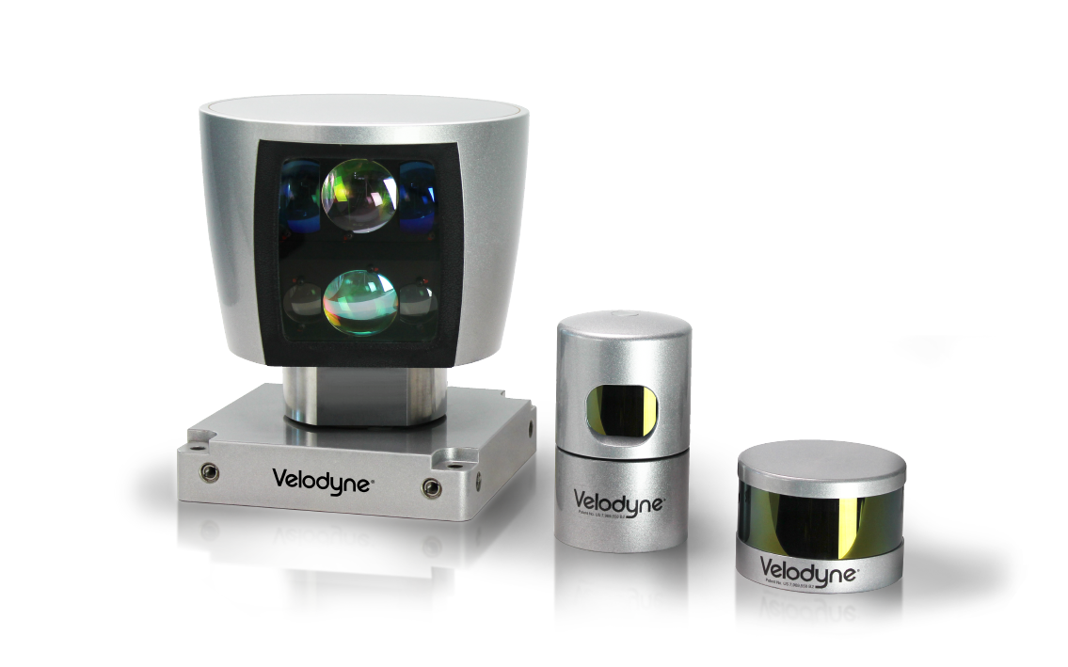

Velodyne lidar sensors, with HDL 64, HDL 32, VLP 16 from left to right. The larger the sensor, the higher the resolution

Here are the specs for a HDL 64 lidar. The lidar has 64 layers, where each layer is sent out at a different angle from the z axis, so different inclines. Each layer covers a 360 degree view and has an angular resolution of 0.08 degrees. On average the lidar scans ten times a second. The lidar can pick out objects up to 120M for cars and foliage, and can sense pavement up to 50M.

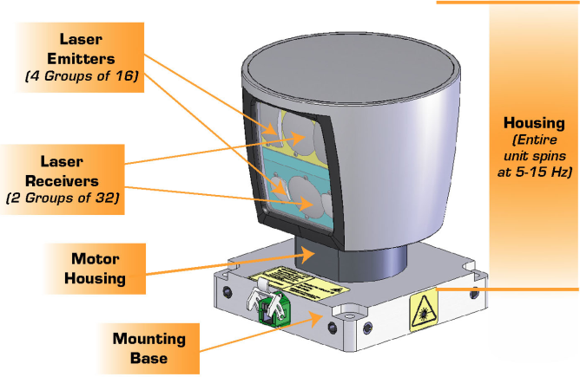

VLP 64 schematic, showing lidar emitters, receivers, and housing.

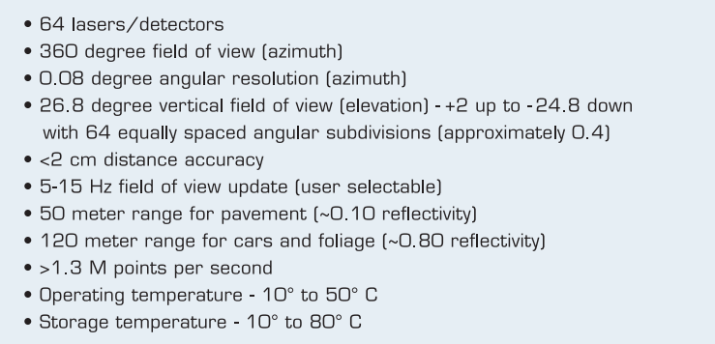

VLP Sensor Specifications

### Point Clouds

**PCD Files**

Let’s dive into how lidar data is stored. Lidar data is stored in a format called Point Cloud Data (PCD for short). A .pcd file is a list of (x,y,z) cartesian coordinates along with intensity values, it’s a single snapshot of the environment, so after a single scan. That means with a VLP 64 lidar, a pcd file would have around 256,000 (x,y,z,i) values.

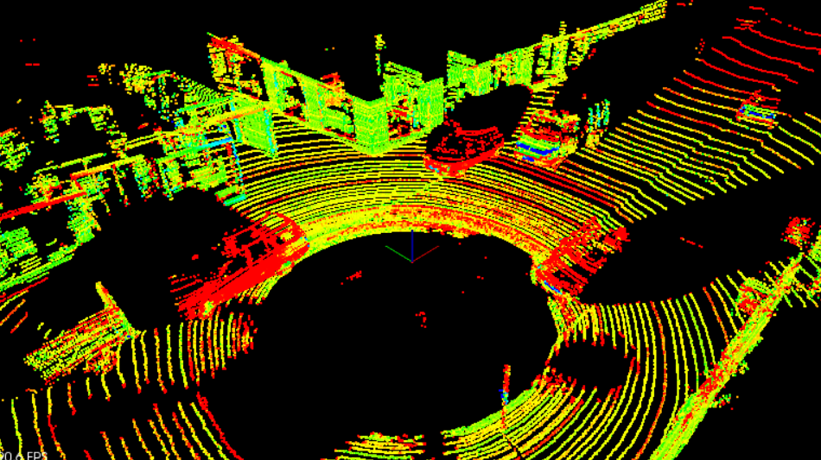

PCD of a city block with parked cars, and a passing van. Intensity values are being shown as different colors. The big black spot is where the car with the lidar sensor is located

**PCD Coordinates**

The coordinate system for point cloud data is the same as the car’s local coordinate system. In this coordinate system the x axis is pointing towards the front of the car, and the y axis is pointing to the left of the car. Also since this coordinate system is right-handed the z axis points up above the car.

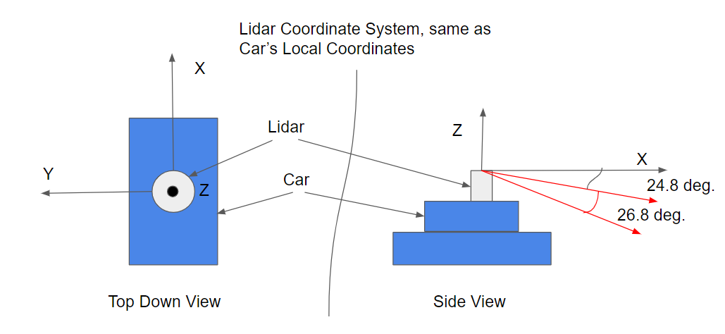

### The PCL Library

In this module you will be working on processing point cloud data to find obstacles. All the code will be done in a C++ environment, so some familiarity with C++ will definitely be helpful. PCL is an open source C++ library for working with point clouds. You will be using it to visualize data, render shapes, and become familiar with some of its built in processing functions. Some documentation for PCL can be found [here](http://pointclouds.org/).

PCL is widely used in the robotics community for working with point cloud data, and there are many tutorials available online for using it. There are a lot of built in functions in PCL that can help to detect obstacles. Built in PCL functions that will be used later in this module are Segmentation, Extraction, and Clustering.

### The Course Starter Code

All the code for doing lidar obstacle detection is contained in a GitHub repository. The classroom has workspace environments that already include all the dependencies for getting started right way. You can also clone the repo, and use the README to get started on your own machine as well. Here is the [link](https://github.com/udacity/SFND_Lidar_Obstacle_Detection).

You will mostly be working out of two main files, which are environment.cpp and processPointClouds.cpp. The environment.cpp file contains the main function and will generate the runnable executable. The processPointClouds.cpp file will contain all your function placeholders to process the pcd.

There are some other files worth mentioning, like sensors/lidar.h, which simulates lidar sensing and creates point cloud data. Also render.cpp and render.h which have functions for rendering objects onto the screen.

**Code Structure**

* Top-level CMakeLists.txt
* Readme
* src
  + render
    - box.h - this file has the struct definitions for box objects
    - render.h
    - render.cpp - this file, along with the header, define the classes and methods for rendering objects.
  + sensors
    - data - this directory contains pcd data used in the course.
    - lidar.h - has functions using ray casting for creating pcd.
* environment.cpp - the main file for using pcl viewer and processing and visualizing pcd.
* processPointClouds.h
* processPointClouds.cpp - Functions for filtering, segmenting, clustering, boxing, loading, and saving pcd.

### Compiling the Lidar Simulator

**Compilation Instructions**

* In the terminal workspace below, make sure that GPU is enabled.
* Click on Desktop button on lower right.
* Click on Terminator to load up work space desktop terminal.
* From the terminal, go to the project root directory, cd /home/workspace/SFND-Lidar-Obstacle-Detection.
* Create a new directory from the project root named build with the following command: mkdir build.
* Then go into the build directory: cd build.
* Run cmake pointing to the CMakeLists.txt in the root: cmake ... If everything went well you should see something like
  + Configuring done
  + Generating done
  + Build files have been written to: /your directory/simple_highway/build
* If cmake was successful, then from inside build run make: make
* If make built target environment 100%, it will have generated an executable called environment. This build process is defined from the CMakeLists.txt file.

### Running the Simulator

**Instructions**

Once you have built an executable file, you can lunch it by doing ./environment. Now you should see a window popping up that looks like the image above.

Here you have a simple highway simulator environment with the ego car in green in the center lane (that’s your car), and the other traffic cars in blue. Everything is rendered using PCL with simple boxes, lines, and colors. You can move around your environment with the mouse. Try holding the left mouse button to orbit around the scene. You can also pan around the scene by holding the middle mouse button and moving. To zoom, use the middle scroll mouse button or the right mouse button while moving.

**Recap**

* Using terminator in the virtual desktop, run the executable from the build directory using ./environment.
* You should see a 3D popup window with the road and cars.
* You can move around the environment.
* Zoom: hold the right mouse key and move the mouse forward/backwards, or use your mouse scroller.
* Pan: Hold down the middle mouse button (the scroller) and move the mouse.
* Rotate: Hold the left mouse button and move the mouse.

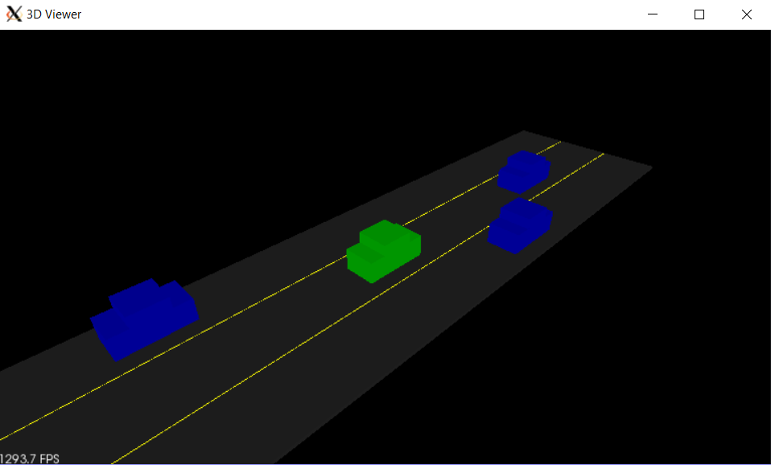

### The PCL Viewer

**PCL Viewer Overview**

In *environment.cpp* a pcl viewer is created. The viewer is used to handle all your visualization of objects on the screen. Some functions that use the pcl viewer inside *environment.cpp* are *initCamera* and *initHighway*. The *initCamera* function helps you set up different viewing angles in your window. There are five different options: XY, TopDown, Side, and FPS. XY gives a 45 degree angle view, while FPS is First Person Sense and gives the sensation of being in the car’s driver seat.

Also, the functions from *render* heavily use the *viewer* as well. You might notice that *viewer* is usually passed in as a reference. That way the process is more streamlined because something doesn't need to get returned.

### Creating the Lidar Object

The first thing you are going to do is create a lidar object. The lidar object is defined by the *src/sensors/lidar.h* header file which is included at the top of environment.cpp. Also in *environment.cpp* is the *simpleHighway* function, which takes a reference argument for the PCL visualizer *viewer* that was discussed previously.

**Exercise Instructions**

You will instantiate a pointer to a *Lidar* object in the *simpleHighway* function. You should create the *Lidar* pointer object on the heap, using the *new* keyword. The *Lidar* constructor takes two arguments: cars and the slope of the ground - these arguments are necessary for modeling ray collisions. The *Lidar* object should be created with a slope of 0.

**Note**

The lidar arguments are necessary for modeling ray collisions. The Lidar object is going to be holding point cloud data which could be very large. By instantiating on the heap, we have more memory to work with than the 2MB on the stack. However, it takes longer to look up objects on the heap, while stack lookup is very fast.

### Using the Lidar Object

To go further with your newly created *Lidar* object, check out *src/sensors/lidar.h* to see how everything is defined. In this header file, you can see the ray object being defined. Lidar will use these rays to sense its surrounding by doing ray casting. The *scan* function from the lidar struct will be what is doing the ray casting.

Now let's call the lidar scan function and see how lidar rays look. Back in your environment file, right after the call to the Lidar constructor, you can use the scan function and then render the lidar rays.

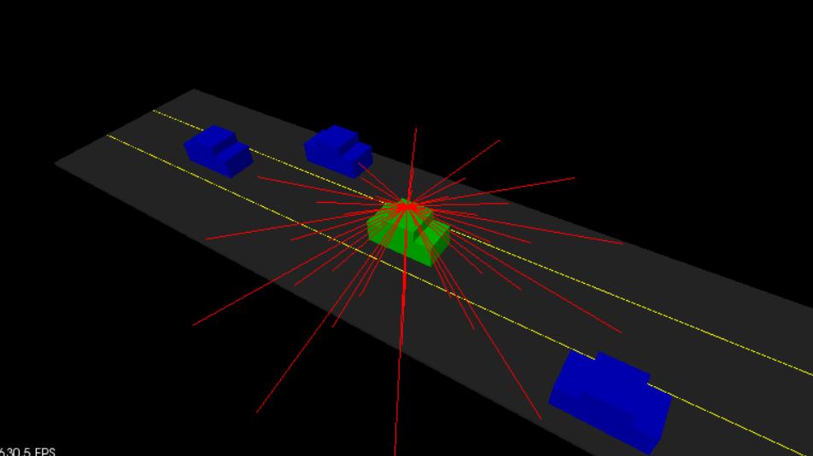

**Exercise**

* To create a point cloud, call the lidar *scan()* method on your lidar object.
* You will store results in a PointCloud pointer object, *pcl::PointCloud<pcl::PointXYZ>::Ptr*
* The type of point for the PointCloud will be *pcl::PointXYZ*.
* Call the *renderRays* function with generated PointCloud pointer.

**Note**

The syntax of PointCloud with the template is similar to the syntax of vectors or other std container libraries: *ContainerName<ObjectName>*.

The Ptr type from PointCloud indicates that the object is actually a pointer - a 32 bit integer that contains the memory address of your point cloud object. Many functions in pcl use point cloud pointers as arguments, so it's convenient to return the inputCloud in this form.

The renderRays function is defined in *src/render*. It contains functions that allow us to render points and shapes to the pcl viewer. You will be using it to render your lidar rays as line segments in the viewer.

The arguments for the renderRaysfunction is viewer, which gets passed in by reference. This means that any changes to the viewer in the body of the renderRays function directly affect the viewer outside the function scope. The lidar position also gets passed in, as well as the point cloud that your scan function generated. The type of point for the PointCloud will be *pcl::PointXYZ*. We will talk about some other different types of point clouds in a bit.

### Templates and Different Point Cloud Data

**Why Use Templates**

The lidar scan function used previously produced a pcl PointCloud object with pcl::PointXYZ points. The object uses a template because there are many different types of point clouds: some that are 3D, some that are 2D, some that include color and intensity. Here you are working with plain 3D point clouds so PointXYZ is used. However, later in the course you will have points with an intensity component as well.

Instead of defining two separate functions one with an argument for PointXYZ and the other for PointXYZI, templates can automate this process. With templates, you only have to write the function once and use the template like an argument to specify the point type.

**Templates and Pointers**

If you haven’t used templates with pointers before, you may have noticed in the code that *typename* is used whenever a pointer is used that depends on a template. For example in the function signature here:

*typename pcl::PointCloud<PointT>::Ptr ProcessPointClouds<PointT>::FilterCloud(typename pcl::PointCloud<PointT>::Ptr cloud, float filterRes, Eigen::Vector4f minPoint, Eigen::Vector4f maxPoint)*

The reason for this is the following: Given a piece of code with a type name parameter, like pcl::PointCloud<PointT>::Ptr, the compiler is unable to determine if the code is a value or a type without knowing the value for the type name parameter. The compiler will assume that the code represents a value. If the code actually represents a typename, you will need to specify that.

### Adjusting Lidar Parameters

You can orbit and move around the scene to see the different rays that are being cast. The current lidar settings will limit what you can do, however. The resolution is low, and as you can see from the scene, only one of the rays is touching a car. So The next task for you will be to increase your lidar's resolution so you can clearly see the other cars around. To do this, follow the instructions from the TODO statements in lidar.h.

The changes include increasing the minimum distance so you don't include contact points from the roof of your car, increasing both the horizontal and vertical angle resolution, and finally, adding noise. The noise you will be adding is actually quite high since units are meters, but it will yield more interesting and realistic point data in the scene. Also feel completely free to experiment and play around with these lidar hyper parameters!

**Exercise**

* Now you will increase lidar resolution by increasing the number of vertical layers and the angular resolution around the z-axis.
  + *numLayers* should change from 3 to 8.
  + *horizontalLayerIncrement* should change from pi/6 to pi/64.
* Set *minDistance* to 5 (meters) to remove points from your vehicle's roof.
* Add noise, around 0.2 to get a more interesting pcd.

When you are finished with the exercise, your output should look like the image below.

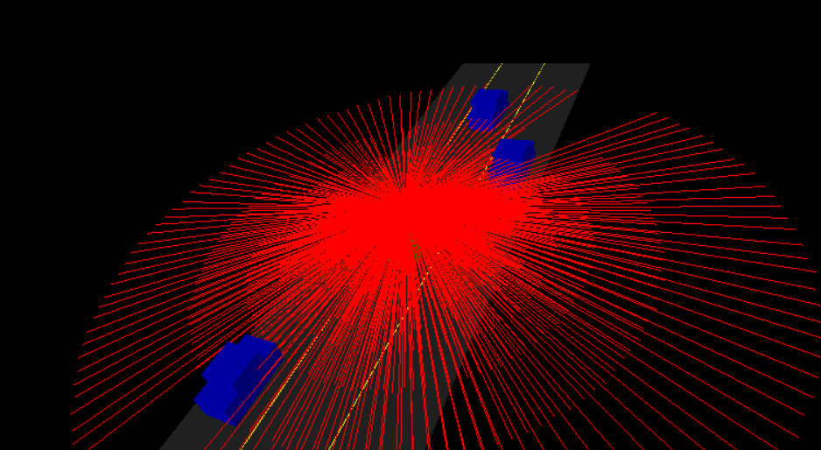

### Examining the Point Cloud

Now that you can see what the lidar rays look like, what about the actual point cloud data that you will be using and processing? You can view the point cloud data using the *renderPointCloud* function in render. You can also choose to turn off the rendering for the highway scene so you can see what the point cloud looks like by itself.

The result in the image above is without noise and with lidar *minDistance* set to zero. With a high lidar *minDistance*, you can remove the points above that are hitting the roof of your car, since these won't help you detect other cars. Also, some noise variance helps to create more interesting looking point clouds. Additionally, adding noise will help you to develop more robust point processing functions.

**Exercise**

Now you will view the lidar's point cloud by itself, without the rays.

* To do this, call *renderPointCloud* instead of *renderRays* in the *simpleHighway* function.
* You can also view the point cloud without obstacles by setting *renderScene* to *false* in *environment.cpp*.

When you are finished, your output should look like the image below.

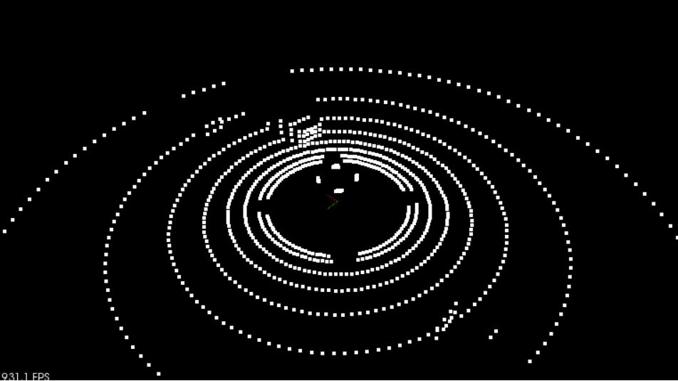

## Point Cloud Segmentation

### Segmentation

We want to be able to locate obstacles in the scene. However, some objects in our scene our not obstacles. What would be objects that appear in the pcd but are not obstacles? For the most part, any free space on the road is not an obstacle, and if the road is flat it’s fairly straightforward to pick out road points from non-road points. To do this we will use a method called Planar Segmentation which uses the RANSAC (random sample consensus) algorithm.

### Point Processing

The first thing you are going to do is create a *processPointClouds* object. This is defined by the *src/processPointClouds.cpp* and *src/processPointClouds.h* files. This object is going to contain all the methods that you will be using in this module for processing lidar data. The process object also has helper methods for loading and saving PCD files. By the time you compete this exercise, the code should compile but you will still need to complete the next few concepts before getting results.

**Instructions**

* Open the *src/environment.cpp* file.
* Inside the function *simpleHighway*, create a *processPointClouds* object. You can do this either on the stack or the heap.
* The processor should use point cloud type of *pcl::PointXYZ*.

### Segmenting the Plane with PCL

In this exercise you will be separating the points that belong to the road from the points that belong to the scene.

**The SegmentPlane Function Stub**

Let's put the point processor to use now.

You will define the *SegmentPlane* function in *src/processPointClouds.cpp*. There is already a declaration for this function, and you just need to fill in the defintion. At the top of the function, you will notice a template parameter *PointT*. You will be using this as a variable to represent any type of point cloud, and it will come in handy later when you are processing point clouds with intensity values.

**SegmentPlane Function Signature**

*std::pair<typename pcl::PointCloud<PointT>::Ptr, typename pcl::PointCloud<PointT>::Ptr> SegmentPlane(typename pcl::PointCloud<PointT>::Ptr cloud, int maxIterations, float distanceThreshold);*

The function accepts a point cloud, max iterations, and distance tolerance as arguments. Segmentation uses an iterative process. More iterations have a chance of returning better results but take longer. The segmentation algorithm fits a plane to the points and uses the distance tolerance to decide which points belong to that plane. A larger tolerance includes more points in the plane.

Have a look at the return type in the code above. *SegmentPlane* will return a *std::pair* holding point cloud pointer types. If you are not familiar with pairs check out the documentation [here](http://www.cplusplus.com/reference/utility/pair/pair/). You will use the pair object to hold your segmented results for the obstacle point cloud and the road point cloud. This way, you can later visualize both point clouds in the pcl viewer and analyze the results.

**SegmentPlane Body**

The first thing you see in the code above in the *SegmentPlane* function stub is a timer. This can be useful for measuring how long it takes to run the function. If it’s taking a really long time to process the segmentation, then the function is not going to be useful running in real-time on a self-driving car.

**Instructions**

To get started filling in the function you can use pcl’s segmentation object. For reference check out this pcl tutorial on [segmentation](http://pointclouds.org/documentation/tutorials/extract_indices.php#extract-indices). In particular check out lines 38-48.

### Separating Point Clouds

In the previous exercise you got inliers which are indices for the fitted plane. Now you will be using these inliers to create the plane point cloud and obstacle point cloud.

**Instructions**

You can separate point clouds by calling the *SeparateClouds* function from *processPointCloud*. You can use this function inside *SegmentPlane* with the calculated inliers and input cloud.

Inside the *SeparateClouds* function stub, create two new point cloud pointers, one for obstacles (non-plane points), and one for road (plane points). The inliers can be added to the plane cloud by looping over the inlier indices and pushing the corresponding inlier point into the plane cloud’s point vector.

To generate the obstacle cloud, one way to use PCL to do this is to use an *extract* object, which subtracts the plane cloud from the input cloud. Now you can return the *std::pair* with the newly created obstacle and plane clouds:

*std::pair<typename pcl::PointCloud<PointT>::Ptr, typename pcl::PointCloud<PointT>::Ptr> segResult(obstCloud,planeCloud);*

The pcl segmentation tutorial shows how to use an extract object in lines 67-70.

Back in environment.cpp you can then call pointProcessor function on the input cloud and render the two segmented point clouds in different colors.

*std::pair<pcl::PointCloud<pcl::PointXYZ>::Ptr, pcl::PointCloud<pcl::PointXYZ>::Ptr> segmentCloud = pointProcessor->SegmentPlane(inputCloud, 100, 0.2);*

*renderPointCloud(viewer,segmentCloud.first,"obstCloud",Color(1,0,0));*

*renderPointCloud(viewer,segmentCloud.second,"planeCloud",Color(0,1,0));*

**Notes**

The above example is using 100 iterations, and a distance tolerance of 0.2 meters. You are highly encouraged to play around and experiment with these values! This point cloud is very simple and 100 iterations are way more than needed. You can also monitor how changing the iterations affects the time it takes for the segmentation function to process using the functions predefined timer log. Before rendering the two clouds you will want to remember to turn off rendering from the input cloud done in the previous lesson, otherwise the clouds will all overlap, and it will be hard to distinguish the segmented ones. The renderPointCloud function includes color options (Red,Green,Blue). By default the cloud is white if no color is specified. Here the obstacle cloud as is rendered as red, and the plane cloud as green.

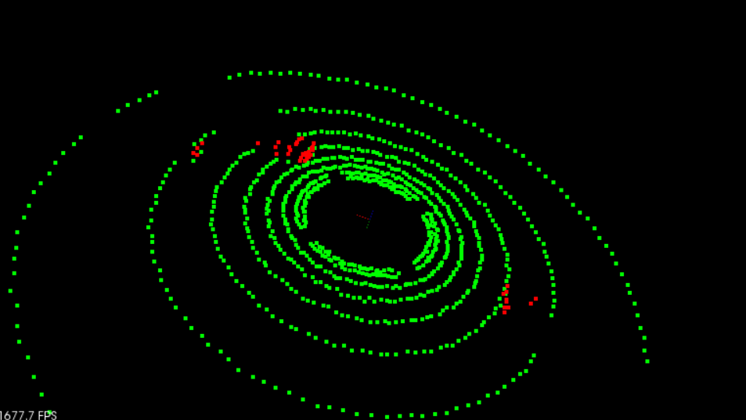

### RANSAC

RANSAC stands for Random Sample Consensus, and is a method for detecting outliers in data. RANSAC runs for a max number of iterations, and returns the model with the best fit. Each iteration randomly picks a subsample of the data and fits a model through it, such as a line or a plane. Then the iteration with the highest number of inliers or the lowest noise is used as the best model.

One type of RANSAC version selects the smallest possible subset of points to fit. For a line, that would be two points, and for a plane three points. Then the number of inliers are counted, by iterating through every remaining point and calculating its distance to the model. The points that are within a certain distance to the model are counted as inliers. The iteration that has the highest number of inliers is then the best model. This will be the version that you will implement in this quiz.

Other methods of RANSAC could sample some percentage of the model points, for example 20% of the total points, and then fit a line to that. Then the error of that line is calculated, and the iteration with the lowest error is the best model. This method might have some advantages since not every point at each iteration needs to be considered. It’s good to experiment with different approaches and time results to see what works best.

### Implementing RANSAC for Lines

Here you will complete a quiz that has you implement RANSAC for fitting a line in 2D point data with outliers. The quiz is located in *src/quiz/ransac/ransac2d.cpp*, and the function to fill out is *Ransac*, which takes in arguments for a point cloud, max iterations to run, and distance tolerance. The point cloud is actually *pcl::PointXYZ* but the z component will be set to zero to make things easy to visualize in 2D space.

The data shown below was generated by creating a line with points slightly scattered, and then outliers were added by randomly placing points in the scene. You want to be able to identify which points belong to the line that was originally generated and which points are outliers. To do this you will randomly sample two points from the cloud and fit a line between the points. A helpful line equation for this problem can be seen below.

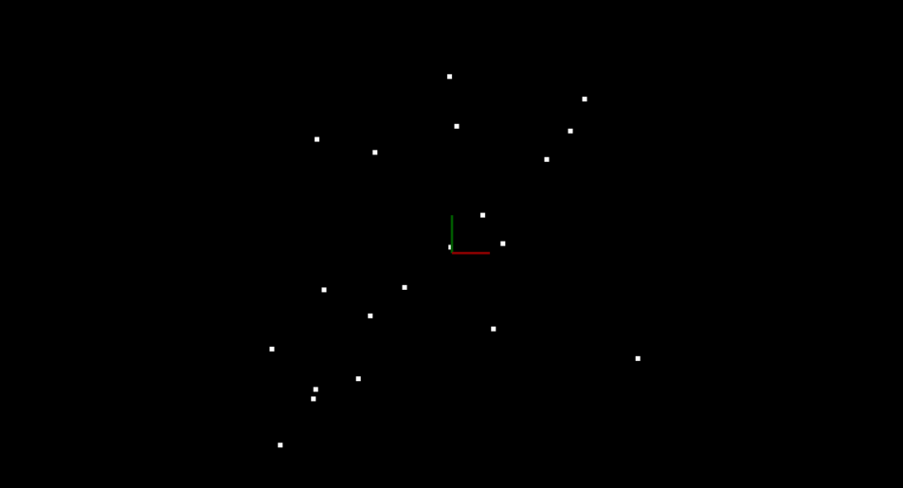

**Equation of a Line through two Points in 2D**

For variables x and y and coefficients A, B, and C, the general equation of a line is:

$Ax+By+C=0$

Given two points: point1 (x1, y1) and point2 (x2, y2), the line through point1 and point2 has the specific form:

$\left(y1-y2\right)x+\left(x2-x1\right)y+\left(x1*y2+x2*y1\right)=0$

**Using Distance to find the best Line**

After fitting the line you can then iterate through all the points and determine if they are inliers by measuring how far away each point is from the line. You can do this for each iteration keeping track of which fitted line had the highest number of inliers. The line with the most inliers will be the best model. The equation for calculating distance between a point and line is shown below. For further details see, <https://brilliant.org/wiki/dot-product-distance-between-point-and-a-line/>.

* Line formula $Ax+By+C=0$
* Point $(x, y)$
* Distance $d= {\left|Ax+By+C\right|}/{sqrt(A^{2}+ }B^{2})$

Below are the results of doing RANSAC to fit a line from the data above. Inliers are green while outliers are red. The function had a max iteration count of 50 and a distance tolerance of 0.5. The max iteration size to run depends on the ratio of inliers to the total number of points. The more inliers our data contains the higher the probability of selecting inliers to fit the line to, and the fewer iterations you need to get a high probability of selecting a good model.

**Instructions**

* Go to *src/quiz/ransac/ransac2d.cpp*
* Complete the function *Ransac* following the instructions above

### Extending RANSAC to Planes

Now that you are getting the hang of RANSACing it, and understanding RANSAC for fitting a line, you can do the same thing for fitting a plane in a 3D point cloud. Your implementation will be used as part of your project, so be sure to complete the implementation in the exercise below!

If you have completed the previous exercise, you can modify your code by using the equation for a plane using three points, and the distance formula for a point to a plane.

**Equation of a Plane through three Points**

$$Ax+By+Cz+D=0$$

For

$point1=(x1, y1, z1)$

$point2=(x2, y2, z2)$

$point3=(x3, y3, z3)$

Use $point1$ as a reference and define two vectors on the plane $v1$ and $v2$ as follows:

* Vector $v1$ travels from $point1$ to $point2$
* Vector $v2$ travels from $point1$ to $point3$

$$v1= <x2-x1, y2-y1, z2-z1>$$

$$v2= <x3-x1, y3-y1, z3-z1>$$

Find normal vector to the plane by taking cross product of $v1$ x $v2$:

$$v1 x v2= <\left(y2-y1\right)\left(z3-z1\right)-\left(z2-z1\right)\left(y3-y1\right), \\ \left(z2-z1\right)\left(x3-x1\right)-\left(x2-x1\right)\left(z3-z1\right), \\ \left(x2-x1\right)\left(y3-y1\right)-\left(y2-y1\right)\left(x3-x1\right)>$$

To simplify notation we can write it in the form:

$$v1 x v2= <i,j,k>$$

then,

$$i\left(x-x1\right)+j\left(y-y1\right)+j\left(z-z1\right)=0, \\ ix+jy+kz-\left(ix1+jy1+kz1\right)=0 \\ A=i, B=j, C=k, \\ D= -\left(ix1+jy1+kz1\right)$$

**Distance between point and plane**

If the plane is

$$Ax+By+Cz+D=0$$

then given a point $\left(x,y,z\right)$, the distance from the point to the plane is:

$$d= {\left|Ax+By+Cz+D\right|}/{sqrt(A^{2}+B^{2}+C^{2})}$$

When implementing RANSAC, try timing how long it takes to execute and compare its time to PCL's built in RANSAC functions.

**Instructions**

* In the workspace below, change line 99, to use *CreateData3D*
* Once Ransac plane fitting is working well, copy the code and extend it to *pointProcessor*, *Segment* function

pcl::PointCloud<pcl::PointXYZ>::Ptr cloud = CreateData3D();

* Modify the *Ransac* function or create a *newRansacPlane* function and use the same implementation as before but now with Plane and Point formulas.

## Clustering Obstacles

### Clustering Obstacles

You have a way to segment points and recognize which ones represent obstacles for your car. It would be great to break up and group those obstacle points, especially if you want to do multiple object tracking with cars, pedestrians, and bicyclists, for instance. One way to do that grouping and cluster point cloud data is called Euclidean clustering.

**Euclidean Clustering**

The idea is you associate groups of points by how close together they are. To do a nearest neighbor search efficiently, you use a KD-Tree data structure which, on average, speeds up your look up time from O(n) to O(log(n)). This is because the tree allows you to better break up your search space. By grouping points into regions in a KD-Tree, you can avoid calculating distance for possibly thousands of points just because you know they are not even considered in a close enough region.

### Euclidean Clustering with PCL

Inside *pointProcessor*, the *Clustering* function is located right under the *SegmentPlane* function that you previously were working on.

PCL provides some documentation for using its built in [Euclidean clustering](http://pointclouds.org/documentation/tutorials/cluster_extraction.php) functions. In particular check out lines 71-82.

**Euclidean Clustering Arguments**

The Euclidean clustering object *ec* takes in a distance tolerance. Any points within that distance will be grouped together. It also has min and max arguments for the number of points to represent as clusters. The idea is: if a cluster is really small, it’s probably just noise and we are not concerned with it. Also a max number of points allows us to better break up very large clusters. If a cluster is very large it might just be that many other clusters are overlapping, and a max tolerance can help us better resolve the object detections. The last argument to the Euclidean cluster object is the Kd-Tree. The tree is created and built using the input cloud points, which in this case are going to be the obstacle cloud points.

Back in environment.cpp let's see how to render the different clusters.

*std::vector<pcl::PointCloud<pcl::PointXYZ>::Ptr> cloudClusters = pointProcessor->Clustering(segmentCloud.first, 1.0, 3, 30);*

*int clusterId = 0;*

*std::vector<Color> colors = {Color(1,0,0), Color(0,1,0), Color(0,0,1)};*

*for(pcl::PointCloud<pcl::PointXYZ>::Ptr cluster : cloudClusters)*

*{*

*std::cout << "cluster size ";*

*pointProcessor->numPoints(cluster);*

*renderPointCloud(viewer,cluster,"obstCloud"+std::to_string(clusterId),colors[clusterId]);*

*++clusterId;*

*}*

In the code above, the *Clustering* method is called and then there is a loop to iterate through each cluster and call *renderPointCloud* on each cluster. The *renderPointCloud* is expecting each pcl viewer point cloud to have a unique identifier, so clusters are counted with *clusterId* and appended to the *obstCloud* string. To get different colors for each of the clusters, a list of colors is defined. Here we simply use red, blue and green.

As a bonus the number of points for each cluster is logged. This can be a helpful debugging tool later when trying to pick good min and max point values.

In this example the min points for a cluster are set to 3, and the max set to 30. The distance tolerance is also set to 1. Some time and effort will be needed to pick good hyperparameters, but many cases actually there won't be a perfect combination to always get perfect results.

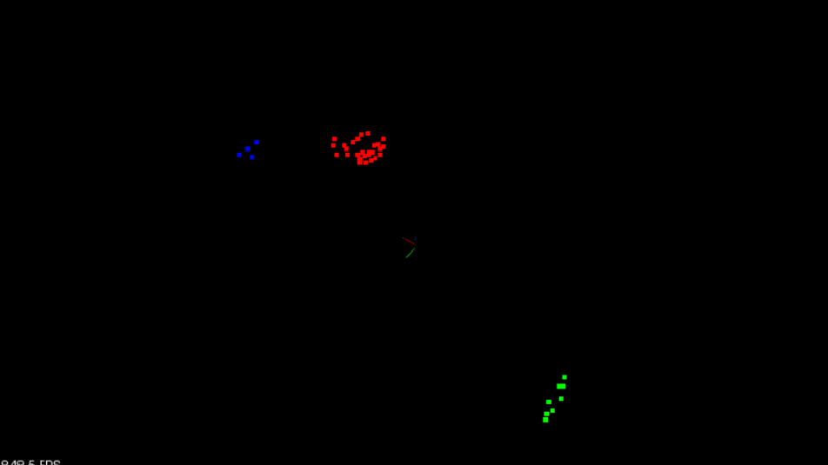

**Instructions**

* Define the function clusters in *pointProcessor* using the pcl document guide above for reference.
* Experiment with different hyperparameters for the clustering algorithm.
* In *environment.cpp* render the different clusters using the code sample above.

### Implementing KD-Tree

A KD-Tree is a binary tree that splits points between alternating axes. By separating space by splitting regions, nearest neighbor search can be made much faster when using an algorithm like Euclidean clustering. In this quiz you will be looking at a 2D example, so the tree will be a 2D-Tree. In the first part of the quiz you will be working from *src/quiz/cluster/kdtree.h* and filling in the function *insert* which takes a 2D point represented by a vector containing two floats, and a point ID. The ID is a way to uniquely identify points and a way to tell which index the point is referenced from on the overall point cloud. To complete the *insert* function let's first talk about how a KD-Tree splits information.

**Inserting Points into the Tree**

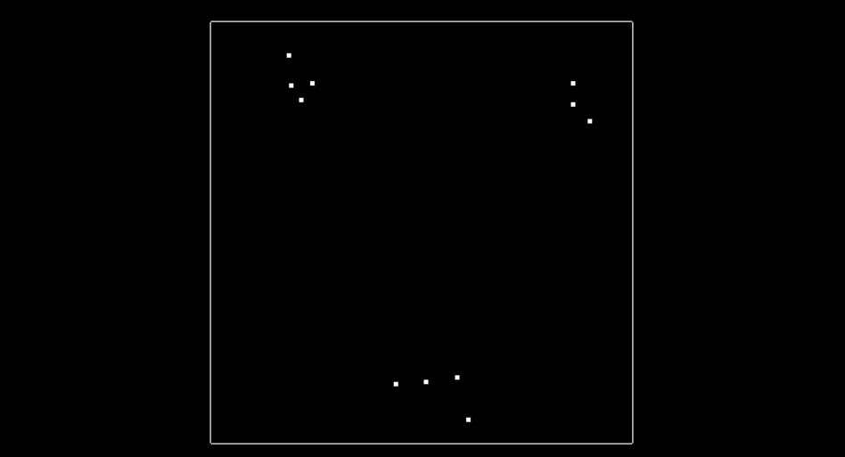

The image above shows what the 2D points look like. In this simple example there are only 11 points, and there are three clusters where points are in close proximity to each other. You will be finding these clusters later.

In *src/quiz/cluster/cluster.cpp* there is a function for rendering the tree after points have been inserted into it. The image below shows line separations, with blue lines splitting x regions and red lines splitting y regions. The image shows what the tree looks like after all 11 points have been inserted, and you will be writing the code to do this over the next concepts.

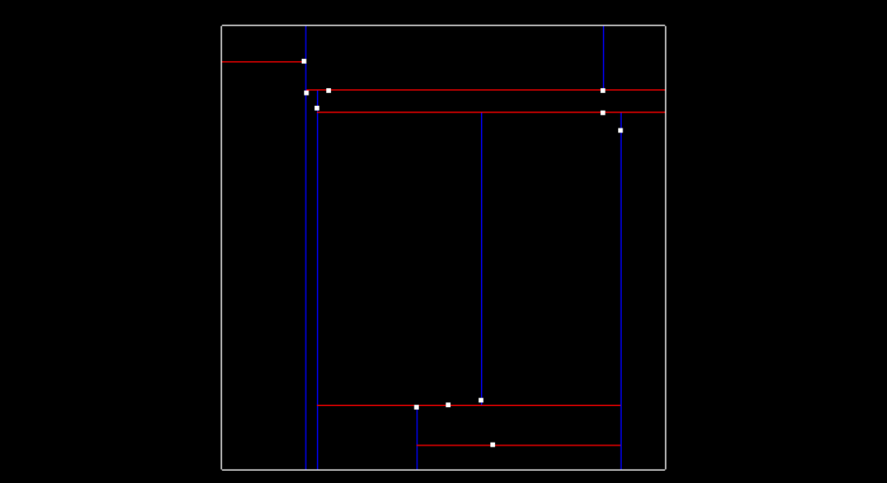

Tree separating x and y regions

### Inserting Points into KD-Tree

Now let’s talk about how exactly the tree is created. At the very beginning when the tree is empty, root is NULL. The point inserted becomes the root, and splits the x region. Here is what this visually looks like, after inserting the first point (-6.2, 7).

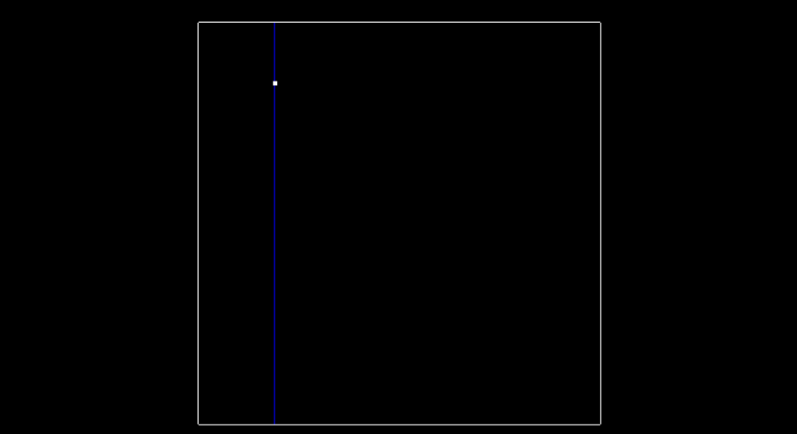

The next point is (-6.3, 8.4). Since we previously split in the x-dimension, and -6.3 is less than -6.2. This Node will be created and be a part of root's left node. The point (-6.3, 8.4) will split the region in the y dimension.

To recap, the root was at depth 0, and split the x region. The next point became the left child of root and had a depth of 1, and split the y region.

A point at depth 2 will split the x region again, so the split dimension number can actually be calculated as depth % 2, where 2 is the number of dimensions we are working with. The image below shows how the tree looks after inserting the second point.

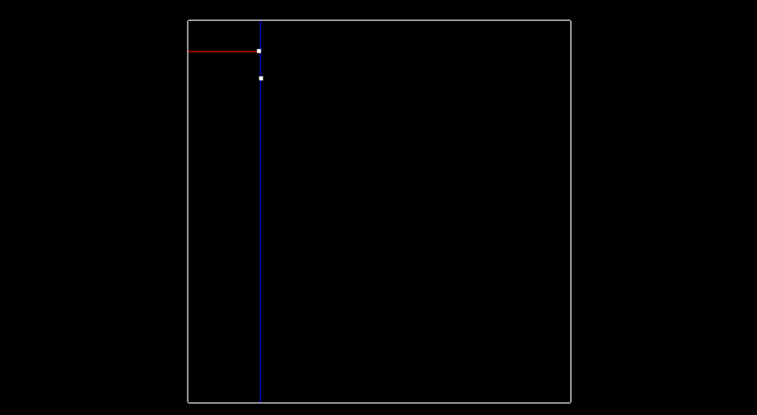

Then here is what the tree looks like after inserting two more points (-5.2, 7.1) and (-5.7, 6.3), and having another x split division from point (-5.7, 6.3). The tree is now at depth 2.

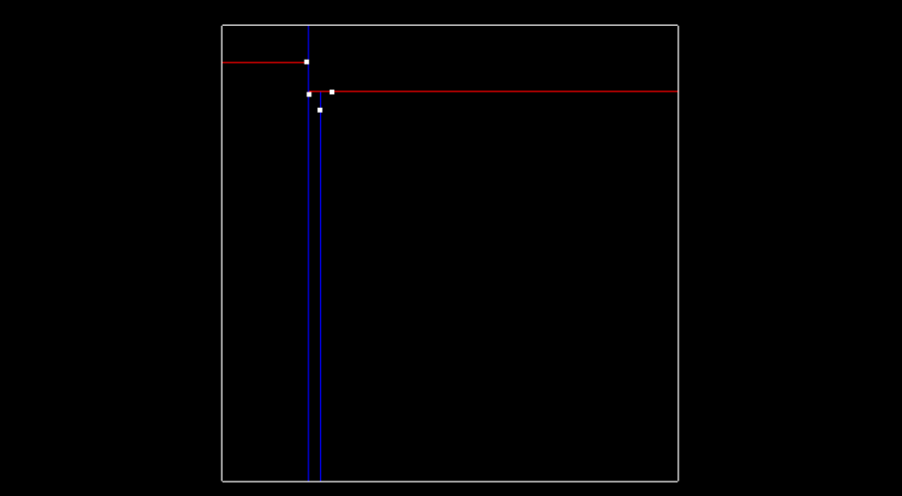

The image below shows so far what the tree looks like after inserting those 4 points. The labeled nodes A, B, C, D, and E are all NULL but if the next point (7.2, 6.1) is inserted, which of those 5 nodes will the new point node be assigned to? Remember to traverse the tree starting at the root. The depth tells you which dimension (x or y) you should use for comparison.

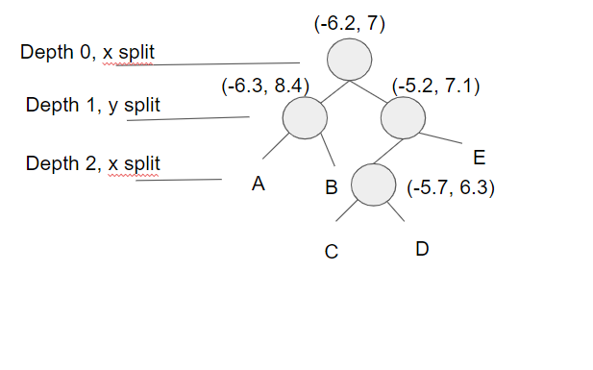

Having a balanced tree that evenly splits regions improves the search time for finding points later. To improve the tree, insert points that alternate between splitting the x region and the y region evenly. To do this pick the median of sorted x and y points. For instance if you are inserting the first four points that we used above (-6.3, 8.4), (-6.2, 7), (-5.2, 7.1), (-5.7, 6.3) we would first insert (-5.2,7.1) since it is the median along the x axis. If there is an even number of elements the lower median is chosen. The next point to be inserted would be (-6.2, 7), the median of the three points for y. This would be followed by (-5.7,6.3) the lower median between the two for x, and then finally (-6.3,8.4). This ordering will allow the tree to more evenly split the region space and improve search time later.

### Insert Points

The previous concept showed how points are inserted into the tree. How about doing this in C++? Implementing a recursive helper function to insert points can be a very nice way to update Nodes. The basic idea is that the tree is traversed until the Node it arrives at is NULL, in which case a new Node is created and replaces the NULL Node. For assigning a Node, one way is to use a double pointer. You could pass in a pointer to the node, starting at root, and then when you want to replace a node you can dereference the double pointer and assign it to the newly created Node. Another way of achieving this is by using a pointer reference as well. For references, check out the code below for doing insertion in C++ but with a binary tree. The insertion for a KD-Tree will be very similar to this.

**Example of Insertion for Binary Tree**

Double Pointer

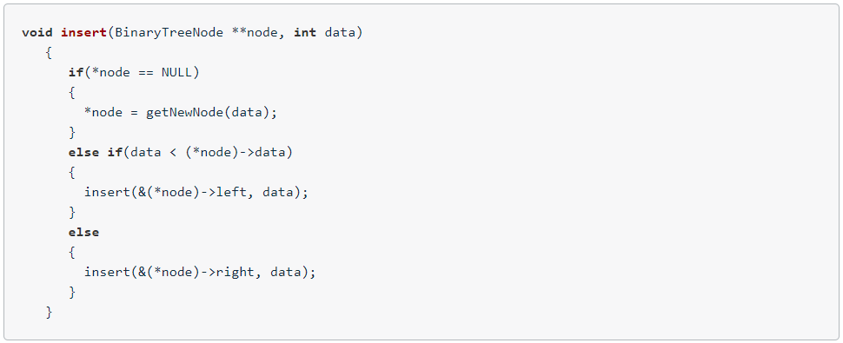

Pointer Reference

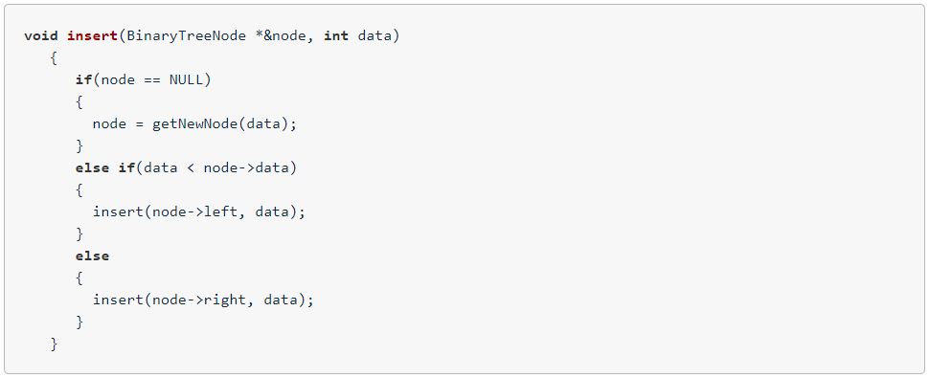

**Instructions**

Check out the quiz and try getting the resulting image from the previous concept, visually showing how each point is separating the x/y regions.

* In *src/quiz/cluster/kdtree.h* fill in the *insert* function.

### Searching Points in a KD Tree

Once points are able to be inserted into the tree, the next step is being able to search for nearby points inside the tree compared to a given target point. Points within a distance of *distanceTol* are considered to be nearby. The KD-Tree is able to split regions and allows certain regions to be completely ruled out, speeding up the process of finding nearby neighbors.

The naive approach of finding nearby neighbors is to go through every single point in the tree and compare their distances with the target, selecting point indices that fall within the distance tolerance of the target. Instead with the KD-Tree you can compare distance within a boxed square that is 2 x *distanceTol* for length, centered around the target point. If the current node point is within this box then you can directly calculate the distance and see if the point id should be added to the list of nearby ids. Then you see if your box crosses over the node division region and if it does compare that next node. You do this recursively, with the advantage being that if the box region is not inside some division region you completely skip that branch.

**Instructions**

* In *src/quiz/cluster/kdtree.h* fill in the *search* function.
* Verify that when the code is run, line 115 of *cluster.cpp* produces the following output:

Test Search

0,1,2,3,

* Experiment by using different point values in the call to *search* in line 115 of *cluster.cpp*. Use target points that are close to points in the tree. If the distance tolerance is large enough then those expected nearby point ids should be returned.

### Euclidean Clustering

Once the KD-Tree method for searching for nearby points is implemented, its not difficult to implement a Euclidean clustering method that groups individual cluster indices based on their proximity. Inside *cluster.cpp* there is a function called *euclideanCluster* which returns a vector of vector ints, this is the list of cluster indices.

To perform the clustering, iterate through each point in the cloud and keep track of which points have been processed already. For each point add it to a list of points defined as a cluster, then get a list of all the points in close proximity to that point by using the *search* function from the previous exercise. For each point in close proximity that hasn't already been processed, add it to the cluster and repeat the process of calling proximity points. Once the recursion stops for the first cluster, create a new cluster and move through the point list, repeating the above process for the new cluster. Once all the points have been processed, there will be a certain number of clusters found, return as a list of clusters.

**Pseudocode**

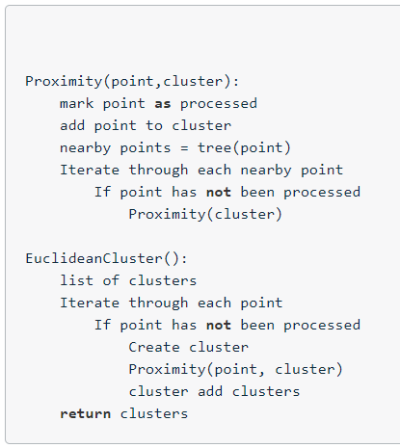

The EuclideanCluster is called in cluster.cpp line 123:

*std::vector<std::vector<int>> clusters = euclideanCluster(points, tree, 3.0);*

The image below shows the expected output results.

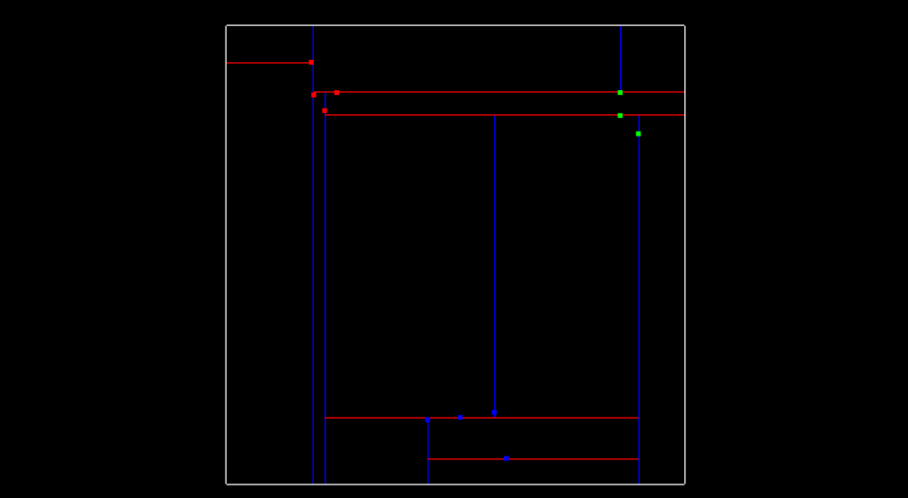

**Instructions**

* In *src/quiz/cluster/cluster.cpp* fill in the *euclideanCluster* function.
* Once the method is working for the 2D point example, try extending it to work with 3D point clouds by doing the same logic but including the extra third dimension.

### Bounding Boxes

Now that you know how point cloud clustering works, we will return to the main project code. In this next exercise, you will add bounding boxes to the point cloud clusters that you previously found.

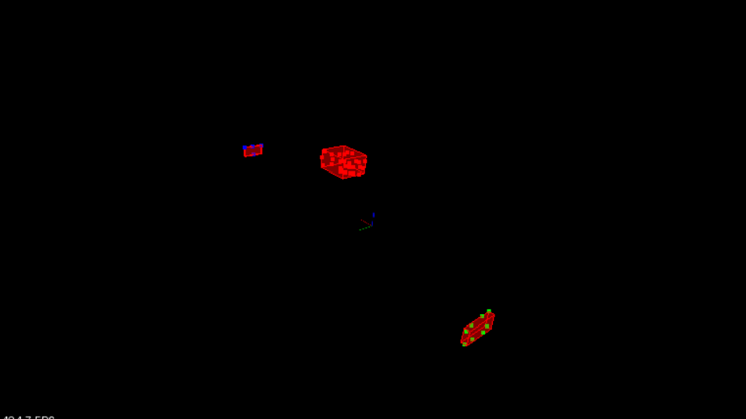

As a final touch, you can add bounding boxes around the clusters. The bounding box volume could also be thought of as space the car is not allowed to enter, or it would result in a collision. Your point processor already has a bounding box function all set up. This function is already predefined since it’s doing a very simple technique for generating a box. The function *BoundingBox* looks at the min and max point values of an input cloud and stores those parameters in a box struct container. To render bounding boxes around your clusters you can add the following code inside the loop that renders clusters in *environment.cpp*.

*Box box = pointProcessor->BoundingBox(cluster);*

*renderBox(viewer,box,clusterId);*

The results of doing this are shown in the image above.

**Instructions**

* In src/environment.cpp add the renderBox function to render boxes around clusters

### Extra Challenge: PCA Boxes

Some comments from the previous concept about the way bounding boxes are calculated. That method of generating bounding boxes the boxes are always oriented along the X and Y axis. This is ok if the cluster that you are looking at has its majority of points orientated along these axes , but what if the cluster was a very long rectangular object at a 45 degree angle to the X axis. The resulting bounding box would be a unnecessarily large, and would constrain your car's available space to move around. See the image below for reference.

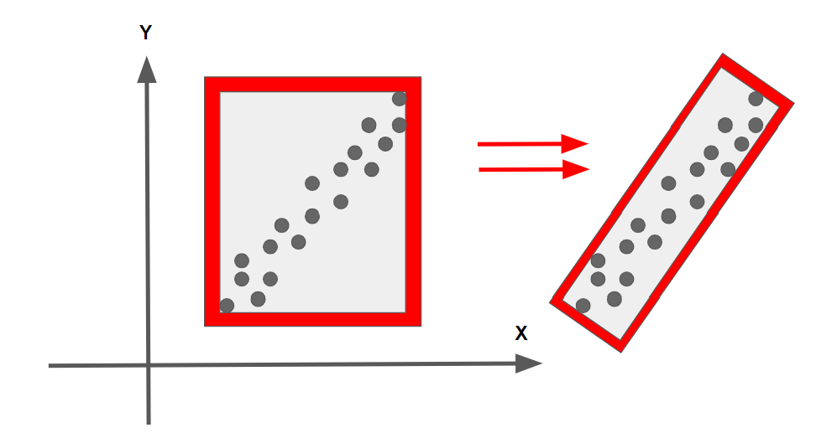

In the above image, the bounding box on the right is more efficient, containing all the points with the minimum area required. It would be nice to take into account box rotation in the XY plane, about the Z axis. Rotation about the X or Y axes would yield weird results, since the car in the majority of situations is not concerned with the Z dimension, or has any control over Z movement.

The file containing the box struct is located in *src/render/box.h* and contains an additional struct called *BoxQ*. This struct has a quaternion member that allows rotations. Also there is an additional *renderBox* function in render.cpp that takes a BoxQ argument and renders the rotational box. There is a blog post about fitting the smallest possible 3D box around a 3D point cloud [here](http://codextechnicanum.blogspot.com/2015/04/find-minimum-oriented-bounding-box-of.html). The solution in the post uses [PCA](https://en.wikipedia.org/wiki/Principal_component_analysis), principal component analysis and includes Z axis rotations as well. A challenge problem is then to find the smallest fitting box but which is oriented flat with the XY plane.

## Working with Real PCD

### Load Real PCD

In the previous lessons you learned how to segment and cluster simple simulated point clouds. Now you will learn how to apply these same skills to actual point cloud data from a self-driving car. You will also learn how to do additional filtering techniques and create a pipeline to perform obstacle detection across multiple streaming pcd files. So let’s get started by loading up some actual point cloud data from a self-driving car.

### Load PCD

To first load up one of the car’s recorded pcd files, you will want to create a new point processor, similar to the one we created before in the *simpleHighway* function. This time however you will be using the pcl *PointXYZI* type, the "I" stands for intensity, which will now be an additional feature for each point in the cloud. In *environment.cpp* you should create a new function called *CityBlock* that will be the same layout as the *simpleHighway* function. The arguments for *CityBlock* will be the same as *simpleHighway*, a reference to the pcl viewer. Inside the new *CityBlock* function you will create a new point processor using a *PointXYZI* template argument. You will use the point processor to load one of the car’s point clouds and then use the *renderPointCloud* function to view it. Don't forget to call *cityBlock* now instead of *simpleHighway* in the *main* function. Check out the code below for reference. All of the car’s pcd files are located in *src/sensors/data/pcd/data_1/*

*void cityBlock(pcl::visualization::PCLVisualizer::Ptr& viewer)*

*{*

*// ----------------------------------------------------*

*// -----Open 3D viewer and display City Block -----*

*// ----------------------------------------------------*

*ProcessPointClouds<pcl::PointXYZI>* pointProcessorI = new ProcessPointClouds<pcl::PointXYZI>();*

*pcl::PointCloud<pcl::PointXYZI>::Ptr inputCloud = pointProcessorI->loadPcd("../src/sensors/data/pcd/data_1/0000000000.pcd");*

*renderPointCloud(viewer,inputCloud,"inputCloud");*

*}*

The image below is what the results of loading and running this look like, if the color is not specified in the *renderPointCloud* function argument, it will default to using the intensity color coding. Looking around the pcd, you can see several cars parked along the sides of the road and a truck approaching to pass the ego car on the left side. Your goal will be to fit bounding boxes around these cars and the passing truck, so then your system could later use that information in its path planner, trying to avoid any collisions with those obstacles.



**Instructions**

* Create *cityBlock* function as shown above
* Replace the *simpleHighwaycall* in main with *cityBlock*
* Compile/Run, The output will look like the image above
* Orbit and Zoom around the point cloud

### Filtering with PCL

The first thing you might notice when looking at the previous loaded point cloud is it’s quite high resolution and spans a pretty far distance. You want your processor pipeline to be able to digest point cloud as quickly as possible, so you will want to filter the cloud down. Here are the two methods that will be used to do this.

**Voxel Grid**

Voxel grid filtering will create a cubic grid and will filter the cloud by only leaving a single point per voxel cube, so the larger the cube length the lower the resolution of the point cloud.

**Region of Interest**

A boxed region is defined and any points outside that box are removed.

To apply these methods you will fill in the point process function *FilterCloud*. The arguments to this function will be your input cloud, voxel grid size, and min/max points representing your region of interest. The function will return the downsampled cloud with only points that were inside the region specified. To get started check out the documentation from PCL for [voxel grid filtering](http://pointclouds.org/documentation/tutorials/voxel_grid.php) and [region of interest](http://docs.pointclouds.org/trunk/classpcl_1_1_crop_box.html).

**Results**

To apply the filtering function, back in *cityBlock* call the pointProcessor FilterCloud function with the loaded pcd.

*// Experiment with the ? values and find what works best*

*filterCloud = pointProcessorI->FilterCloud(inputCloud, ? , Eigen::Vector4f (?, ?, ?, 1), Eigen::Vector4f ( ?, ?, ?, 1));*

*renderPointCloud(viewer,filterCloud,"filterCloud");*

In the filter cloud image below you can now see that the point resolution is much lower than the original, and it cropped everything inside the box points that were specified. It’s important to experiment and play around with the filter input hyper parameters. voxel size should be large enough to help speed up the processing but not so large that object definition is completely lost. For picking a good region, try having a good amount of space in front of the car so it could react quickly in time to any obstacles moving towards it. Also for the sides try to cover at least the width of the road. What’s most important is obstacles that we want to detect are inside the region. Also setting camera angles in *environment.cpp* can help pick a good region of interests. This way you can easily set the camera to have a top down overview or a side overview. One last thing is it would be beneficial to remove points that are hitting the roof of the ego car. You can use a pcl CropBox to find the roof point indices and then feed those indices to a pcl ExtractIndices object to remove them (similar to what your segmentation algorithm used to extract points). The *renderBox* function can be really helpful as well for figuring out how big boxes will look in the scene.

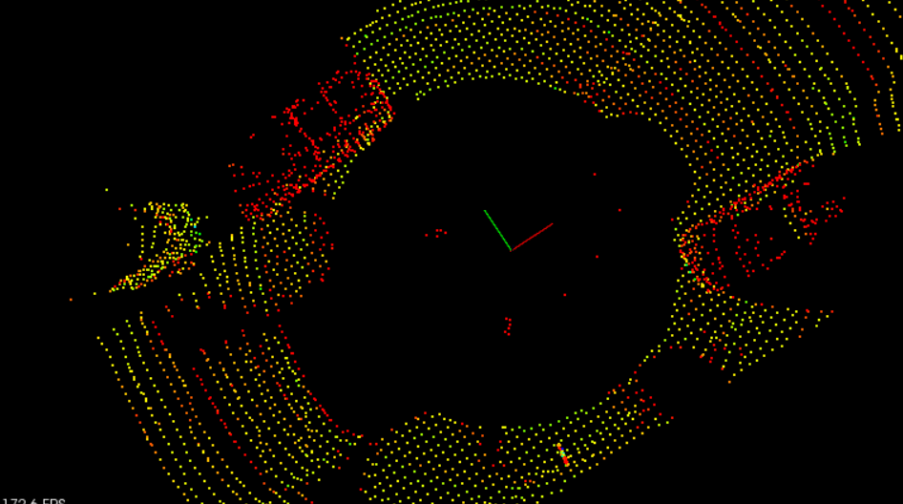

**Instructions**

* Fill in the *FilterCloud* function in *pointProcessor*
* Call *FilterCloud* from *cityBlock* and experiment with hyperparameters
* (Optional) Remove ego car roof points
* Observe the results

### Steps for Obstacle Detection

Now that the pcd is filtered you are ready to deploy the same segmentation and clustering techniques that we applied before in the previous lessons, now using the new intensity point processor inside *cityBlock*.

**Step 1. Segment the filtered cloud into two parts, road and obstacles**

After you filter the point cloud the next step is to segment it. The image below shows the filtered point cloud segmented (road in green), (obstacles in red), with points only in the filtered region of interest. The image also displays a purple box showing the space where the car's roof points were contained, and removed.

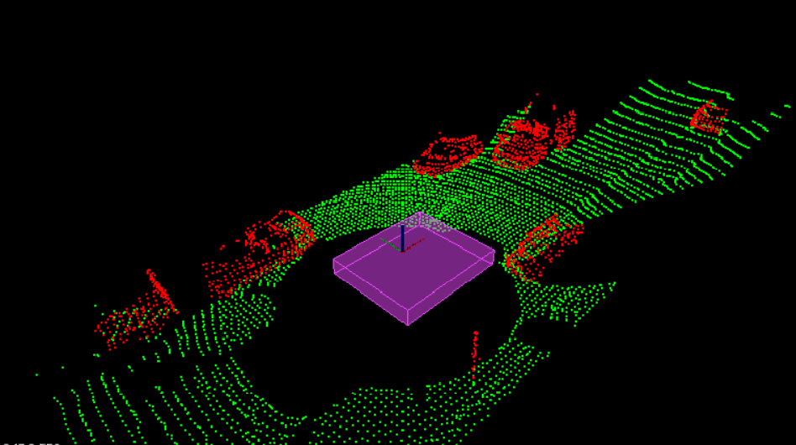

**Step 2. Cluster the obstacle cloud**

Next you cluster the obstacle cloud based on the proximity of neighboring points. The image below shows the clusters in cycled colors of red, yellow, and blue. In that image we see that the oncoming truck is actually broken up into two colors, front and back. This illustrates the challenges with clustering based on proximity, the gap between the front of the truck and the back of the truck is large enough so that they look separate. You might think to fix this by increasing the distance tolerance, but you can also see that the truck is getting really close to one of the side parked cars. Increasing the distance tolerance would run the risk of the truck and parked car being grouped together.

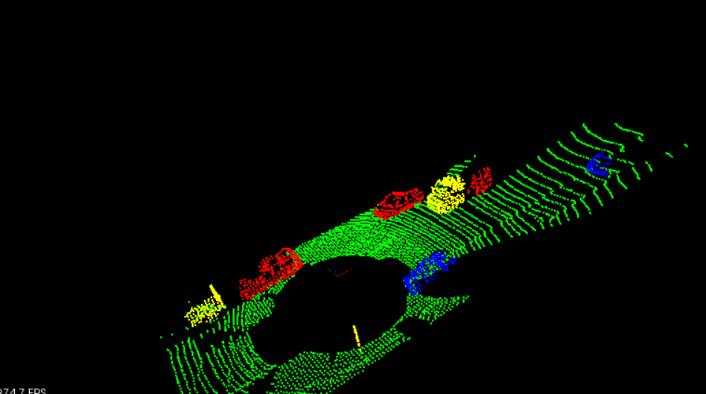

**Step 3. Find bounding boxes for the clusters**

Finally you place bounding boxes around the individual clusters. Since all the detectable vehicles in this scene are along the same axis as our car, the simple already set up bounding box function in point processor should yield good results.

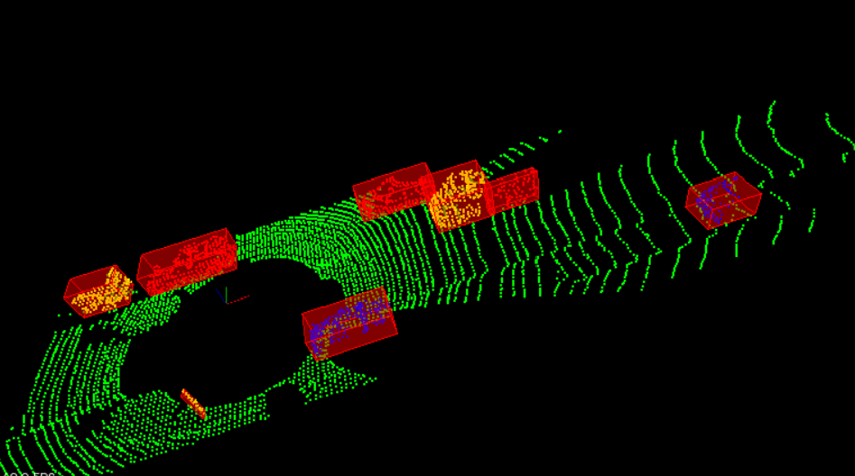

### Stream PCD

In the previous concept you were able to process obstacle detections on a single pcd file, now you are going to be using that same processing pipeline on multiple pcd files. To do this you can slightly modify the previous used *cityBlock* function from *environment.cpp* to support some additional arguments. Now, you will be passing in the point processor to the *cityBlock* function, this is because you don't want to have to recreate this object at every frame. Also the point cloud input will vary from frame to frame, so input point cloud will now become an input argument for *cityBlock*. The *cityBlock* function header should now look like this, and you no longer create the point processor or load a point cloud from inside the function.

**cityBlock new function signature**

*void cityBlock(pcl::visualization::PCLVisualizer::Ptr& viewer, ProcessPointClouds<pcl::PointXYZI>* pointProcessorI, const pcl::PointCloud<pcl::PointXYZI>::Ptr& inputCloud)*

Notice that in the function header you can optionally make *inputCloud* a constant reference by doing *const* and *&* at the end of the variable definition. You don't have to do this but you are not actually changing the *inputCloud* at all, just using it as an input for your point processor function. The benefit of using a constant reference is better memory efficiency, since you don't have to write to that variable's memory, just read from it, so it's a slight performance increase. If you do make this a const reference though, make sure not to modify it, or else you will get a compile error.

**Code inside main**

So now instead of creating your point processor, and loading pcl files from inside *cityBlock* you will do this inside the *main* function in *environment.cpp* right after where the pcl viewer camera position is set up.

*ProcessPointClouds<pcl::PointXYZI>* pointProcessorI = new ProcessPointClouds<pcl::PointXYZI>();*

*std::vector<boost::filesystem::path> stream = pointProcessorI->streamPcd("../src/sensors/data/pcd/data_1");*

*auto streamIterator = stream.begin();*

*pcl::PointCloud<pcl::PointXYZI>::Ptr inputCloudI;*

In the code above, you are making use of a new method from point processor called, *streamPcd*. You tell *streamPcd* a folder directory that contains all the sequentially ordered pcd files you want to process, and it returns a chronologically ordered vector of all those file names, called *stream*. You can then go through the *stream* vector in a couple of ways, one option is to use an iterator. At the end of the above code block, a variable for the input point cloud is also set up.

**PCL Viewer update loop**

The final thing to look at is the pcl viewer run cycle which is down at the bottom of *envrionment.cpp*. while the pcl viewer hasn't stopped, you want to process a new frame, do obstacle detection on it, and then view the results. Let's see how to set up this pcl viewer run cycle method below.

*while (!viewer->wasStopped ())*

*{*

*// Clear viewer*

*viewer->removeAllPointClouds();*

*viewer->removeAllShapes();*

*// Load pcd and run obstacle detection process*

*inputCloudI = pointProcessorI->loadPcd((*streamIterator).string());*

*cityBlock(viewer, pointProcessorI, inputCloudI);*

*streamIterator++;*

*if(streamIterator == stream.end())*

*streamIterator = stream.begin();*

*viewer->spinOnce ();*

*}*

The first thing the above method does is clear any previous rendered point clouds or shapes. Next it loads up your point cloud using your point processor and stream iterator. Then it calls your *cityBlock* function, and updates the iterator. If the iterator hits the end of the vector it simply sets it back to the beginning and that's it. The *viewer->spinOnce()* call controls the frame rate, by default it waits 1 time step, which would make it run as fast as possible. Depending on how timing efficient your obstacle detection functions were set up the faster the viewer's frame rate will be. If you want to check out the input pcd data at the fastest rate then run the code above and only run a single *renderPointCloud* on the input cloud inside *cityBlock*.

### Lidar Obstacle Detection Project

In this project you will take everything that you have learned for processing point clouds, and use it to detect car and trucks on a narrow street using lidar. The detection pipeline should follow the covered methods, filtering, segmentation, clustering, and bounding boxes. Also the segmentation, and clustering methods should be created from scratch using the previous lesson’s guidelines for reference. The finished result will look like the image below, placing bounding boxes around all obstacles on the road.

### Tracking and Challenge Problem

**Tracking Discussion**

You have made it through the entire lidar obstacle detection process. You are able to stream back multiple pcd files and perform filtering, segmentation, clustering, and bounding box detection. Now that you are able to detect obstacles in single frames, you can make your pipeline even more robust by tracking detections over the history of frames. You can create associations between detections in frames and use that to track objects.

One way to create associations between two different frames is by how close in proximity two detections are to each other and how similar they look. There are also a lot more filtering procedures that you can explore, such as looking at detection that are seen in consecutive frames before they are considered. You could also filter based on bounding boxes, their volume and shapes. By deploying tracking methods and associations you could try to dynamically build the shapes of obstacles. Examples of this might be, maybe you see the backside of a long truck, the lidar only first sees the back of the truck. Then later you drive past the truck. letting the lidar see the trucks side. There are many ways to keep exploring and making the detection process more robust.

**Challenge Problem**

If you are up for an additional challenge check out *src/sensors/data/pcd/data_2* to see how well you can detect/track a bicyclist riding in front of the car, along with detecting/tracking the other surrounding obstacles in the scene.



# Radar

## Radar Principles

### The Radar Sensor

The image below shows how radar sensors are used along with a full suite of other sensors in an autonomous vehicle:

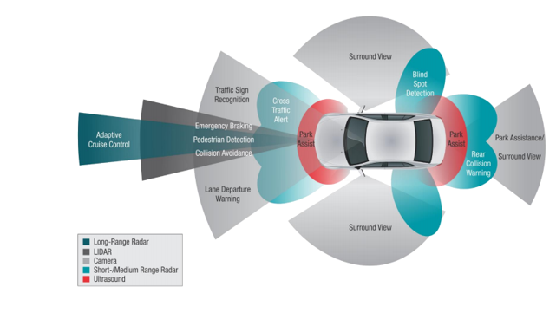

**Radar Operation**

Radar works using the transmission and detection of electromagnetic waves as seen in the following image:

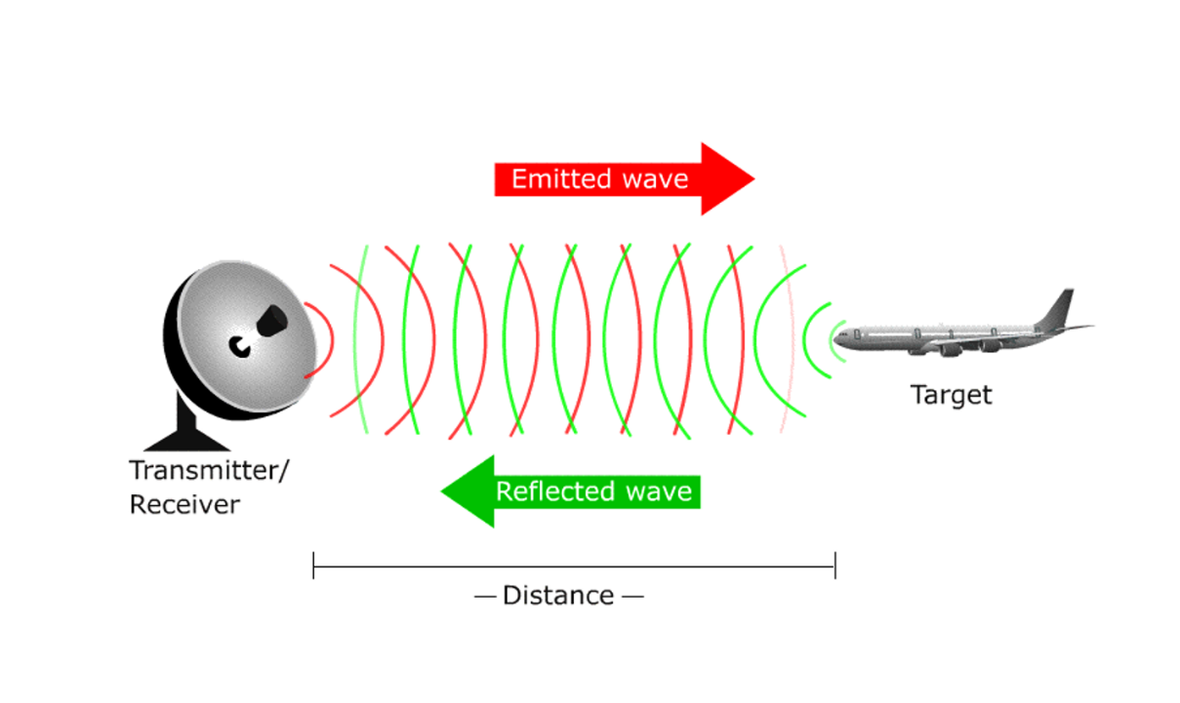

The electromagnetic waves are reflected if they meet an obstacle. If these reflected waves are received again at the place of their origin, then that means an obstacle is in the propagation direction. The frequency of electromagnetic energy used for radar is unaffected by darkness and also penetrates fog and clouds. This permits radar systems to determine the position of road targets that are invisible to the naked eye because of distance, darkness, or weather. Modern radar can extract widely more information from a target's echo signal than its range.

**Radar Construction**

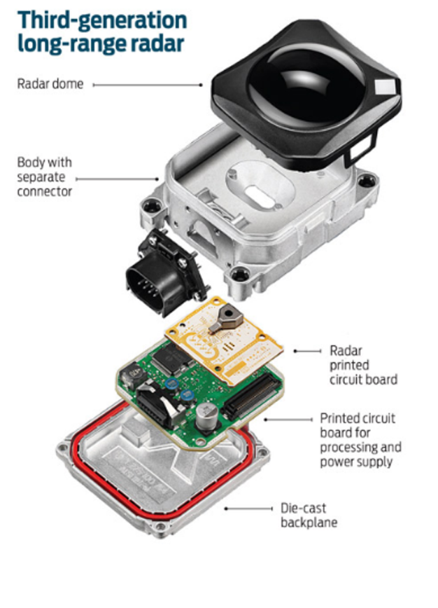

The automotive radars are small size sensors that can easily fit beneath the front grill or the bumper. As seen in the image above a radar module comprises of different parts.

*Radar Dome or Radome*: A radome is a structural, weatherproof enclosure that protects a radar antenna. The radome is constructed of material that minimally attenuates the electromagnetic signal transmitted or received by the antenna, effectively transparent to radio waves.

*Radar Printed Circuit Board*: This is analog hardware that includes the radar transceiver and antenna needed for radio wave generation.

*Printed Circuit Board and Processing*: This includes the Digital Signal Processing (DSP) unit.

**Radar vs Lidar**

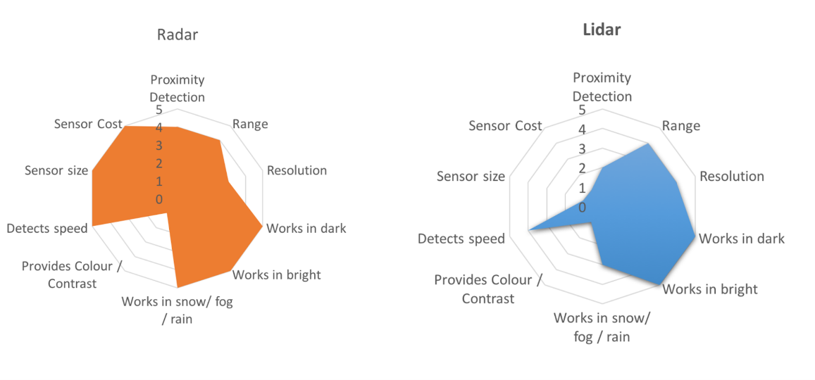

LIDAR can generate high resolution imaging based on reflection of the laser light off from the targets. But LIDARs fail in bad weather conditions as the very small wavelength doesn’t allow to work well in fog or rain. Additionally, LIDAR is an expensive sensor with costs varying from $35,000 to $100,000 as of 2019.

Radar lacks the capability to generate a high resolution image, but it has highly accurate velocity estimation based on the doppler phenomenon. Also, radar wavelength allows it to sense the targets in bad weather conditions as well. Most important is the low manufacturing cost for a Radar. A radar unit can cost as low as a few hundred dollars, allowing a car manufacturer to deploy multiple Radar sensors for 360 degree perception.

### Signal Properties

**Signal Wave Parameters**

Wavelength (λ) is the physical length from one point of a wave to the same point on the next wave, and it is calculated as

λ = $\frac{speed of light}{frequency}$

The higher the frequency the smaller the wavelength.

The *frequency* of a wave is the number of waves that pass by each second, and is measured in Hertz (Hz). The automotive radar generally operates at W band (76GHz - 81GHz). The signal at this frequency is referred to as millimeterWave since the wavelength is in mm.

The *Bandwidth* of a signal is the difference between the highest and the lowest frequency components in a continuous band of frequencies.

The *Amplitude* is the strength of the signal. Often it corresponds to the power of the RF signal/electromagnetic field defined in dB/dBm. It is relevant while configuring the output power of the radar and sensing the received signal. Higher the amplitude of the Radar signal, more is the visibility of radar. Automotive Radar can operate at max of 55 dBm output power (316 W)

**Phase of a Signal**

Phase is a particular point in time on the cycle of a waveform, measured as an angle in degrees. A complete cycle is 360°. The phase for each argument value, relative to the start of the cycle, is shown in the image below, in degrees from 0° to 360° and in radians from 0 to 2π.

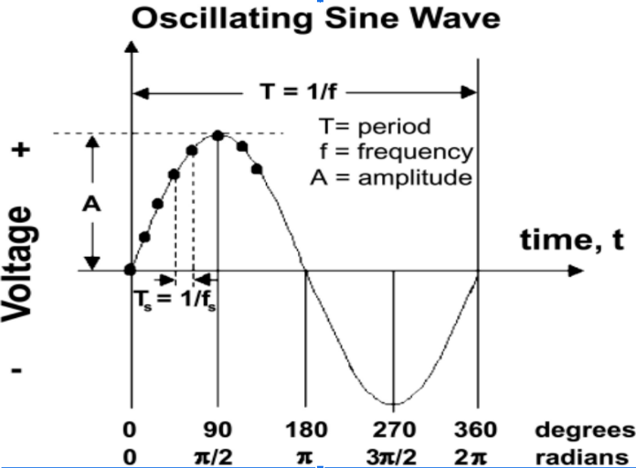

The frequency can also be defined as the first derivative of the phase with respect to the time.

$frequency= \frac{dφ}{dt}$ where $φ=phase of the signal$

The difference between the phases of two periodic signals is called the phase difference. At values of when the difference is zero, the two signals are said to be in phase, otherwise they are out of phase with each other.

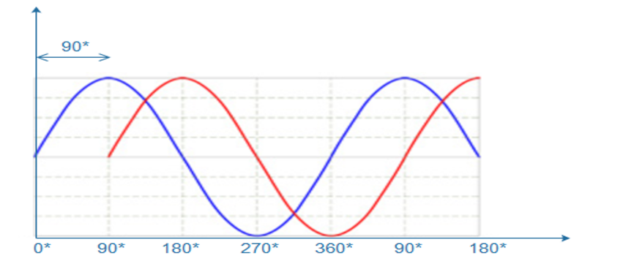

**General Equation of a Wave**

A wave travelling in space is defined by the following equation:

$y\left(t\right)=A cos⁡(2π*f_{c}*t+ φ)$

### FMCW

FMCW radar (Frequency-Modulated Continuous Wave radar) is a special type of radar sensor which radiates continuous transmission power. FMCW radar’s ability to measure very small ranges to the target as well as its ability to measure simultaneously the target range and its relative velocity makes it the first choice type of radar for automotive applications.

**FMCW Chirps**

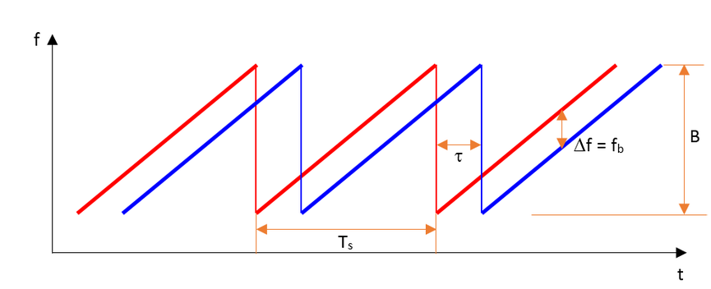

A Frequency Modulated Continous Wave (FMCW) is a signal in which the frequency increases/decreases with time. They are also referred to as upramps and downramps. The two most common waveform pattern used for FMCW radars are sawtooth and triangular. The sawtooth waveform generally uses just the upramps, whereas the triangular waveform uses both upramps and downramps.

Each chirp is defined by its slope. The slope is given by its chirp frequency bandwidth $B$ or $B_{sweep}$ (y-axis) and its chirp time $T_{s}$ (x-axis). Hence,

$Slope= \frac{B}{T_{s}}$

The range resolution requirement decides the $B$, whereas the maximum velocity capability of a radar is determined by the chirp time $T_{s}$.

One chirp sequence or segment comprises of multiple chirps. Each chirp is sampled multiple times to give multiple range measurements and radar transmits in order to measure doppler velocity accurately.

### FMCW Hardware and Antenna

**FMCW Hardware Overview**

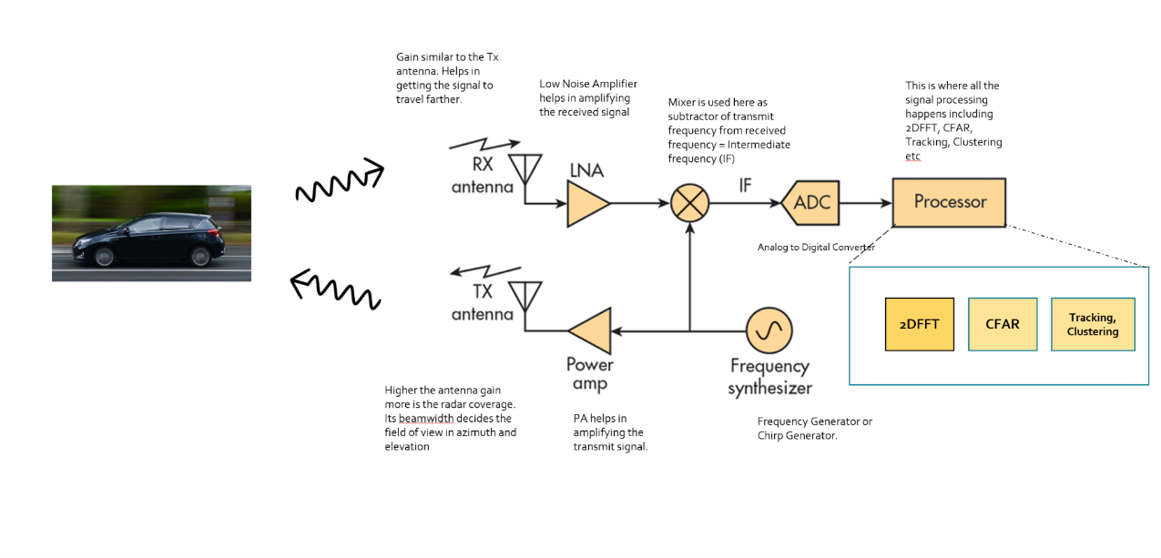

*Frequency Synthesizer*: The frequency synthesizer is the component that generates the frequency to bring the chirp frequency all the way to 77GHz in case of automotive radar.

*Power Amp*: The power amp amplifies the signal so the signal can reach long distance. Since the signal attenuates as it radiates, it needs higher power (amplitude) to reach targets at greater distances.

*Antenna*: The antenna converts the electrical energy into electromagnetic waves which radiate through the air, hit the target, and get reflected back toward the radar receiver antenna. The Antenna also increases the strength of the signal by focusing the energy in the desired direction. Additionally, the antenna pattern determines the field of view for the radar.

*Mixer*: In FMCW radar, the mixer multiplies the return signal with the sweeping signal generated by the frequency synthesizer. The operation works as frequency subtraction to give the frequency delta - also known as frequency shift or Intermediate frequency (IF). IF = Synthesizer Frequency - Return Signal Frequency.

*Processor*: The processor is the processing unit where all the Digital Signal processing, Detection, Tracking, Clustering, and other algorithms take place. This unit could be a microcontroller or even an FPGA.

**Antenna Details**

As defined in the FMCW Hardware definitions, the antenna is a transducer that converts the electrical energy into electromagnetic waves. In the case of radar, these waves travel through the air and hit the target. Depending on the surface type and shape of the target, the waves get partially reflected back in the direction of the radar. The receiver antenna at the radar amplifies the received signal further and sends it to the receiver chain for further processing.

**The Antenna Pattern**

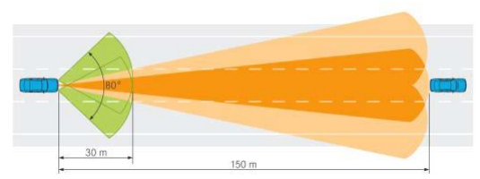

The *antenna pattern* is the geometric pattern of the strengths of the relative field emitted by the antenna. The *beamwidth* of the antenna determines the field of view for the radar sensor. If the requirement for the radar is to just sense the targets in its own lane then the beamwidth needs to be small enough to cover the complete lane up to desired range. If the beamwidth is wider than the lane width, it will sense the targets in the other lanes as well.

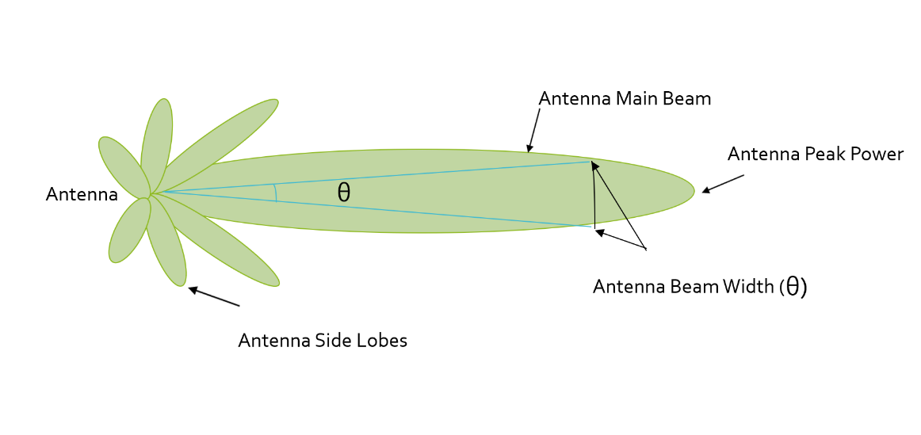

Antenna radiation not only comprises of the main beam but the sidelobes as well. Antenna sidelobes are critical because they can generate false alarms and pick interference from undesired direction. As seen in the pattern, the sidelobes of the antenna point in different directions and can sense targets that are not in the main beam. To avoid sidelobe detections it is critical to suppress the sidelobe levels to more than 30dB from the peak of the main beam.

**Antenna Types**

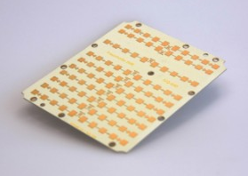

There are many types of antenna (dipole, patch, horn) that can be used at 77GHz, but the most commonly used antenna type in automotive radar is the patch antenna . The low cost, easy fabrication, and low profile of Patch Array Antennas makes them an ideal choice for automotive radar applications.

### Radar Cross Section

**Radar Cross Section Overview**

The size and ability of a target to reflect radar energy is defined by a single term, σ, known as the radar cross-section, which has units of $m^{2}.$ This unit shows that the radar cross section is an area. The target radar cross sectional area depends on:

* The target’s physical geometry and exterior features:  
  Smooth edges or surface would scatter the waves in all directions, hence lower RCS. Whereas, sharp corners will focus the return signal back in the direction of the source leading to higher RCS. (Image below for different target geometries)
* The direction of the illuminating radar
* The radar transmitter’s frequency
* The material used in the cars, trucks, bicycles, and even in some cases, the clothing material for pedestrians.

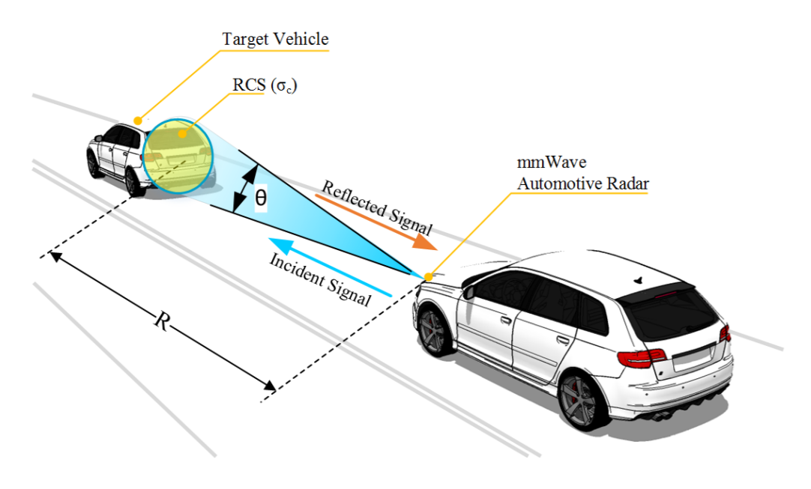

If absolutely all of the incident radar energy on the target were reflected equally in all directions, then the radar cross section would be equal to the target's cross-sectional area as seen by the transmitter. In practice, some energy is absorbed and the reflected energy is not distributed equally in all directions. Therefore, the radar cross-section is quite difficult to estimate and is normally determined by measurement.

Returns from different target geometries:

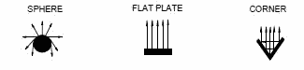

**RCS Units**

This RCS can also be defined using a logarithmic value (dB), since it increases the return signal strength. The formula for converting from RCS to dB is given by:

${RCS}_{dB}=10*\log\left({RCS}_{m^{2}}\right)$

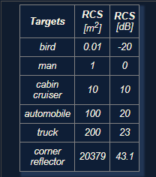

### Radar Range Equation

**Range Equation Overview**

Using the Radar Range equation we can design the radar transmitter, receiver, and antenna to have the desired power, gain and noise performance to meet the range requirements.

A long range radar designed to cover 300m range and detect a target with smaller cross section would need higher transmit power and more antenna gain as compared to a short range radar designed to cover just 50m for similar target. A target with higher cross section can be detected at a longer range as compared to a target with smaller cross section.

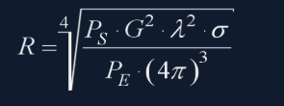

* $R$- Maximum Range a radar can detect targets.
* $P_{s}$- Transmitted Power from Radar ($dBm$)
* $G$- Gain of the Transmit/Receive Antenna ($dBi$)
* $λ$- Wavelength of the signal ($m$)
* $σ$- radar cross section ($m^{2})$
* $P_{E}$- Minimum received power radar can detect

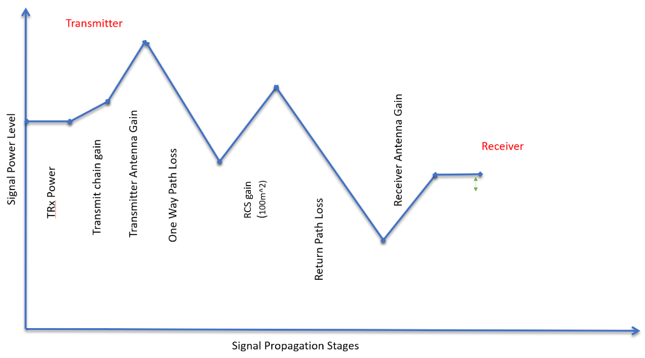

The image above shows the variation in the signal strength level as it travels through transmitter, over the air and at the receiver

The image above shows the variation in the signal strength level :

* The transmitter power
* Power Amplifiers further increase the signal strength - Transmit chain gain
* Signal is further amplified using an antenna
* One Way Path Loss represents the loss in the signal strength as it travels towards the target
* On getting reflected from the target the signal gets amplified based on the RCS of the target
* After RCS gain the signal travel back towards the radar and has similar loss in strength as going forward
* The receiver antenna amplifies the return signal before sending it to the processing unit

**Radar Detection**

Below is an illustration showing the output of a radar's range detection. The peaks correspond to the strength of the return signal from targets and the frequency relates to the range. Relationship between frequency and range will be discussed in next lesson.

A radar cannot detect a signal that is below the noise level. The noise level is determined by the thermal noise generated by the receiver. To successfully detect a target, the return signal strength needs to be larger than the noise level. This is defined by a property called signal to noise ratio, or SNR.

SNR is a quantitative measure of a signal strength as compared to the level of noise. If the SNR is too low it becomes difficult for a radar to distinguish the signal from noise. Hence, higher SNR is desirable for successful detection of the target. Generally, a 7-13 dB SNR ensures successful detection in a road scenario.

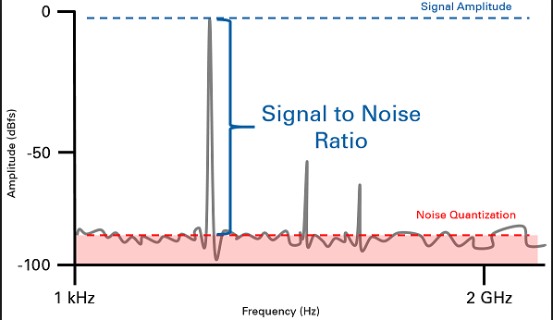

The image above shows the logarithmic value of SNR = power level (in dBm) - noise level (dBm). The plot shows the output of Range FFT. In general, the higher the SNR value, the greater are the chances of successful Radar detection.

## Range-Doppler Estimation

### Range, Velocity and Angle Resolution

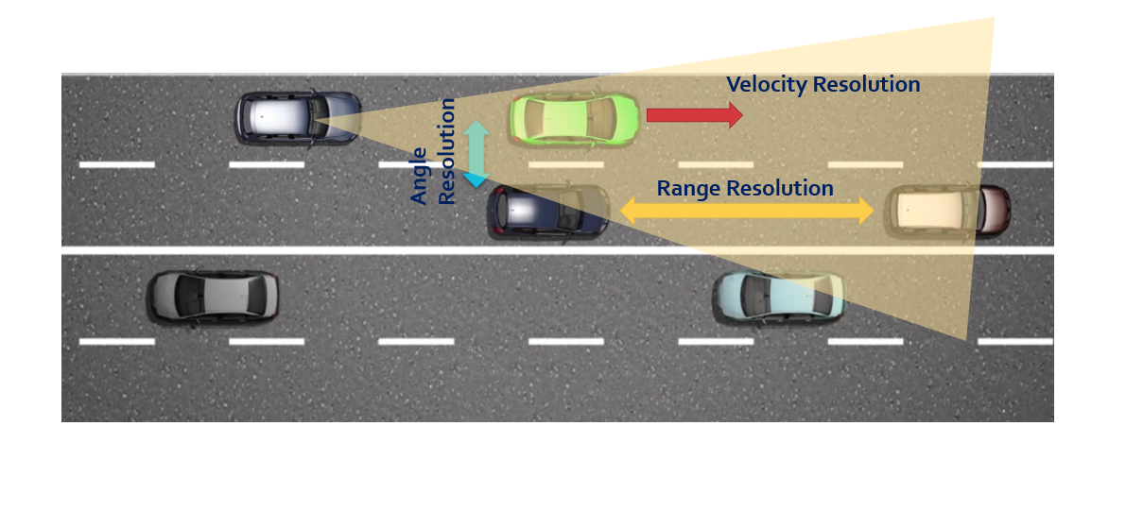

**Range Resolution**: It is the capability of the radar to distinguish between two targets that are very close to each other in range. If a radar has range resolution of 4 meters then it cannot separate on range basis a pedestrian standing 1 m away from the car.

The range resolution is solely dependent on the bandwidth of the chirp $B_{sweep}$:

$d_{res}= \frac{c}{2B_{sweep}}$

**Velocity Resolution**: If two targets have the same range they can still be resolved if they are traveling at different velocities. The velocity resolution is dependent on the number of chirps. As discussed for our case we selected to send 128 chirps. A higher number of chirps increases the velocity resolution, but it also takes longer to process the signal.

**Angle Resolution**: Radar is capable of separating two targets spatially. If two targets are at similar range travelling at same velocities, then they can still be resolved based on their angle in radar coordinate system. Angle resolution depends on different parameters depending on the angle estimation technique used.

### Range Estimation

**Range Estimation Overview**

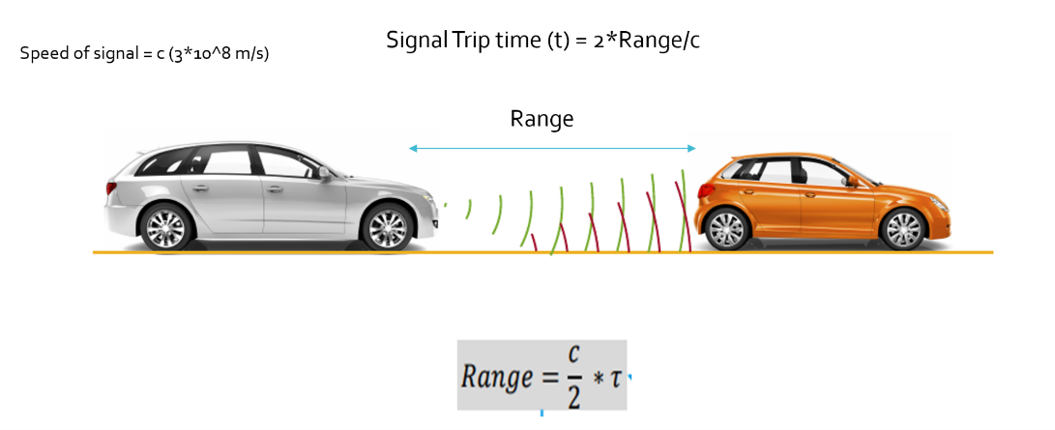

Radar determines the range of the target by measuring the trip time of the electromagnetic signal it radiates. It is known that EM wave travels at a known speed (300,000,000 m/s), so to determine the range the radar needs to calculate the trip time by measuring the shift in the frequency.

**Range Estimation Equation**

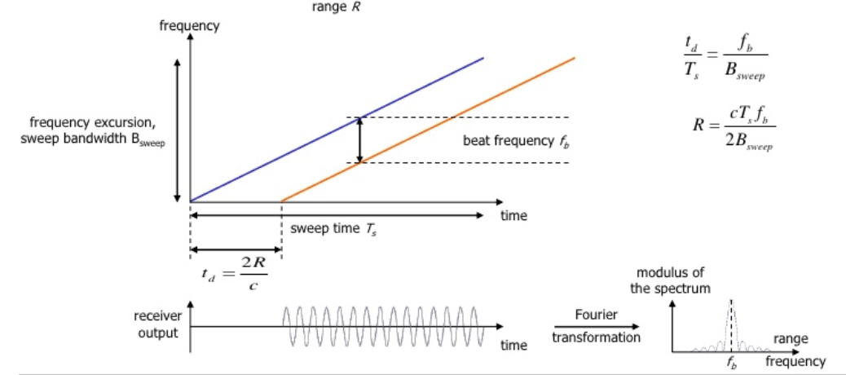

The FMCW waveform has the characteristic that the frequency varies linearly with time. If radar can determine the delta between the received frequency and hardware’s continuously ramping frequency then it can calculate the trip time and hence the range. We further divide Range estimate by 2, since the frequency delta corresponds to two way trip.

It is important to understand that if a target is stationary then a transmitted frequency and received frequency are the same. But, the ramping frequency within the hardware is continuously changing with time. So, when we take the delta (beat frequency) between the received and ramping frequency we get the trip time.

$R= \frac{cT_{s}f_{b}}{2B_{sweep}}$

Here, $f_{b}$ is the beat frequency, which is measured by the radar by subtracting the received frequency from the hardware’s ramping frequency:

$f_{b}= f_{ramping}- f_{received}$

As seen in the equation, the range calculation requires chirp time $T_{s}$ and chirp Bandwidth $B_{sweep}$. Those values are determined as we define the configuration of the radar based on its range resolution and trip time for Radar’s maximum range.

**System Level Range Calculation**

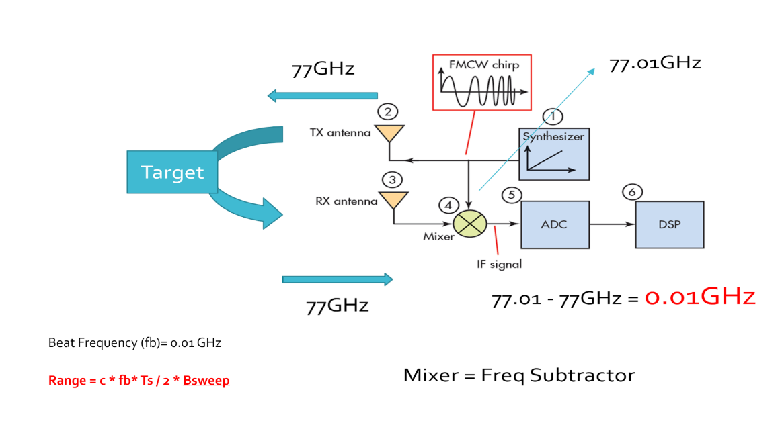

As seen in the image above, the Synthesizer generates FMCW chirp for a given $B_{sweep}$ and $T_{s}$. Let’s say the signal gets transmitted at 77GHz and it returns to the radar after hitting the target in a certain time duration. The radar receiver captures the signal, processes (subtraction) and measures the frequency delta between received signal and linearly ramping signal. This delta in frequency is called as beat frequency and it is proportional to the trip time. So based on the equation above, the radar calculates the range.

### Doppler Estimation

**Doppler Estimation Overview**

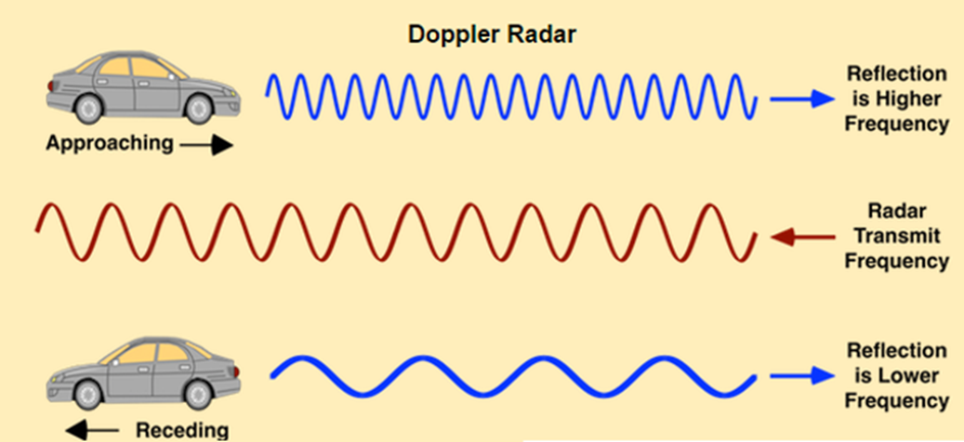

The velocity estimation for radar is based on an age old phenomenon called the doppler effect. As per doppler theory an approaching target will shift an emitted and reflected frequency higher, whereas a receding target will shift the both frequencies to be lower than the transmitted frequency.

**FMCW Doppler Measurements**

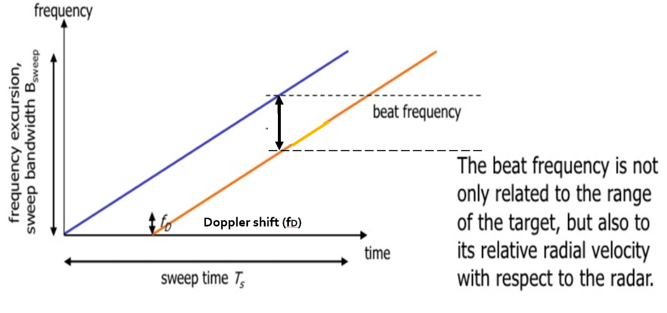

As discussed above, there will be a shift in the received signal frequency due to the doppler effect of the target’s velocity. The doppler shift is directly proportional to the velocity of the target as shown below:

$f_{D}= \frac{2v_{r}}{λ}$

$f_{D}$: shift in the transmitted frequency due to the doppler

$v_{r}$: relative velocity of the target

$λ$: wavelength of the signal

By measuring the shift in the frequency due to doppler, radar can determine the velocity. The receding target will have a negative velocity due to the frequency dropping lower, whereas the approaching target will have positive velocity as the frequency shifts higher.

The beat frequency comprises of both frequency components: $f_{r}$ (frequency delta due to range) and $f_{d}$ (frequency shift due to velocity). Although, in the case of automotive radar the $f_{d}$ is very small in comparison to the $f_{r}$. Hence, the doppler velocity is calculated by measuring the rate of change of phase across multiple chirps.

The following equation shows the relationship between the rate of change of the phase $φ$, and the frequency:

$$\frac{dφ}{dt}= frequency$$

**Doppler Phase Shift**

Keeping that in consideration, we calculate the doppler frequency by measuring the rate of change of phase. The phase change occurs due to small displacement of a moving target for every chirp duration. Since, each chirp duration is generally in microseconds, it results in small displacement in mm (millimeters). These small displacements for every chirp leads to change in phase. Using this rate of change of phase we can determine the doppler frequency.

If the path between a target and the radar is changed by an amount Δx, the phase of the wave received by radar is shifted by

$Δφ= \frac{Δx}{λ} \left(λ=2π or 360˚\right)$ $$Δφ=f* \frac{Δx}{c} (λ= f/c)$$

where λ and f are, respectively, the wavelength and frequency of the signal and c is the speed of propagation. The resulting change in observed frequency is

$Δf= \frac{Δφ}{Δt}$

where $Δt$ is the time taken for the observation of the phase change.

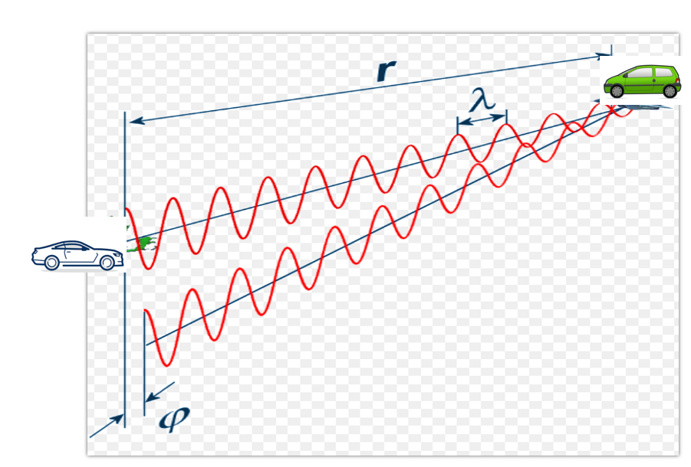

### Fast Fourier Transform

**FFT Overview**

So far we discussed the theory of range and doppler estimation along with the equations to calculate them. But, for a radar to efficiently process these measurements digitally, the signal needs to be converted from analog to digital domain and further from time domain to frequency domain.

ADC (Analog Digital Converter) converts the analog signal into digital. But, post ADC the Fast Fourier Transform is used to convert the signal from time domain to frequency domain. Conversion to frequency domain is important to do the spectral analysis of the signal and determine the shifts in frequency due to range and doppler.

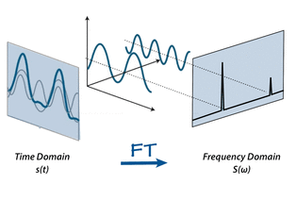

The traveling signal is in time domain. Time domain signal comprises of multiple frequency components as shown in the image above. In order to separate out all frequency components the FFT technique is used. FFT gives the frequency response of the return signal with each peak in frequency spectrum representing the detected target’s characteristics.

**FFT and FMCW**

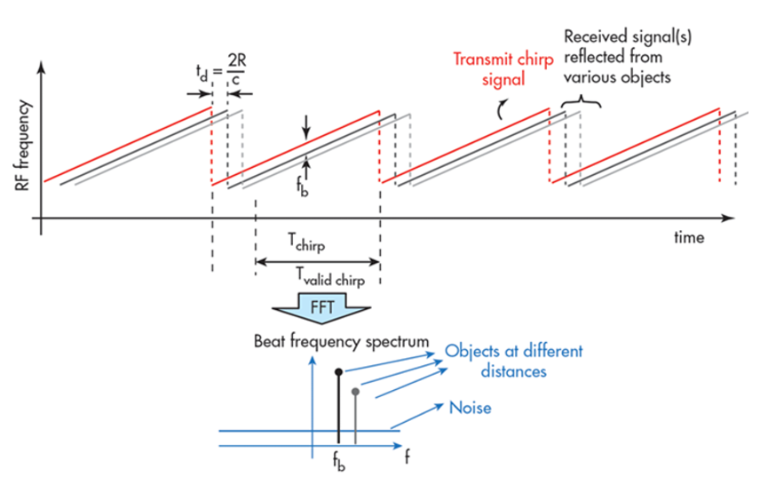

As seen in the image below, the Range FFTs are run for every sample on each chirp. Since each chirp is sampled N times, it will generate a range FFT block of N * (Number of chirps). These FFT blocks are also called FFT bins.

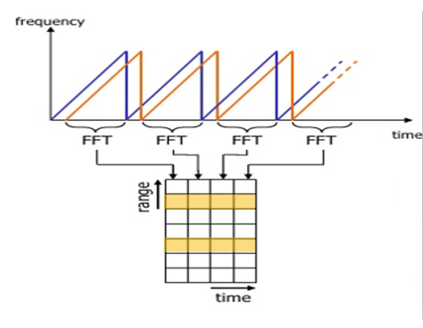

Range FFT

Each chirp is sampled N times, and for each sample it produces a range bin. The process is repeated for every single chirp. Hence creating a FFT block of N*(Number of chirps).

Each bin in every column of block represents increasing range value, so that the end of last bin represents the maximum range of a radar.

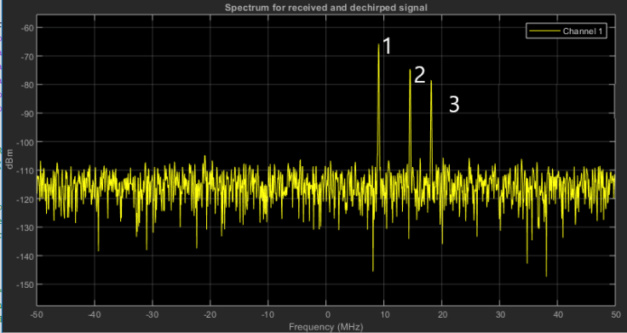

Output of Range FFT in MATLAB. X-axis = Beat Frequency, Y-axis = Signal power in dBm

Above is the output of the 1st stage FFT (i.e Range FFT). The three peaks in the frequency domain corresponds to the beat frequencies of three different cars located at 150, 240 and 300 m range from the ego vehicle.

### The 2D FFT

Once the range bins are determined by running range FFT across all the chirps, a second FFT is implemented along the second dimension to determine the doppler frequency shift. As discussed, the doppler is estimated by processing the rate of change of phase across multiple chirps. Hence, the doppler FFT is implemented after all the chirps in the segment are sent and range FFTs are run on them.

The output of the first FFT gives the beat frequency, amplitude, and phase for each target. This phase varies as we move from one chirp to another (one bin to another on each row) due to the target’s small displacements. Once the second FFT is implemented it determines the rate of change of phase, which is nothing but the doppler frequency shift.

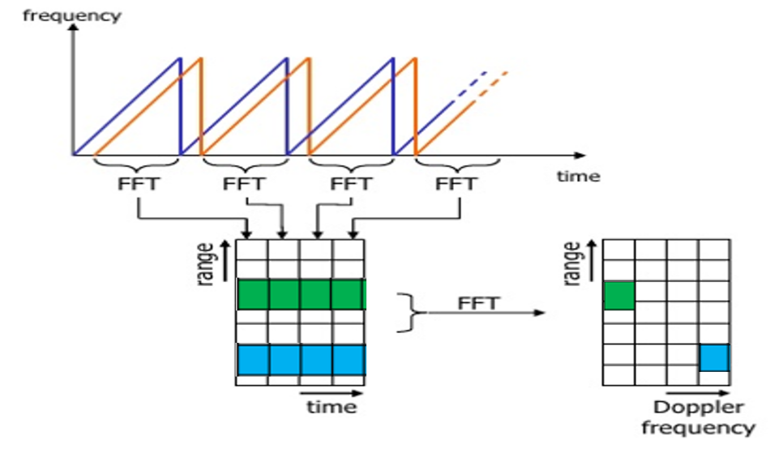

After running 2nd FFT across the rows of FFT block we get the doppler FFT. The complete implementation is called 2D FFT.

After 2D FFT each bin in every column of block represents increasing range value and each bin in the row corresponds to a velocity value. The output of Range Doppler response represents an image with Range on one axis and Doppler on the other. This image is called as Range Doppler Map (RDM). These maps are often used as user interface to understand the perception of the targets.

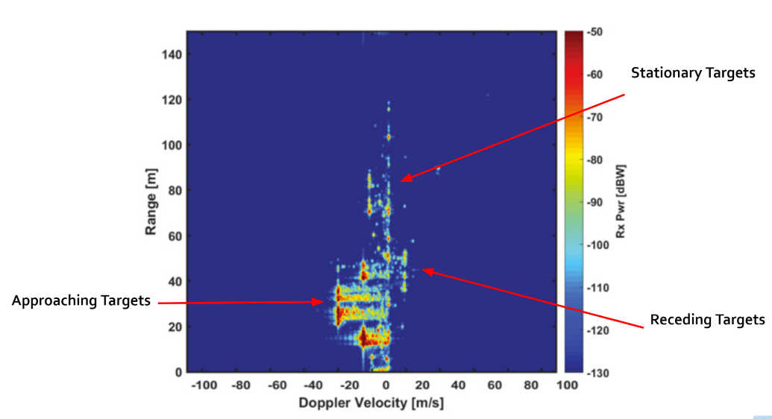

## Clutter, CFAR, AoA

### Clutter

Radar not only receives the reflected signals from the objects of interest, but also from the environment and unwanted objects. The backscatter from these unwanted sources is called clutter.

These unwanted signals are generally produced by reflections from the ground, sea, buildings, trees, rain, fog etc. The magnitude of the clutter signal depends upon:

* The nature of the surface - ground, water, snow (e.g deserts have low reflectivity, whereas the frozen snow has high reflectivity)
* Smoothness of the surface
* Grazing angle - Angle the radar beam makes with the surface
* Radar Frequency

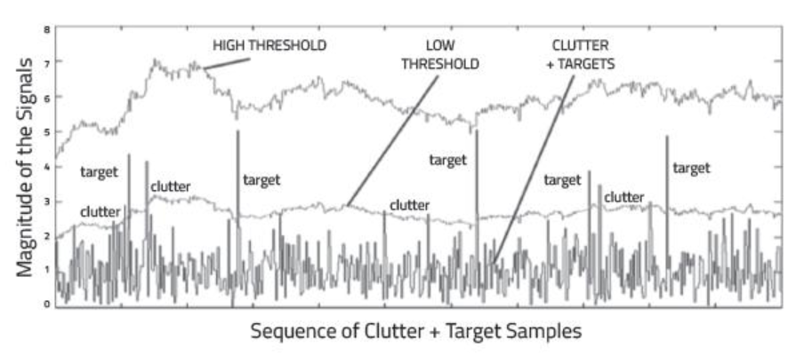

Return Signal from multiple targets along with some from the clutter

**Clutter Thresholding**

It is important to filter out clutter for successful detection of targets. This is critical in a driving scenario to avoid the car from suddenly braking in the absence of valid targets. This sudden braking happens when the radar detects reflections that are generated from the clutter.

One technique to remove clutter is to remove the signals having 0 doppler velocity. Since, the clutter in the driving scenario are often created by the stationary targets, the 0 doppler filtering can help get rid of them.

The downside of 0 doppler filtering is that the radar would not be able to detect the stationary targets in its path. This would lead to detection failures.

Another technique is to use fixed clutter thresholding. With fixed thresholding, signal below the threshold value is rejected. With this method, if the detection threshold is set too high, there will be very few false alarms, but it will also mask the valid targets. If the threshold is set too low, then it would lead to too many false alarms. In other words, the false alarm rate would be too high.

The false alarm rate is the rate of erroneous radar detections by noise or other interfering signals. It is a measure of the presence of detected radar targets when there is no valid target present.

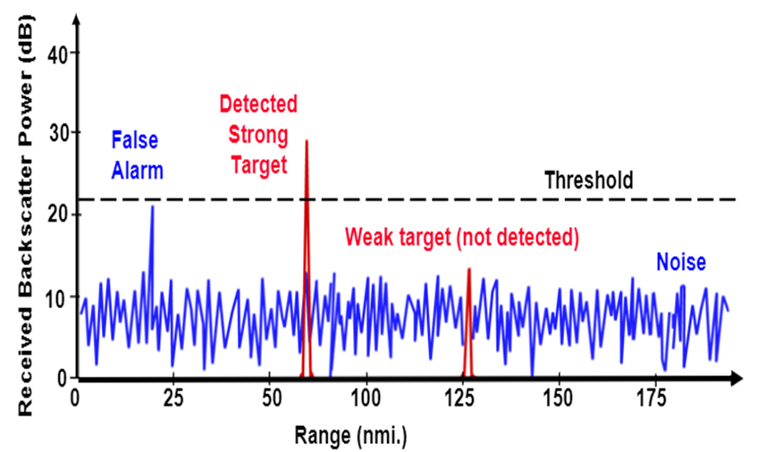

Fixed Threshold leading to False Alarms and missed detections of weak target

**Dynamic Thresholding**

Another approach to clutter thresholding is to use dynamic thresholding. Dynamic thresholding involves varying the threshold level to reduce the false alarm rate.

CFAR (Constant False Alarm Rate) is a dynamic thresholding technique. With this technique, the noise at every or group of range/doppler bins is monitored and the signal is compared to the local noise level. This comparison is used to create a threshold which holds the false alarm rate constant.

### CFAR

CFAR

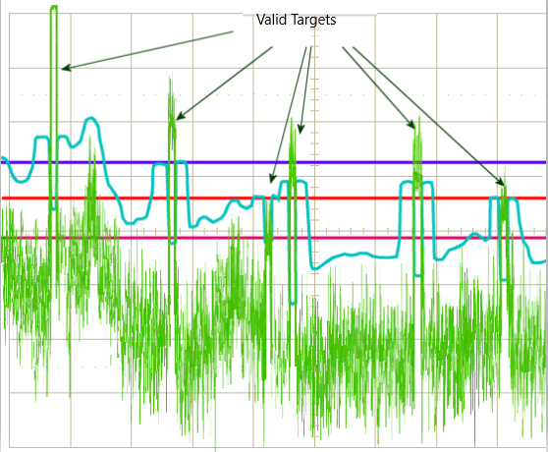

CA-CFAR and OS-CFAR

The false alarm issue can be resolved by implementing the constant false alarm rate. CFAR varies the detection threshold based on the vehicle surroundings. The CFAR technique estimates the level of interference in radar range and doppler cells “Training Cells” on either or both the side of the “Cell Under Test”. The estimate is then used to decide if the target is in the Cell Under Test (CUT).

The process loops across all the range cells and decides the presence of target based on the noise estimate. The basis of the process is that when noise is present, the cells around the cell of interest will contain a good estimate of the noise, i.e. it assumes that the noise or interference is spatially or temporarily homogeneous. Theoretically it will produce a constant false alarm rate, which is independent of the noise or clutter level.

There are multiple categories of CFAR:

* Cell Averaging CFAR (CA-CFAR)
* Ordered Statistics CFAR (OS CFAR)
* Maximum Minimum Statistic (MAMIS CFAR)
* And, multiple variants of CA-CFAR.

Here, we will be covering the basic CA-CFAR.

### CA-CFAR

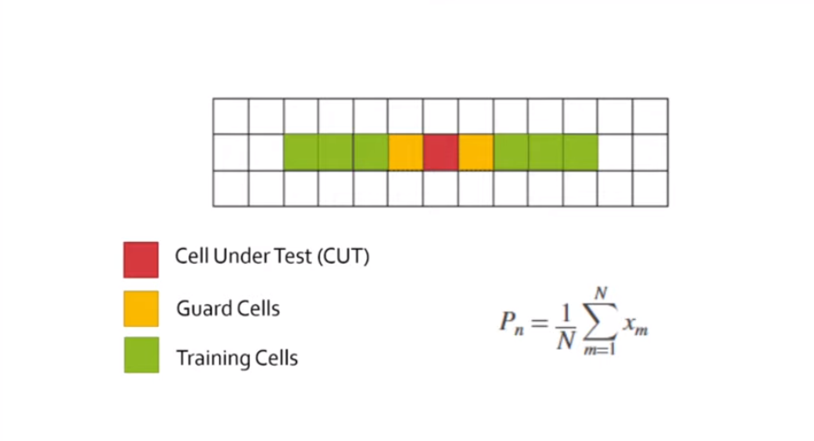

CA-CFAR Training Cells : 3 Guard Cell : 1

CA-CFAR is the most commonly used CFAR detection technique. As seen in the previous lesson, the FFT blocks are generated on implementing range and doppler FFTs across the number of chirps. The CFAR process includes the sliding of a window across the cells in FFT blocks. Each window consists of the following cells.

**Cell Under Test** : The cell that is tested to detect the presence of the target by comparing the signal level against the noise estimate (threshold).

**Training Cells** : The level of noise is measured over the Training Cells. The Training Cells can be divided into two regions, the cells lagging the CUT, called lagging Training Cells and the cells leading the CUT, called Leading Training Cells. The noise is estimated by averaging the noise under the training cells. In some cases either leading or lagging cell average is taken, while in the other the leading and lagging cell average is combined and the higher of two is considered for noise level estimate.The number of training cells should be decided based on the environment. If a dense traffic scenario then the fewer training cells should be used, as closely spaced targets can impact the noise estimate.

**Guard Cells** : The cells just next to CUT are assigned as Guard Cells. The purpose of the Guard Cells is to avoid the target signal from leaking into the training cells that could adversely affect the noise estimate. The number of guard cells should be decided based on the leakage of the target signal out of the cell under test. If target reflections are strong they often get into surrounding bins.

**Threshold Factor (Offset)** : Use an offset value to scale the noise threshold. If the signal strength is defined in logarithmic form then add this offset value to the average noise estimate, else multiply it.

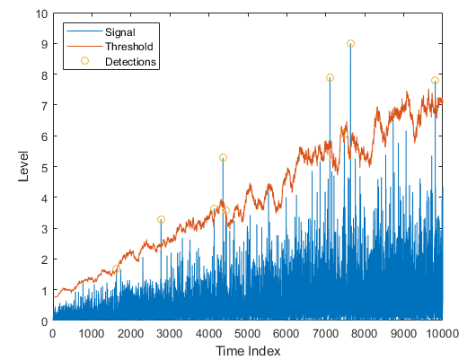

### CFAR 2D

The 2D CFAR is similar to 1D CFAR, but is implemented in both dimensions of the range doppler block. The 2D CA-CFAR implementation involves the training cells occupying the cells surrounding the cell under test with a guard grid in between to prevent the impact of a target signal on the noise estimate.

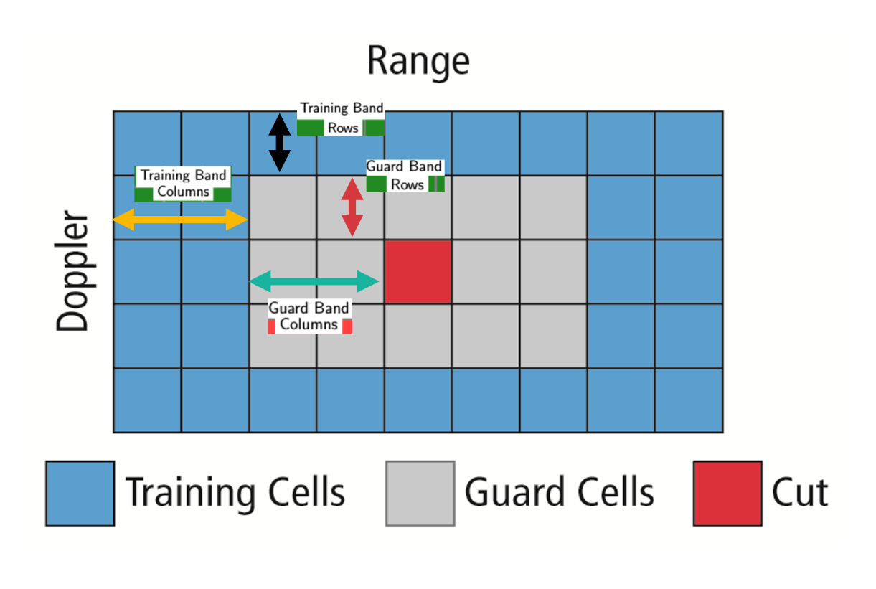

### Angle of Arrival

A phased array antenna is an antenna array that steers the beam electronically in the desired direction. The array steers the beam if each antenna element in an array is excited by the signal with certain phase values. This phenomenon is referred to as beam scanning.

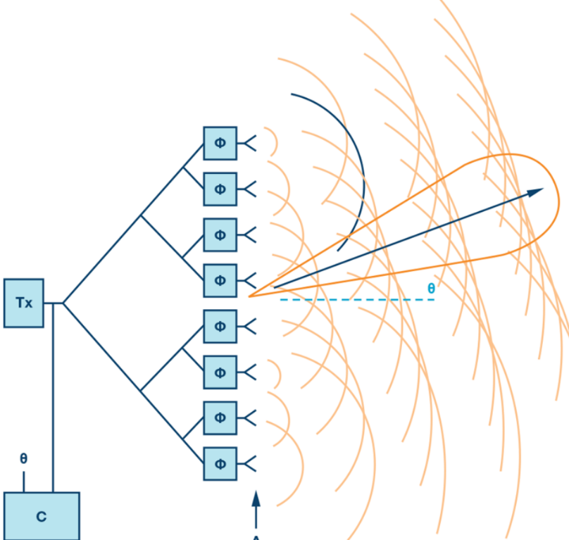

Beam Steering Design.

Here the Φ represents the phase shifters. Phase shifters are the electronic components that changes the phase to make the beam steer in a desired direction.

For antenna beam to steer in a desired direction, the phase shifters are programmed to have constant phase increments. If an antenna comprises of six radiating elements and the phase delta required to steer a beam in a given direction is 15 degrees, then the following would be the phase value on each element [0,15,30,45,60,75] degrees. The increment phase shift along with the spacing between antenna elements (d) determines the steering angle of an antenna using the following equation

$Φ=360*d*sin⁡(Θ)/λ$

* $Φ$ = incremental phase shift
* $d$ = spacing between antenna elements
* $Θ$ = steering direction from normal of the antenna surface
* $λ$ = wavelength of the signal

As the radar scan the surroundings by steering the beam at the programmed angles, it can sense the angle of the return signal. This helps Radar create a spatial perception of the environment.

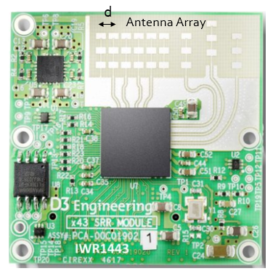

As the radar scans the surroundings by steering the beam at the programmed angles, it measures the SNR of reflected signals from targets located at different angles spatially. This helps in creating an angle of arrival vs SNR grid for radar’s spatial perception.

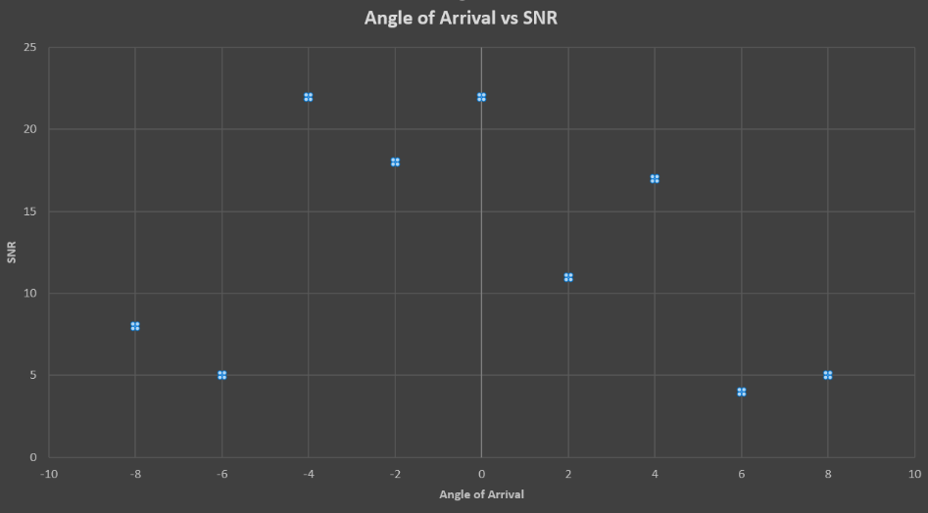

* + 1. Placeholder

## Clustering and Tracking

### Clustering

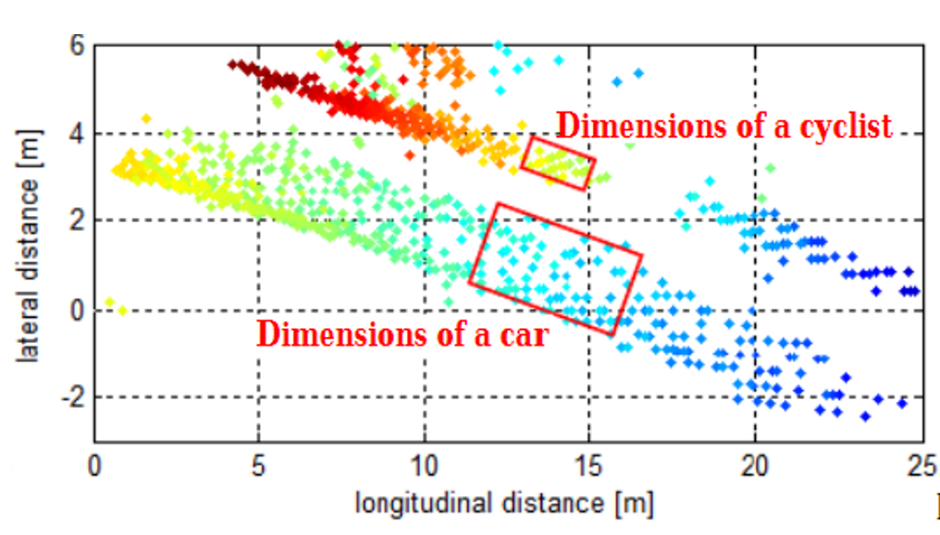

Clustering of a car and bicycle

For enhanced perception in autonomous driving, there is a need to track multiple targets separately. The object tracking is computationally expensive and tracking multiple targets simultaneously requires lots of processing power and memory.

Due to the advancements in radar technology and increasing sensing resolutions, a radar can generate detections from plentitude of scattering points on the target. If a tracker is assigned to every detection from the same target, then it can overburden the processing unit. Hence, it is important to cluster the detections from every target and assign a single track for each.

Here we will discuss the basic clustering algorithm based on the euclidean distance. The algorithm here groups the detection points based on their proximity measured by the euclidean distance between those points.

All the detection points that are within the size of the target are considered as one cluster, merged into a centroid position. Each cluster is now assigned a new range and velocity, which is the mean of measured range and velocity of all the detection points that form the cluster.

This allows valid tracking for each target.

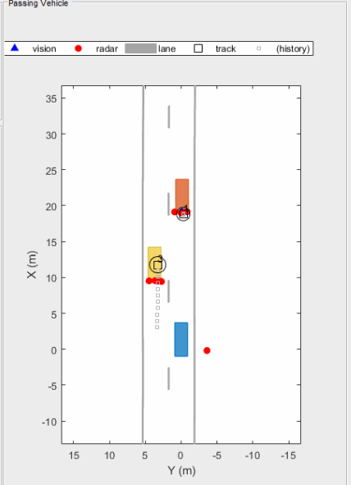

Above is an illustration of the clustering scenario. In the image the blue car is an ego vehicle (vehicle with sensor) and the detections are generated from the orange and yellow vehicles. Using clustering algorithm all the detections associated with the single target are merged into one point. This helps in the detection and assigning the tracks to a target.

### Kalman Tracking

**MATLAB Sensor Fusion**

Sensor fusion and control algorithms for automated driving systems require rigorous testing. Vehicle-based testing is not only time consuming to set up, but also difficult to reproduce. Automated Driving System Toolbox provides functionality to define road networks, actors, vehicles, and traffic scenarios, as well as statistical models for simulating synthetic radar and camera sensor detection. This example shows how to generate a scenario, simulate sensor detections, and use sensor fusion to track simulated vehicles. The main benefit of using scenario generation and sensor simulation over sensor recording is the ability to create rare and potentially dangerous events and test the vehicle algorithms with them.

* + 1. Placeholder

## Radar Target Generation and Detection

### Radar Target Generation and Detection

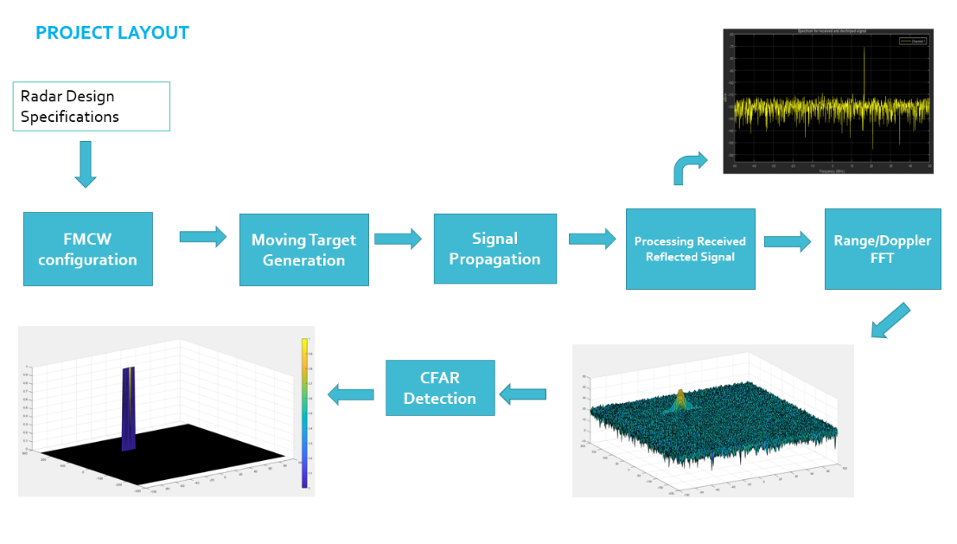

* Configure the FMCW waveform based on the system requirements.
* Define the range and velocity of target and simulate its displacement.
* For the same simulation loop process the transmit and receive signal to determine the beat signal
* Perform Range FFT on the received signal to determine the Range
* Towards the end, perform the CFAR processing on the output of 2nd FFT to display the target.

**Radar System Requirements**

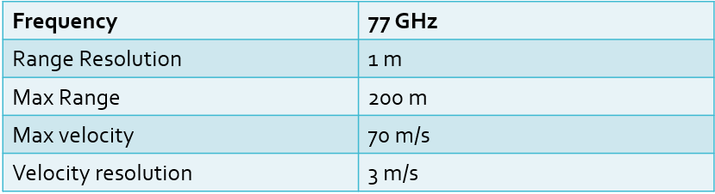

System Requirements defines the design of a Radar. The sensor fusion design for different driving scenarios requires different system configurations from a Radar. In this project, you will designing a Radar based on the given system requirements (above). Max Range and Range Resolution will be considered here for waveform design.

* The sweep bandwidth can be determined according to the range resolution and the sweep slope is calculated using both sweep bandwidth and sweep time.
$$Bandwidth\left(B_{sweep}\right)= \frac{speed of light}{2*rangeResolution}$$

* The sweep time can be computed based on the time needed for the signal to travel the unambiguous maximum range. In general, for an FMCW radar system, the sweep time should be at least 5 to 6 times the round trip time. This example uses a factor of 5.5.Giving the slope of the chirp signal

$$T_{chirp}=5.5* \frac{2R_{max}}{c}$$

Giving the slope of the chirp signal

$$Slope= \frac{Bandwidth}{T_{chirp}}$$

**Initial Range and Velocity of the Target**

You will provide the initial range and velocity of the target. Range cannot exceed the max value of 200m and velocity can be any value in the range of -70 to + 70 m/s.

**Target Generation and Detection**

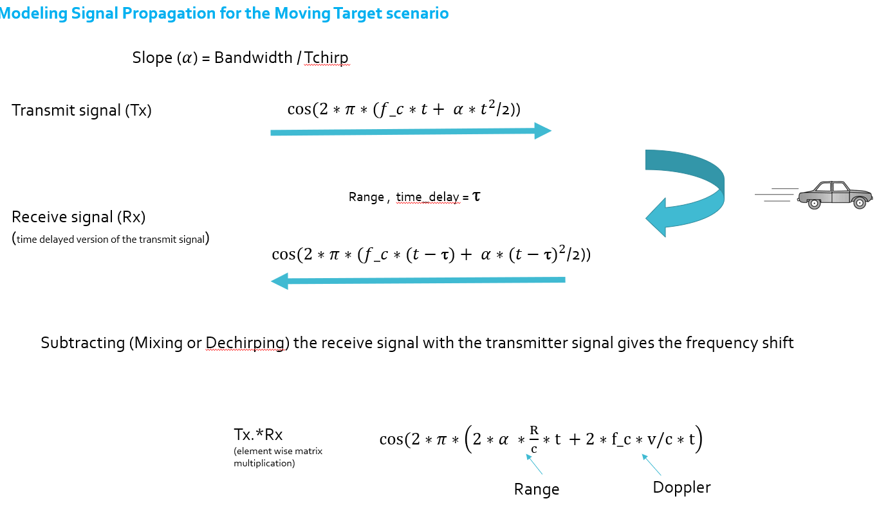

Next, you will be simulating the signal propagation and moving target scenario.

Theory : In terms of wave equation, FMCW transmit and receive signals are defined using these wave equations, where α = *Slope of the signal*. The Transmit Signal is given by:

$$T_{x}=\cos\left(2π\left(f_{c}t+ \frac{αt^{2}}{2}\right)\right)$$

The received signal is nothing but the time delayed version of the Transmit Signal. In digital signal processing the time delayed version is defined by $(t- τ)$, where $τ$ represents the delay time, which in radar processing is the trip time for the signal.

Replacing $t$ with $(t- τ)$ gives the Receive Signal:

$$R_{x}= \cos\left(2π\left(f_{c}(t-τ)+ \frac{α{(t- τ)}^{2}}{2}\right)\right)$$

On mixing these two signals, we get the beat signal, which holds the values for both range as well as doppler. By implementing the 2D FFT on this beat signal, we can extract both Range and Doppler information.

The beat signal can be calculated by multiplying the Transmit signal with Receive signal. This process in turn works as frequency subtraction. It is implemented by element by element multiplication of transmit and receive signal matrices.

$$Mixed or Beat Signal=\left(T_{x}.*R_{x}\right)$$

$$T_{x}.*R_{x}= \cos\left(2π\left(\frac{2αR}{c}t+ \frac{2f_{c}v}{c}t\right)\right)$$

**FFT Operation**

* Implement the 1D FFT on the Mixed Signal
* Reshape the vector into Nr*Nd array.
* Run the FFT on the beat signal along the range bins dimension (Nr)
* Normalize the FFT output.
* Take the absolute value of that output.
* Keep one half of the signal
* Plot the output
* There should be a peak at the initial position of the target

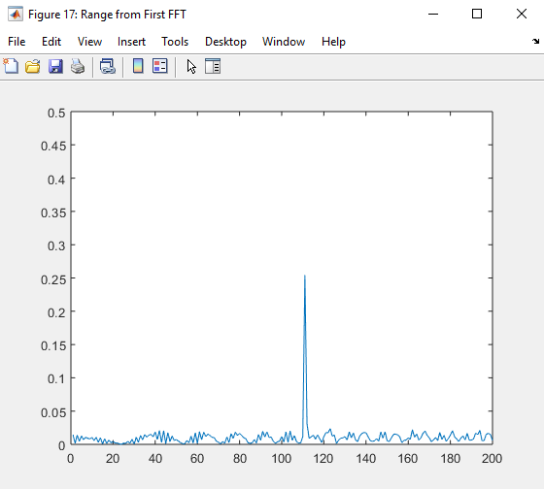

The 1st FFT output for the target located at 110 meters

The 2nd FFT is already implemented in the code. It will generate a Range Doppler Map as seen in the image below and it will be given by variable ‘RDM’. Next task is to implement the CFAR on this Range Doppler Map.

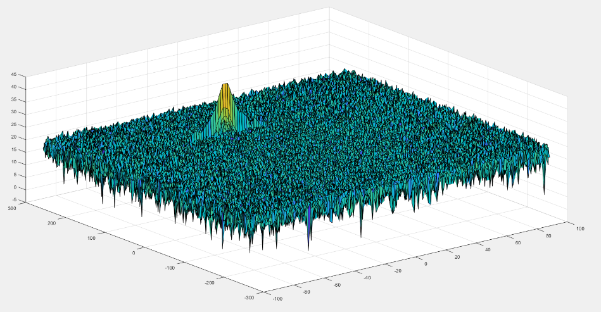

2D FFT output - Range Doppler Map

**2D CFAR**

* Determine the number of Training cells for each dimension. Similarly, pick the number of guard cells.
* Slide the cell under test across the complete matrix. Make sure the CUT has margin for Training and Guard cells from the edges.
* For every iteration sum the signal level within all the training cells. To sum convert the value from logarithmic to linear using db2pow function.
* Average the summed values for all of the training cells used. After averaging convert it back to logarithmic using pow2db.
* Further add the offset to it to determine the threshold.
* Next, compare the signal under CUT against this threshold.
* If the CUT level > threshold assign it a value of 1, else equate it to 0.

The process above will generate a thresholded block, which is smaller than the Range Doppler Map as the CUTs cannot be located at the edges of the matrix due to the presence of Target and Guard cells. Hence, those cells will not be thresholded. To keep the map size same as it was before CFAR, equate all the non-thresholded cells to 0.

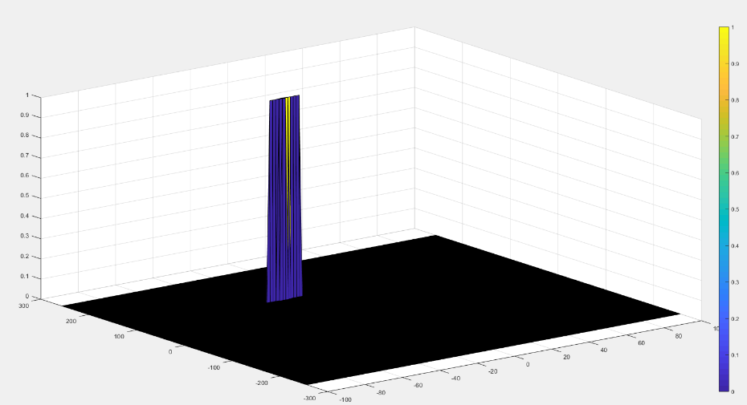

The output of the 2D CFAR process

Once you have completed this, you are done. Congratulations on doing a great job on this final project!

# Camera

## Autonomous Vehicles and Computer Vision

### Levels of Autonomous Driving

According to CB Insights, there are 46 corporations currently working on autonomous vehicles (as of April 2019). This includes automakers such as Audi, Tesla, BMW, Volvo or GM but also new additions to the automotive space such as Alphabet / Waymo, Uber or Baidu - who hail from totally different industries.

It is expected that the autonomous vehicle market will grow from $54 billion in 2019 to $556 billion in 2026, according to Allied Market Research estimates. Such growth rates, combined with technological break-throughs of recent years, explain why things are moving so fast and why everyone is trying to get a share of this emerging market.

In addition to autonomous vehicles, there are systems which assist the driver in various driving tasks such as changing lanes, remembering speed signs or braking in time in case the preceding vehicle suddenly decelerates. Such systems are referred to as Advanced Driver Assistance Systems (ADAS) and they are the predecessor of a fully autonomous vehicle. There are some vehicles in the market, however, that imply full autonomy (such as the Tesla Autopilot), but are ‚only‘ an ADAS systems.

Before we analyze a selection of autonomous vehicle prototypes and their respective sensors, let us look at a way to define autonomy - because not all autonomous cars and driver assistance systems are created equal. The following graphic shows the „levels of autonomous driving“, which the Society of Autonomous Engineers (SAE) has defined.

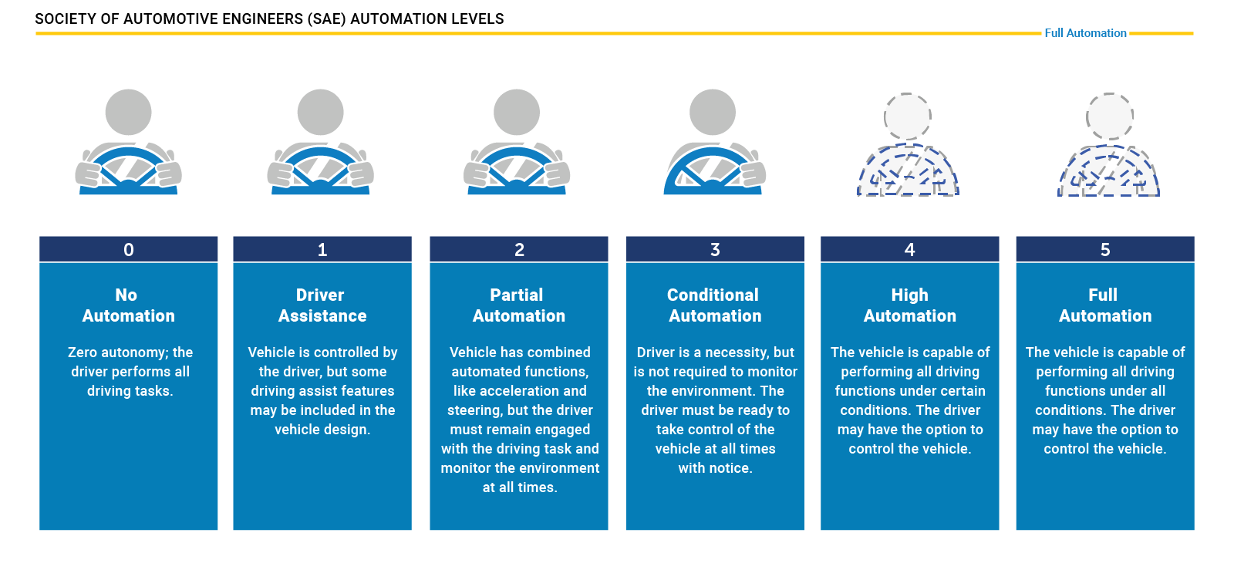

For many years, ADAS products such as forward collision warning (FCW) or adaptive cruise control (ACC) were the only systems available that provided at least some degree of automation in a selected number of driving situations (e.g. on highways, in cities at low speed).

Tesla has been one of the first companies world-wide to introduce a system into the market that promised a high degree of autonomy, the Auto Pilot. On the SAE chart however, this system is „only“ at level 2, that means the driver must remain engaged and should monitor the environment at all times.

The step to level 3 is a large one as the driver is no longer required to monitor the environment, even though he must be able to take back control at all times. From a legal viewpoint this means that the responsibility for the driving task is with the car and thus with the manufacturer. This is why we do not see a large number of commercially available vehicles with level 3 systems on board yet. Several manufacturers have announced such systems but at the time of writing (May 2019), we do not find them in the market. The reason for this is three-fold:

* Such systems must be build reliable enough to minimize the number of faulty decisions. Engineers usually solve this problem by adding a large number of sensors to the car, which makes such systems (very) costly.
* The fear of law suits arising from accidents results in an intentionally reduced availability of systems, for example by limiting the driving speed or the scenario (e.g. only in traffic jams on highways with clearly visible lane markings at speeds below 60kph).
* The readiness of the driver to take control of the vehicle can not be guaranteed at all times. There are many situations in which this is not possible due to human reaction times and alertness levels.

Therefore, many experts believe that level 3 systems will only be a transition step to more advanced systems which are operating on levels 4 and 5. At those levels, the vehicle is capable of performing all driving tasks and the „driver“ is not required to take control. Obviously, such systems will require a strong engineering effort to guarantee driver and road user safety at all times.

### Autonomous Vehicle Sensor Sets

In the last section you have learned about the different levels of autonomous driving and about the leap it takes to move from level 2 to level 3 or even further. It should now be obvious that one key to level 4 and level 5 autonomy is a smart combination of sensors and perception algorithms to monitor the vehicle environment at all times to guarantee a proper and safe reaction to all traffic events.

To give you an idea of how this problem is approached in practice, this section contains a brief overview of some vehicles that aim at realizing level 4 or even level 5 driving. As this course is mostly about cameras and computer vision and to a small degree also about Lidar, let us focus mainly on those two sensor types. Let us now take a look at a few autonomous vehicles and their respective sensor suites.

**The Uber ATG Autonomous Vehicle**

The current version of the Uber autonomous vehicle combines a top-mounted 360° Lidar scanner with several cameras and radar sensors placed around the car circumference.

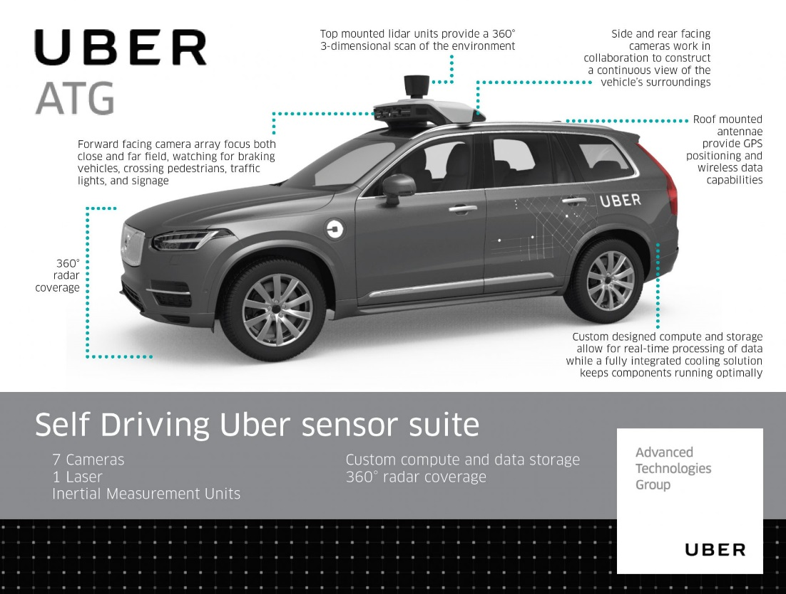

Let us take a look at those sensor classes one-by one:

* *Cameras*: Ubers fleet of modified Volvo XC90 SUVs features a range of cameras on their roofs, plus additional cameras that point to the sides and behind the car. The roof cameras are able to focus both close and far field, watch for braking vehicles, crossing pedestrians, traffic lights, and signage. The cameras feed their material to a central on-board computer, which also receives the signals of the other sensors to create a precise image of the vehicle’s surroundings. Much like human eyes, the performance of camera systems at night is strongly reduced, which makes them less reliable to locate objects with the required detection rates and positional accuracy. This is why the Uber fleet is equipped with two additional sensor types.
* *Radar*: Radar systems emit radio waves which are reflected off of (many but not all) objects. The returning waves can be analyzed with regard to their runtime (which gives distance) as well as their shifted frequency (which gives relative speed). The latter property clearly distinguished the radar from the other two sensor types as it is the only one who is able to directly measure the speed of objects. Also, radar is very robust against adverse weather conditions like heavy snow and thick fog. Used by cruise control systems for many years, radar works best when identifying larger objects with good reflective properties. When it comes to detecting smaller or „soft“ objects (humans, animals) with reduced reflective properties, the radar detection performance drops. Even though camera and radar combine well, there are situations where both sensors do not work optimally - which is why Uber chose to throw a third sensor into the mix.
* *Lidar* : Lidar works in a similar way to radar, but instead of emitting radio waves it uses infrared light. The roof-mounted sensor rotates at a high velocity and builds a detailed 3D image of its surroundings. In case of the Velodyne VLS-128, a total of 128 laser beams is used to detect obstacles up to a distance of 300 meters. During a single spin through 360 degrees, a total of up to 4 million data points per second is generated. Similar to the camera, Lidar is an optical sensor. It has the significant advantage however of "bringing its own light source“, whereas cameras are dependent on ambient light and the vehicle headlights. It has to be noted however, that Lidar performance is also reduced in adverse environmental conditions such as snow, heavy rain or fog. Coupled with low reflective properties of certain materials, a Lidar might thus fail at generating a sufficiently dense point cloud for some objects in traffic, leaving only a few 3D points with which to work. It is thus a good idea to combine Lidar with other sensors to ensure that detection performance is sufficiently high for autonomous navigation through traffic.

**Mercedes Benz Autonomous Prototype**

Currently, German car maker Mercedes Benz is developing an autonomous vehicle prototype that is equipped with cameras, Lidar and radar sensors, similar to the Uber vehicle. Mercedes uses several cameras to scan the area around the vehicle. Of special interest is a stereo setup consisting of two synchronized cameras, which is able to measure depth by finding corresponding features in both images. The picture below shows the entire host of cameras used by the system. Mercedes states that the stereo camera alone generates a total of 100 gigabytes of data for every kilometer driven.

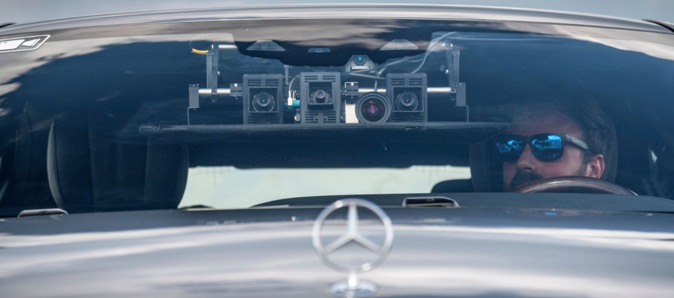

**The Tesla Autopilot**

When the Autopilot system was first sold, it basically was a combination of adaptive cruise control and lane change assist - a set of functions which had long been available with other manufacturers around the globe. The name „Autopilot“ implied however, that the car would be truly autonomous. And indeed did many Tesla owners test the system to its limits by climbing onto the back seat , reading a book or taking a nap while being driven by the system. On the SAE scale however, the Autopilot can „only“ be classified as level 2, i.e. the driver is responsible for the driving task at all times.

In October 2016, the Tesla Model S and X sensor set was significantly upgraded and the capabilities of the Autopilot were extended by regular airborne software updates.

The image shows the interior of a Tesla with the camera views superimposed on the right side. The image shows left and right rear-facing cameras as well as a forward-facing camera for medium-range perception.

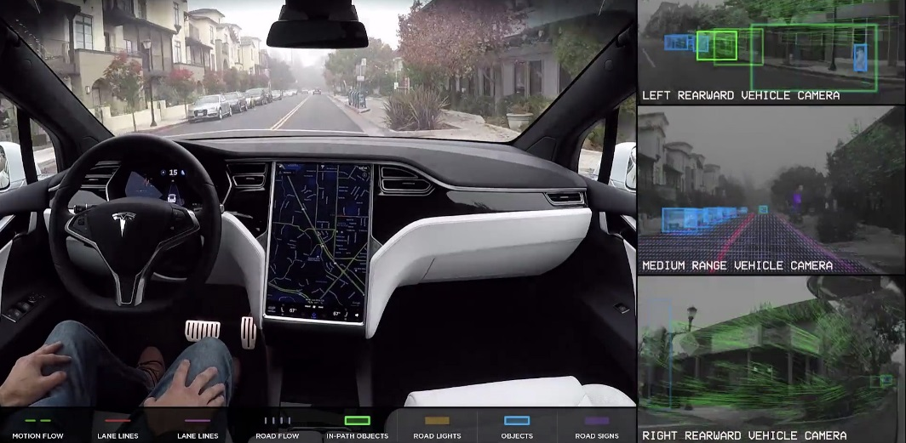

As can be seen in the overview, the system combines several camera sensors with partially overlapping fields of view with a forward-facing radar sensor.

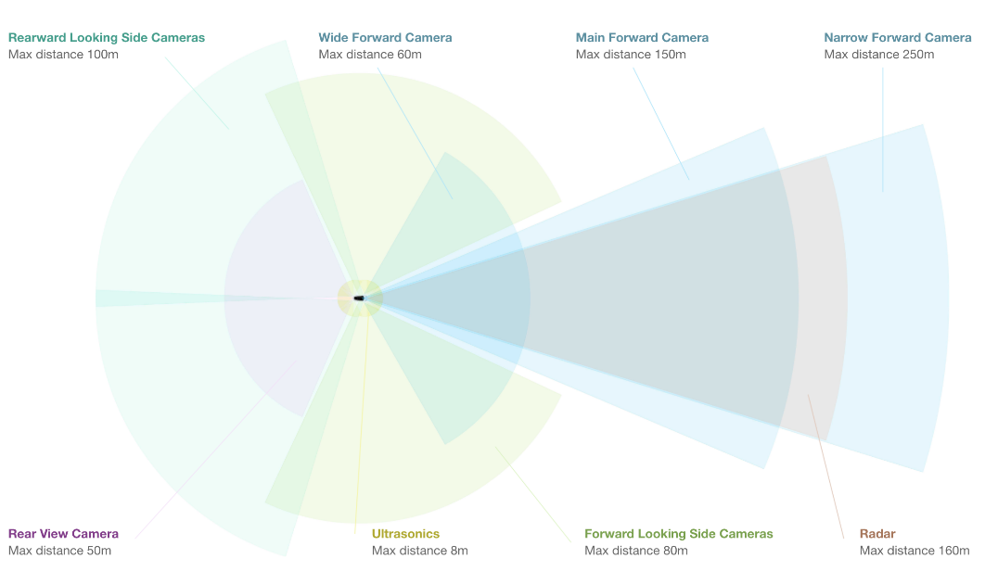

Let us look at each sensor type in turn:

* *Cameras* : The forward-facing optical array consists of four cameras with differing focal lengths. The narrow-forward camera captures footage up until 250m in front, the forward camera with a slightly larger opening angle looks up until 150m in front, a wide-angle camera that captures 60m in front, and a set of forward-looking side cameras that capture footage 80m in front and to the side of the car. The wide-angle camera is designed to read road signs and traffic lights, allowing the car to react accordingly. It is debated however, whether this feature can be reliably used in traffic.
* *Radar* : The forward-looking radar can see up to 160m ahead of the car. According to Tesla founder Elon Musk it is able to see through "sand, snow, fog—almost anything".
* *Sonar* : A 360° ultrasonic sonar detects obstacles in an eight-meter radius around the car. The ultrasonic sensors work at any speed and are used to spot objects in close proximity of the car. The ultrasonic sensors can also be used to assist the car when automatically switching lanes. Their range however, compared to the other sensors of the set, is significantly limited and ends at about 8 meters distance.

As you may have noticed, Tesla is not using a Lidar sensor despite its plans to offer level 4 or even level 5 autonomous driving with this setup. Unlike many other manufacturers who aim at full autonomy such as Uber, Waymo and several others, Tesla is convinced that a set of high-performance cameras coupled with a powerful radar sensor will be sufficient for level 4 / level 5 autonomy. At the time of writing, there is a fierce debate going on about the best sensor set of autonomous vehicles. Tesla argues that the price and packaging disadvantage of Lidar would make the Autopilot unattractive to customers. Harsh critics such as GM's director of autonomous vehicle integration Scott Miller disagrees and argues with the highly elevated safety requirements of autonomous vehicles, which would not be met with cameras and radar alone.

Is has to be noted however that in all sensor setups, be it Uber, Tesla, Waymo or traditional manufacturers such as Mercedes or Audi, cameras are always used. Even though there is an ongoing debate on wether radar or Lidar or a combination of the two would be best, cameras are never in question. It is therefore a good idea to learn about cameras and computer vision, which we will do in great detail in this course.

**Sensor Selection Criteria**

The design of an autonomous or ADAS-equipped vehicle involves the selection of a suitable sensor set. As you have learned in the preceding section, there is a discussion going on about which combination of sensors would be necessary to reach full (or even partial) autonomy. In this section, you will learn about sensor selection criteria as well as the differences between camera, Lidar and radar with respect to each criterion.

In the following, the most typical selection criteria are briefly discussed.

1. **Range** : Lidar and radar systems can detect objects at distances ranging from a few meters to more than 200m. Many Lidar systems have difficulties detecting objects at very close distances, whereas radar can detect objects from less than a meter, depending on the system type (either long, mid or short range) . Mono cameras are not able to reliably measure metric distance to object - this is only possible by making some assumptions about the nature of the world (e.g. planar road surface). Stereo cameras on the other hand can measure distance, but only up to a distance of approx. 80m with accuracy deteriorating significantly from there.
2. **Spatial** **resolution** : Lidar scans have a spatial resolution in the order of 0.1° due to the short wavelength of the emitted IR laser light . This allows for high-resolution 3D scans and thus characterization of objects in a scene. Radar on the other hand can not resolve small features very well, especially as distances increase. The spatial resolution of camera systems is defined by the optics, by the pixel size on the image and by its signal-to-noise ratio. Details on small object are lost as soon as the light rays emanating from them are spread to several pixels on the image sensor (blurring). Also, when little ambient light exists to illuminate objects, spatial resolution increases as objects details are superimposed by increasing noise levels of the imager.
3. **Robustness** **in** **darkness** : Both radar and Lidar have an excellent robustness in darkness, as they are both active sensors. While daytime performance of Lidar systems is very good, they have an even better performance at night because there is no ambient sunlight that might interfere with the detection of IR laser reflections. Cameras on the other hand have a very reduced detection capability at night, as they are passive sensors that rely on ambient light. Even though there have been advances in night time performance of image sensors, they have the lowest performance among the three sensor types.
4. **Robustness** **in** **rain,** **snow,** **fog** : One of the biggest benefits of radar sensors is their performance under adverse weather conditions. They are not significantly affected by snow, heavy rain or any other obstruction in the air such as fog or sand particles. As an optical system, Lidar and camera are susceptible to adverse weather and its performance usually degrades significantly with increasing levels of adversity.
5. **Classification** **of** **objects** : Cameras excel at classifying objects such as vehicles, pedestrians, speed signs and many others. This is one of the prime advantage of camera systems and recent advances in AI emphasize this even stronger. Lidar scans with their high-density 3D point clouds also allow for a certain level of classification, albeit with less object diversity than cameras. Radar systems do not allow for much object classification.
6. **Perceiving** **2D** **structures** : Camera systems are the only sensor able to interpret two-dimensional information such as speed signs, lane markings or traffic lights, as they are able to measure both color and light intensity. This is the primary advantage of cameras over the other sensor types.
7. **Measure** **speed** : Radar can directly measure the velocity of objects by exploiting the Doppler frequency shift. This is one of the primary advantages of radar sensors. Lidar can only approximate speed by using successive distance measurements, which makes it less accurate in this regard. Cameras, even though they are not able to measure distance, can measure time to collision by observing the displacement of objects on the image plane. This property will be used later in this course.
8. **System** **cost** : Radar systems have been widely used in the automotive industry in recent years with current systems being highly compact and affordable. The same holds for mono cameras, which have a price well below US$100 in most cases. Stereo cameras are more expensive due to the increased hardware cost and the significantly lower number of units in the market. Lidar has gained popularity over the last years, especially in the automotive industry. Due to technological advances, its cost has dropped from more than US$75,000 to below US$5,000. Many experts predict that the cost of a Lidar module might drop to less than US$500 over the next years.
9. **Package** **size** : Both radar and mono cameras can be integrated very well into vehicles. Stereo cameras are in some cases bulky, which makes it harder to integrate them behind the windshield as they sometimes may restrict the driver's field of vision. Lidar systems exist in various sizes. The 360° scanning Lidar is typically mounted on top of the roof and is thus very well visible. The industry shift towards much smaller solid-state Lidar systems will dramatically shrink the system size of Lidar sensors in the very near future.
10. **Computational** **requirements** : Lidar and radar require little back-end processing. While cameras are a cost-efficient and easily available sensor, they require significant processing to extract useful information from the images, which adds to the overall system cost.

### Camera Technology Overview

In this section you will learn about the basic properties of a camera. We will start from the most basic model called a „pinhole camera“ and then progress to using lenses, which are a key component of camera systems. You need this knowledge in order to understand how a camera creates images, which of its properties influence image appearance and quality and which parameters you have to consider in order to successfully extract meaningful information from these images.

**The Pinhole Camera**

A very simple camera can be designed by placing a light barrier with a tiny opening (the pinhole) between an object of interest. The light emitted by the object passes through the pinhole and lands on a photosensitive surface which stores the light information as an image. The reason why the pinhole has been made so small is to avoid image blurring due to superimposing rays of light stemming from various parts of the object of interest.

This simple principle has been well known for centuries and was for example used by artists to create photorealistic portraits.

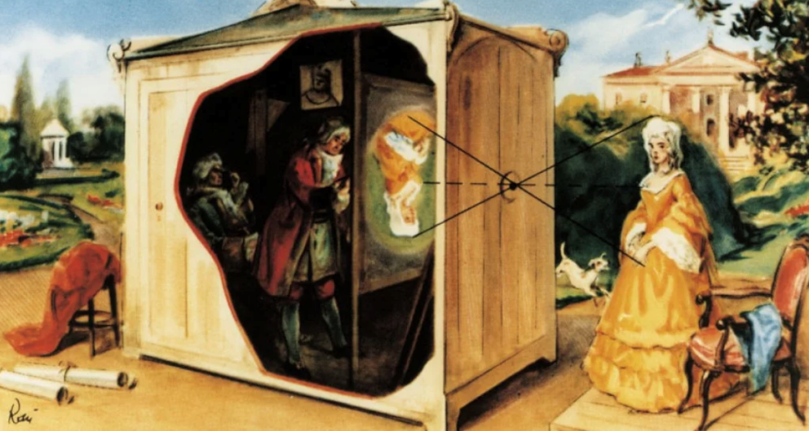

A formal model of the pinhole camera model is shown below:

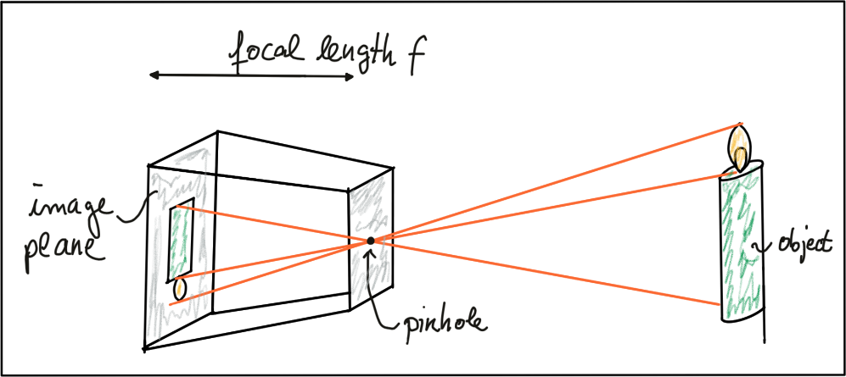

The photosensitive surface on the left is called the *image plane* whereas the pinhole is called the *camera center*. The distance between the camera center and the image plane is called the *focal length f*.

A point P on the object of interest can be mapped to a point P’ on the image plane by casting a beam through the center of projection until it hits the image plane as shown in the figure below.

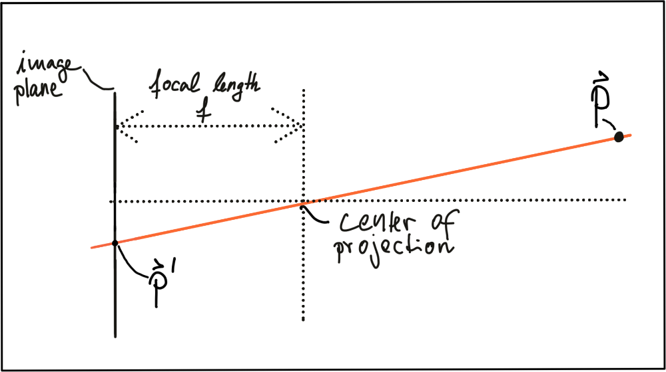

In three-dimensional space, the relation between $P$ and $P^{'}$ is expressed by the following equations:

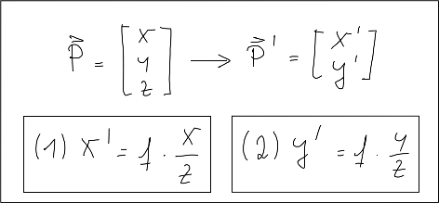

Based on these equations, we are able to compute the 2D position of an object on the image plane, given the 3D position of the object in space as well as the focal length of the camera. Note however that the resulting coordinates x’ and y’ are metrical coordinates and not pixel positions yet.

The problem with pinhole cameras is that the amount of light passing through the pinhole is not sufficient to generate a decent image on an image sensor. If one were to increase the amount of light by widening the pinhole opening as shown in the figure below, rays of light from other parts of the object of interest would superimpose each other, leading to a blurring effect: The larger the pinhole, the brighter the image but at the same time, the more severe the blurring of the object on the image plane would be.

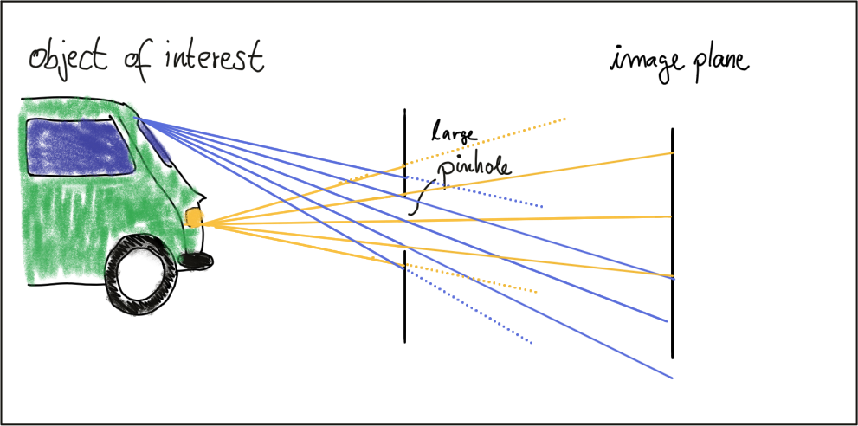

One way to solve this problem is use a lens, which is able to capture multiple rays of light that emanate from the same point on the object of interest. So let’s look at lenses next.

**Lenses and Apertures**

A properly sized and positioned lens refracts all rays of light that emanate from a point $P_{1}$ on an object in space such that they converge to a single point $p_{1}^{'}$ in the image plane. Rays of light passing through the lens center are not refracted however, they continue on as a straight line until they intersect the image plane.

Points on the object that are closer or farther away, such as $P_{2}$ appear out of focus on the image plane, because the set of light rays emanating from them does not converge in a point but rather in a circle with a finite radius instead. This blurry circle is usually referred to as circle of confusion (COF). To reduce blurring, an aperture can be used, which is a concentric opening of usually adjustable size placed directly behind the lens. The following figure illustrates the principle:

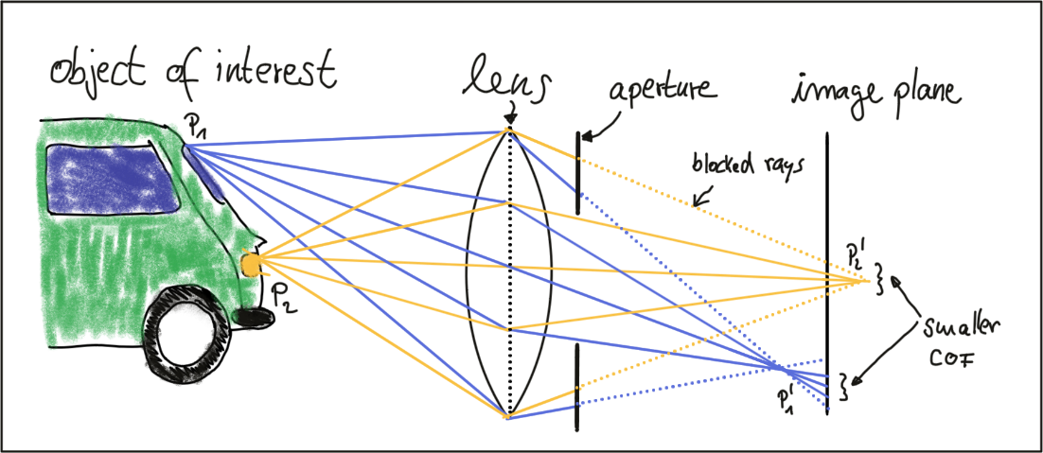

By reducing the diameter of the aperture, light rays passing through the lens on the outer edges are blocked, which reduces the size of the COF on the image plane. It can easily be seen that a smaller aperture results in reduced blurring, but at the expense of low light sensitivity. The larger the aperture, the more light rays are focused onto the image area, resulting in brighter images with a better signal-to-noise ratio.

So how can we compute where an object in space will appear in the image? Given a 3D point in space, its 2D position on the image plane after passing through a lens can be computed similar to the pinhole camera. In practice, lenses introduce distortion into images, depending on the lens type. The distortion most relevant to practice is called “radial distortion”. It is caused by the focal length of the lens not being uniform over its diameter. Therefore, the magnification effect of the lens changes depending on the distance between the camera center (the optical axis) and the ray of light passing through the lens. If the magnification increases the resulting distortion effect is called ‚pin cushion distortion‘. It decreases, it is called ‚barrel distortion‘ instead. Barrel distortions usually occur, when wide-angle lenses are used. In the figure below, both distortion types are illustrated.

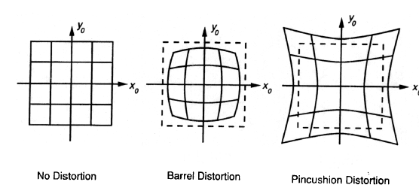

When extracting information from camera images, many applications seek to draw conclusions on the spatial location of objects of interest (e.g. vehicles). To get there, the distortion effect of the lens must be removed or at least mitigated. The relevant process is called calibration. For each camera-lens-setup, a calibration procedure must be performed so the distortion parameters can be individually computed. This is usually done by taking a set of pictures of well-known objects such as planar checkerboard patterns, from whose known geometry all lens and image sensor parameters can be robustly derived. The process of removing distortions from a camera image is called rectification. In the image below, the calibration setup used to rectify most of the images in this course is shown. It can easily be seen that lines at both left and right are distorted significantly.

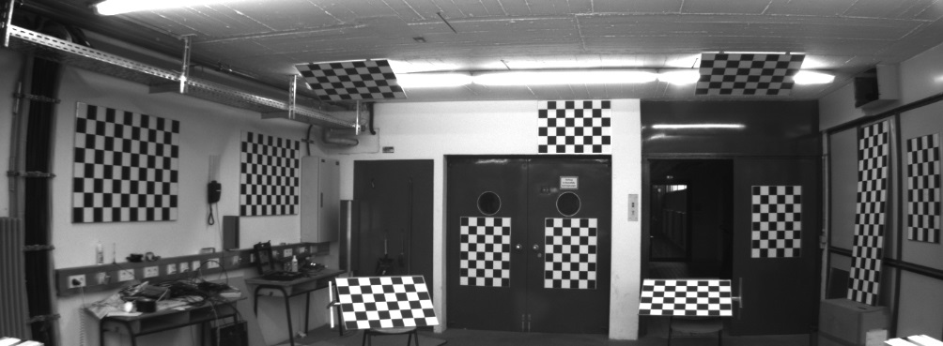

It is beyond the scope of this course however to go into the details of distortion correction. Most of the images you will be using are already free of lens distortion. When using your own camera setup however, a calibration procedure must be performed when precise measurements and a spatial reconstruction of objects is the goal.

As mentioned before, the projection of points in 3D space onto the image plane does not directly correspond to what we see in actual digital images, which are made up of thousands of picture elements or pixels. To understand how images can be expressed in discrete pixels, we need to take a closer look at the above-mentioned camera model once more. In the figure below, the camera center is shown with a position $O$ in space along with its own coordinate system with axes $i$, $j$ and $k$, where $k$ is pointing into the direction of the image plane. The position $C^{'}$

where $k$ intersects the image plane is called the principal point and represents the center of the image coordinate system.

The first step after projecting a point $P$ in space onto the image plane is thus to subtract the principal point coordinates so that the discrete image has its own coordinate system centered in e.g. the lower left corner of the image plane

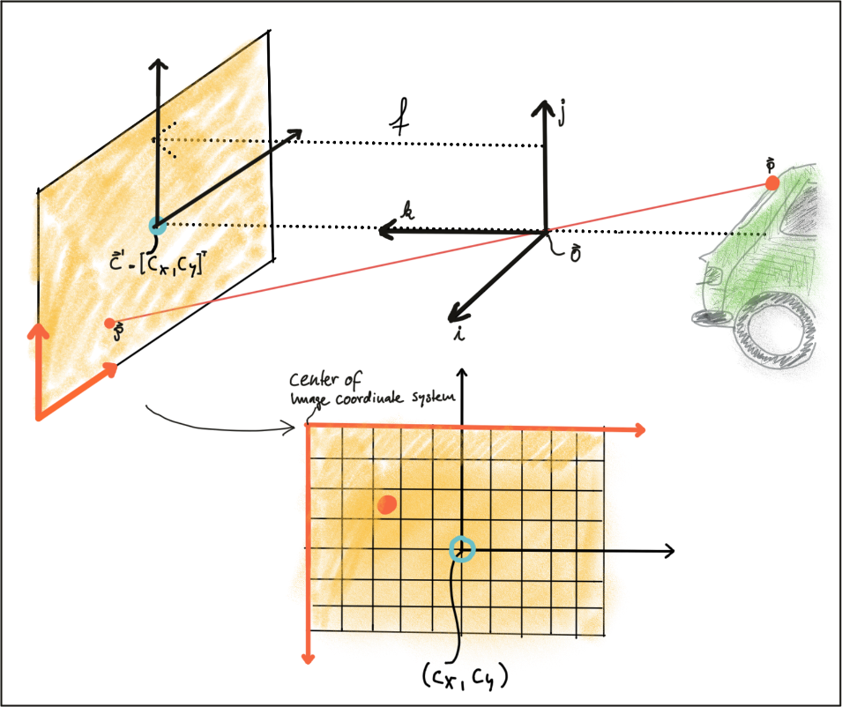

The second step in the transformation process is to move from metric to pixel coordinates. To do so, we can use parameters $k$ and $l$ provided by the calibration procedure which convert meters to pixels and which can be easily integrated into the projection equations as seen below. Note that in image coordinates, the y-axis has its origin in the upper-left corner and is pointing downwards.

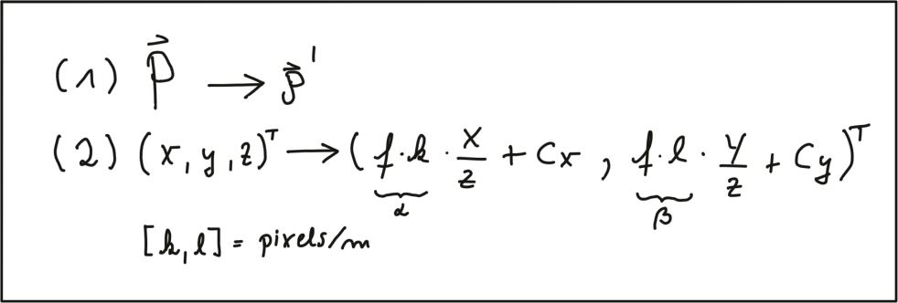

In a later section of this course, we will be mapping Lidar 3D points into the camera image. To do so, we will make use of these equations. Specifically, the product of focal width $f$ and $k$ and $l$ respectively (also termed alpha and beta) will be used in a calibration matrix to simplify the mapping operation significantly.

One final note on image rectification: In many applications (e.g. feature tracking) it makes sense to process the original image to avoid interpolation errors when the rectified image is computed and transformed pixels do not fall exactly onto the center of a discrete pixel in the rectified image but close to the border to another pixel instead. In such a case, it is advisable to locate the features in the unmodified original image and then transform the resulting coordinates using the equations above. When using deep learning based on a set of trained weights, it makes sense to rectify the image first before feeding it to a network - if we would use the original image, distortions (such as from a fish-eye lens) would lead to detection errors as networks are usually trained on a distortion-free image set.

**Imagers and Bayer Pattern**

In this last section, you will learn how rays of light with a certain wavelength are converted into color pixels that can be stored digitally.

When an image is captured by a camera, light passes through the lens and falls on the image sensor. This sensor consists of light sensitive elements that register the amount of light that falls on them and convert it into a corresponding number of electrons. The more light, the more electrons are generated. Once the exposure time is complete, the generated electrons are converted into a voltage, which is finally transformed into a discrete number by means of an A/D-converter.

Currently, there are two main image technologies, which are CCD (Charge-Coupled Device) and CMOS (Complementary Metal-oxide Semiconductor). Both technologies convert electrons into voltage and are inherently color blind, as they cannot distinguish the different wavelengths which generate the electrons. To enable color vision, tiny filter elements (also micro-lenses) are placed in front of each pixel which only allow a certain wavelength to pass through. One common way to map wavelength to color is to arrange the filter elements in an RGB (Red, Green, Blue) pattern to allow the primary colors to pass through individually, which gives us three individual images - one for each primary color.

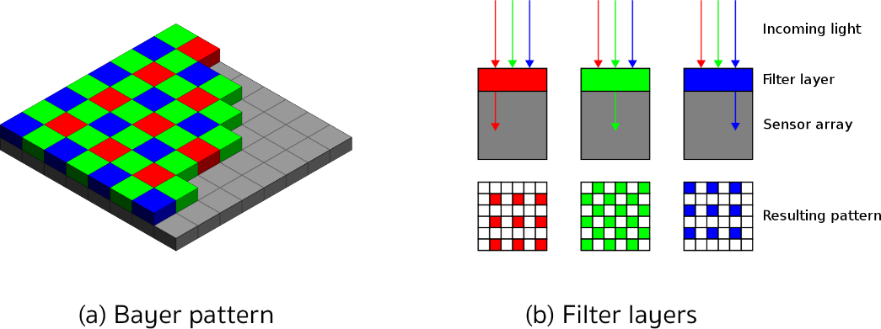

Mixed in different combinations, RGB values can produce most of the colors visible to the human eye. When each discrete color value is coded with 8bits (i.e. 256 values), a total of 16.7 million different colors can be created with the RGB filter concept. The most common way of arranging the RGB filters is called a Bayer pattern, which has alternating rows of red-green and green-blue filters. Since the human eye is more sensitive to green than to red or blue, the Bayer array has twice as many green color filters. When processing color images in a computer vision application, all three RGB layers are available and it has to be decided which color layers to use. If processing power is limited, the different channels are combined into a gray scale image. In the upcoming section on computer vision, you will be introduced to the OpenCV computer vision library.

**CCD vs CMOS**

In a CCD sensor, the electrons collected in each picture element are transferred from the chip through a single or only a few output nodes. The charges are then converted to voltage levels, buffered, and sent out as an analog signal. This signal is then amplified and converted to discrete numbers using an A/D-converter outside the sensor. Originally, CCD technology has had several advantages compared to CMOS, such as higher light sensitivity and less noise. In recent years, however, these differences have all but disappeared. The major disadvantages of CCD are a higher production price and a higher power consumption (up to 100x more than CMOS) , which usually leads to heat issues in the camera.

CMOS sensors were originally used for machine vision applications, but the image quality was poor due to their inferior light sensitivity. With modern CMOS sensors however, both quality and light sensitivity have significantly increased. The CMOS technology has several advantages: Unlike CCD, CMOS chips incorporate amplifiers and A/D-converters, which brings a huge cost advantage. With CCD, those components are located outside of the chip. CMOS sensors also have a faster data readout, lower power consumption, higher noise immunity, and a smaller system size. In automotive applications, almost all cameras use CMOS sensors because of these advantages

### The OpenCV Computer Vision Library

Throughout this course, you will be using the OpenCV, which is a cross-platform computer vision library which was originally developed in the year 2000 to provide a common infrastructure for computer vision applications and to accelerate the use of machine vision in science and engineering projects. Originally founded by Intel, the open-source library is now supported by several companies and hundreds of experts all over the globe.



The library has more than 2500 algorithms that can be used to detect and recognize faces, identify objects, classify human actions in videos, track camera movements, track moving objects, perform machine learning and many more. OpenCV is written natively in C++ but has interfaces to Python, Java and Matlab as well. In this course, you will be using the C++ version of OpenCV.

The major advantage in using the OpenCV library is that you will be able to leverage a well-tested set of state-of-the-art computer vision algorithms. Without having to concentrate on the actual implementation of computer vision concepts such as Sobel operators, keypoint detection or machine learning you can use them right out of the box and concentrate on combining them in the right way to develop a working software prototype. Despite this ease of use however, a good understanding of the theories behind those concepts is needed to use them correctly.

In the following, you will familiarize yourself with some basic concepts you will need to get started with OpenCV and to prepare yourself for the more advanced lessons later in the course. The libraries listed below will be used extensively throughout this lecture. They are however only a small part of the entire OpenCV. Later, you will also include some specialized libraries such as flann (Fast Library for Approximate Nearest Neighbors) or dnn (Deep Neural Networks), which will be described only in those sections of this course where they are used.

A note on namespaces: Most OpenCV functions exist within the _cv_ namespace. Usually, to shorten the code, the using namespace cv command is used in many applications. In this course however, this is not done to make it clear when we are using function calls from the OpenCV.

**OpenCV Library Overview**

The core module is the section of the library that contains all of the basic object types and their operations. To use the library in your code, the following header has to be included:

#include "opencv2/core/core.hpp"

The highgui module contains user interface functions that can be used to display images or take simple user input. To use the library in your code, the following header has to be included:

#include "opencv2/highgui/highgui.hpp"

In this project, basic functions such as cv::imshow will be used to display images in a window.

The imgproc (image processing) module contains basic transformations on images, such as image filtering, geometric transformations, feature detection and tracking. To use the library in your code, the following header has to be included:

#include "opencv2/imgproc/imgproc.hpp"

The features2d module contains algorithms for detecting, describing, and matching keypoints between images. To use the library in your code, the following header has to be included:

#include "opencv2/features2d/features2d.hpp"

* + 1. Placeholder

## Engineering a Collision Detection System

### Collision Detection Basics

**The Collision Detection Problem**

A collision avoidance system (CAS) is an active safety feature that warns drivers or even triggers the brake in the event of an imminent collision with an object in the path of driving. If a preceding vehicle is present, the CAS continuously estimates the time-to-collision (TTC). When the TTC falls below a lower threshold, the CAS can then decide to either warn the driver of the imminent danger or - depending on the system - apply the vehicle brakes autonomously. For the engineering task you will be completing in this course this means that you will need to find a way to compute the TTC to the vehicle in front.

Let us take a look at the following scene:

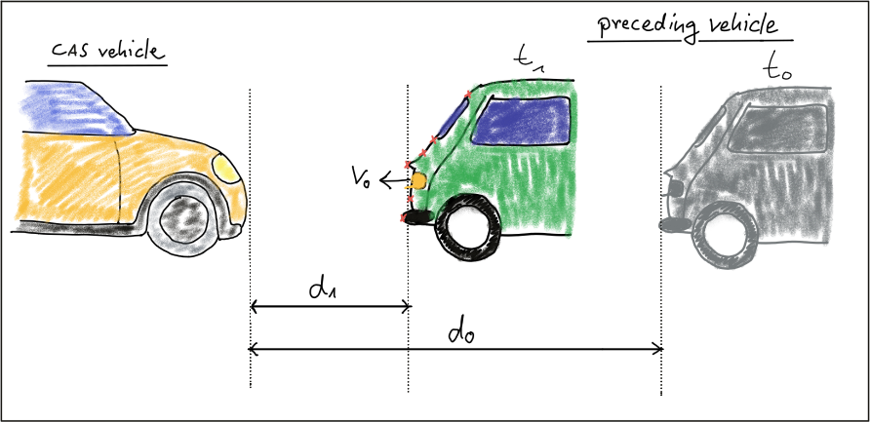

In this traffic scenario, the green vehicle starts to reduce its speed at time $t_{0}$, which is when the yellow vehicle, equipped with a collision sensor, takes the distance measurement $d_{0}$. A moment later, at time $t_{1}$, the green vehicle is considerably closer and a second measurement $d_{1}$ is taken. The goal now is to compute the remaining TTC so the system can warn the driver of the yellow vehicle or even trigger the brakes autonomously.

Before we can do this however, we need to find a way to describe the relative motion of the vehicles with a mathematical model.

**Constant Velocity vs. Constant Acceleration**

To compute the TTC, we need to make assumptions on the physical behavior of the preceding vehicle. One assumption could be that the relative velocity between the yellow and green vehicle in the above figure were constant. This would lead to the so-called constant velocity model (CVM) which is represented by eq. 1 in the following diagram.

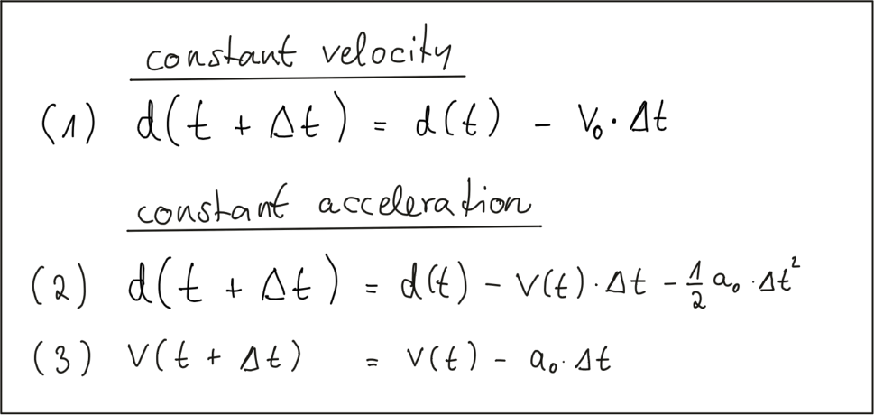

As you can see, the distance to the vehicle at time instant $t+ Δt$ is smaller than at time $t$, because we subtract the product of a constant relative velocity $v_{0}$ and time $Δt$. From an engineering perspective, we would need a sensor capable of measuring the distance to the preceeding vehicle on a precisely times basis with a constant dt between measurements. This could very well be achieved with e.g. a Lidar sensor.

Especially in dynamic traffic situations where a vehicle is braking hard, the CVM is not accurate enough however, as the relative velocity between both vehicles changes between measurements. In the following figure, the approaching vehicle is shown at three time instants with increasing velocity.

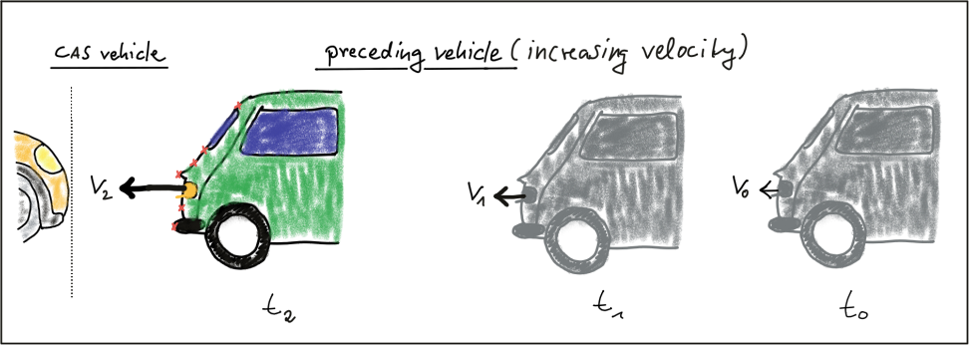

We can thus expand on our CVM by assuming velocity to be a function of time and subtract a second term in eq. 2 which is the product of a constant acceleration and the squared time dt between both measurements. Eq. 3 displays velocity as a function of time, which is also dependent on the constant acceleration we used in eq. 2. This model is referred to as constant acceleration model (CAM) and it is commonly used in commercially available collision detection systems. On a side note, if we were using a radar sensor instead of a Lidar, a direct measurement on velocity could be taken by exploiting a frequency shift in the returning electromagnetic wave due to the Doppler effect. This is a significant advantage over sensors such as Lidar, where velocity can only be computed based on (noisy) distance measurements.

In this course, we will be using a CVM instead of the CAM as it is much simpler to handle with regard to the math involved and with regard to the complexity of the programming task ahead of you. For small instances of dt we will assume that the CVM model is accurate enough and that it will give us a decent estimate of the TTC. Should you be involved in building a commercial version of such a system at a later stage in your career however, keep in mind that you should be using a constant acceleration model instead.

### Estimating TTC with Lidar

**The Math Behind Time-To-Collision**

In the following, let us assume that our CAS-equipped vehicle is using a Lidar sensor to take distance measurements on preceding vehicles. The sensor in this scenario will give us the distance to the closest 3D point in the path of driving. In the figure below, the closest point is indicated by a red line emanating from a Lidar sensor on top of the CAS vehicle.

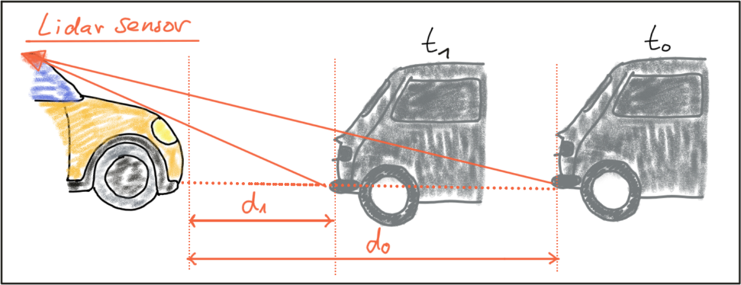

Based on the model of a constant-velocity we discussed in the last section, the velocity $v_{0}$ can be computed from two successive Lidar measurements as follows:

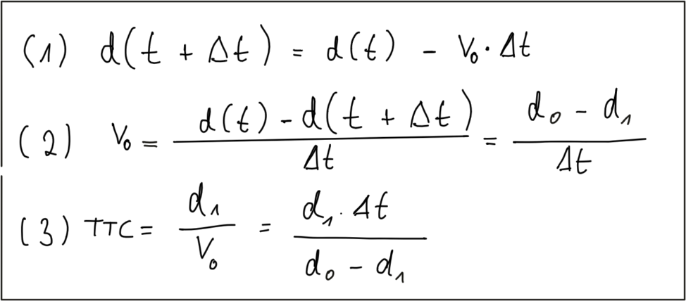

Once the relative velocity $v_{0}$ is known, the time to collision can easily be computed by dividing the remaining distance between both vehicles by $v_{0}$. So given a Lidar sensor which is able to take precise distance measurements, a system for TTC estimation can be developed based based on a CVM and on the set of equations shown above. Note however that a radar sensor would be the superior solution for TTC computation as it can directly measure the relative speed, whereas with the Lidar sensor we need to compute $v_{0}$ from two (noisy) distance measurements.

**Preparing the Lidar Point Cloud**

The following image shows a Lidar point cloud as an overlay over a camera image taken in a highway scenario with a preceding vehicle directly in the path of driving. Distance to the sensor is color-coded (green is far away, red is close). On the left side, a bird-view perspective of the Lidar points is shown as well.

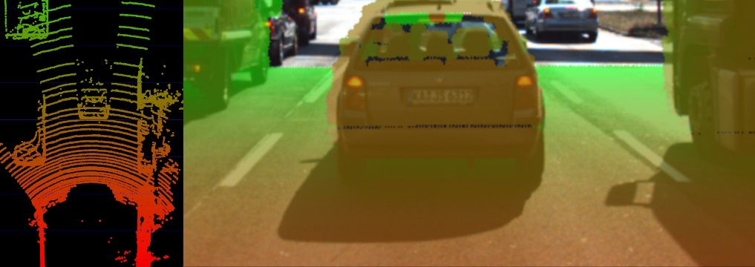

As can easily be seen, the Lidar sensor provides measurements on the vehicles as well as on the road surface. Also, some 3D points in the camera image do not seem accurate when compared to their surrounding neighbors. Especially the points near the roof of the preceding vehicle differ in color from the points on the tailgate.

As measurement accuracy is correlated to the amount of light reflected from an object, it makes sense to consider the reflectiveness r of each Lidar point which we can access in addition to the x, y and z coordinates. The image below highlights high reflectiveness with green, whereas regions with low reflectiveness are shown as red. An analysis of the associated reflectivity of the point cloud shows that such deviations often occur in regions with reduced reflectiveness.

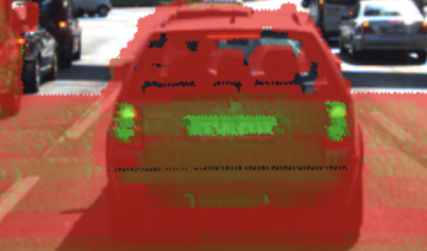

In order to derive a stable TTC measurement from the given point cloud, two main steps have to be performed:

* Remove measurements on the road surface
* Remove measurements with low reflectivity

In the figure below, Lidar points are shown in a top-view perspective and as an image overlay after applying the filtering. After removing Lidar points in this manner, it is now much easier to derive the distance d(t) to the preceding vehicle.

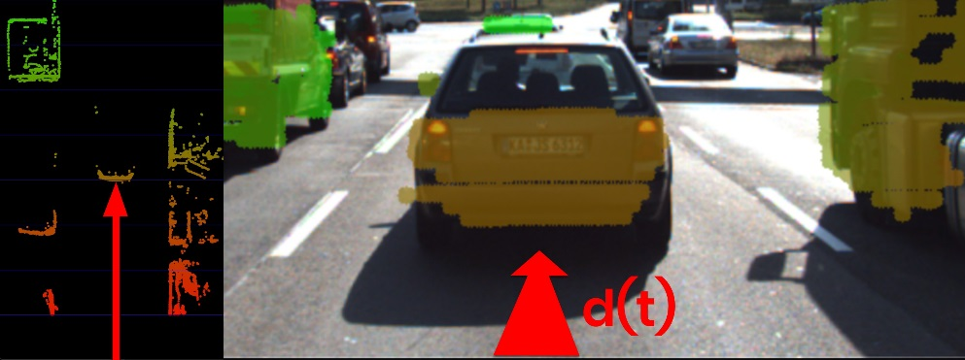

In a later lesson, you will learn how to project Lidar points into the camera image and how to perform the removal procedure as seen in the above examples. For now, let us assume that for each time step dt, the Lidar sensor would return the distance d(t+dt) to the preceding vehicle.

**Computing TTC from Distance Measurements**

In the code examples in this course, Lidar points are packaged into a data structure called LidarPoints. As seen below, the structure consists of the point coordinates x (forward), y (left) an z (up) in metric coordinates and of the point reflectivity r on a scale between 0 and 1 (high reflectivity).

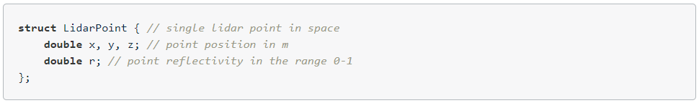

In order to compute the TTC, we need to find the distance to the closest Lidar point in the path of driving. In the figure below, Lidar measurements located on the tailgate of the preceding vehicle are measured at times $t_{0}$ (green) and $t_{1}$ (red). It can be seen, that the distance to the vehicle has decreased slightly between both time instants.

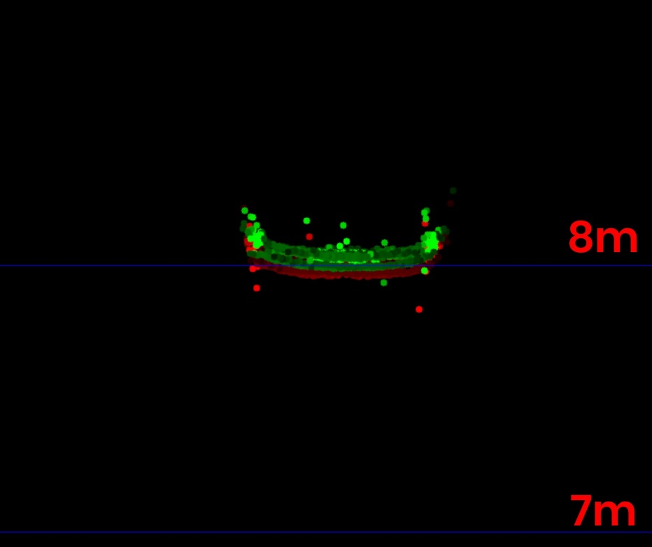

The following code searches for the closest point in the point cloud associated with $t_{0}$ (lidarPointsPrev) and in the point cloud associated with $t_{1}$ (lidarPointsCurr). After finding the distance to the closest points respectively, the TTC is computed based on the formula we derived at the beginning of this section.

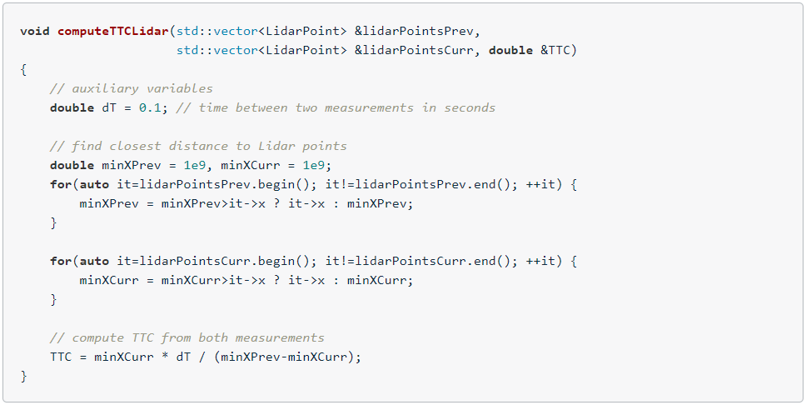

Even though Lidar is a reliable sensor, erroneous measurements may still occur. As seen in the figure above, a small number of points is located behind the tailgate, seemingly without connection to the vehicle. When searching for the closest points, such measurements will pose a problem as the estimated distance will be too small. There are ways to avoid such errors by post-processing the point cloud, but there will be no guarantee that such problems will never occur in practice. It is thus a good idea to perform a more robust computation of minXCurr and minXPrev which is able to cope with a certain number of outliers (in the final project, you will do this) and also look at a second sensor which is able to compute the TTC, such as the camera.

### Estimating TTC with Camera

**Measuring TTC without distance**

Monocular cameras are not able to measure metric distances. They are passive sensors that rely on the ambient light which reflects off of objects into the camera lens. It is thus not possible to measure the runtime of light as with Lidar technology.

To measure distance, a second camera would be needed. Given two images taken by two carefully aligned cameras (also called a stereo setup) at the same time instant, one would have to locate common points of interest in both images (e.g. the tail lights of the preceding vehicle) and then triangulate their distance using camera geometry and perspective projection. For many years, automotive researchers have developed stereo cameras for the use in ADAS products and some of those have made it to market. Especially Mercedes-Benz has pioneered this technology and extensive information can be found here : http://www.6d-vision.com/. With more advanced ADAS products and with autonomous vehicles however, stereo cameras have started to disappear from the market due to their package size, the high price and the high computational load for finding corresponding features.

Despite those limitations of the mono camera, let us see if there is a way to compute TTC without the need to measure distance. Let us consider the constant velocity motion model we introduced in a previous section of this course and think about a way to replace the metric distances d with something the camera can measure reliably, such as pixel distances directly on the image plane. In the following figure, you can see how the height $H$ of the preceding vehicle can be mapped onto the image place using perspective projection. We can see that the same height $H$ maps to different heights $h_{0}$ and $h_{1}$ in the image plane, depending on the distance $d$ and $d_{1}$ of the vehicle. It is obvious that there is a geometric relation between $h$, $H$, $d$ and the focal length $f$ of the pinhole camera - and this is what we want to exploit in the following.

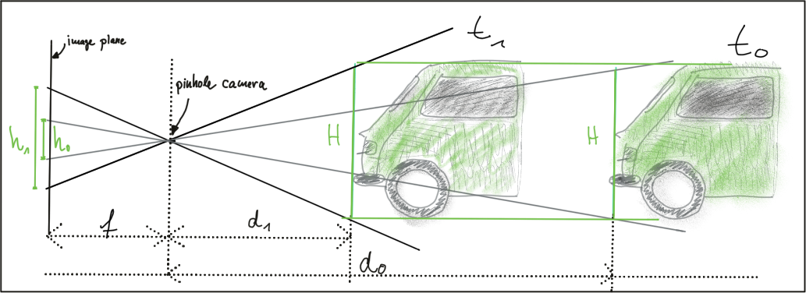

Let us take a look at the following set of equations:

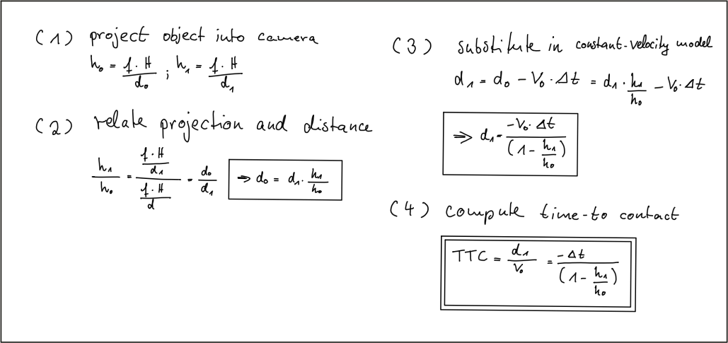

In (1) we use the focal length of the camera and a distance measurement $d_{0}$ performed at time $t_{0}$ to project the height $H$ of the vehicle onto the image plane and thus to a height $h_{0}$ in pixels. The same is done at time $t_{1}$, leading to a projected height $h_{1}.$

In (2), we compute the ratio of the relative heights $h_{0}$ and $h_{1}$. As both $H$ and $f$ are cancelled out, we can observe a direct relation between relative height $h$ and absolute metric distance $d$. We can thus express the distance to the vehicle $d_{0}$ as the product of $d_{1}$ and the ratio of relative heights on the image plane.

In (3), we substitute $d_{0}$ in the equation for constant velocity and solve for $d_{1}$, which is now dependent on the constant relative velocity $v_{0}$, on the time between measuring $d_{0}$ and $d_{1}$ and on the ratio of relative heights on the image plane.

In (4), the TTC is computed as the ratio of remaining distance to impact, which is $d_{1}$, and the constant velocity $v_{0}$. As we can easily see, the TTC now only consists of $Δt$, $h_{0}$ and $h_{1}$. Thus, it is possible to measure the time to collision by observing relative height change on the image sensor. Distance measurements are not needed and we can thus use a mono camera to estimate the time-to-collision by observing changes in relative height (also called scale change) directly in the image.

**The problem with bounding Box Detection**

In the figure below, a neural network has been used to locate vehicles in successive images of a monocular camera. For each vehicle, the network returns a bounding box, whose width and/or height could in principal be used to compute the height ratio in the TTC equation we derived in the last section.

When observed closely however, it can be seen that the bounding boxes do not always reflect the true vehicle dimensions and the aspect ratio differs between images. Using bounding box height or width for TTC computation would thus lead to significant estimation errors.

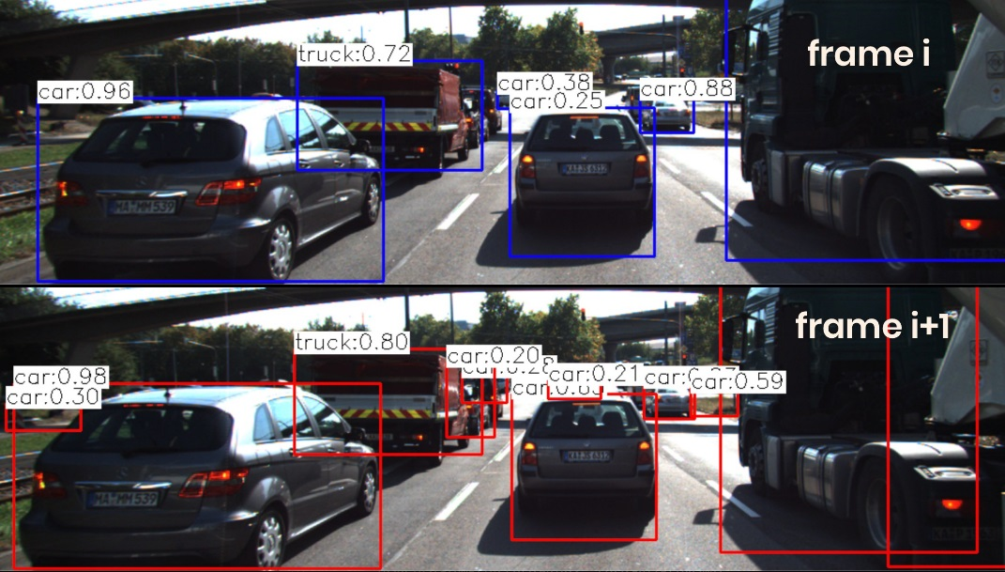

In most engineering tasks, relying on a single measurement or property is not reliable enough. This holds especially true for safety-related products. Therefore, we want to consider whether there are further properties of vehicles and objects we can observe in an image.

**Using Texture Keypoints Instead**

Instead of relying on the detection of the vehicle as a whole we now want to analyze its structure on a smaller scale. If if were possible to locate uniquely identifiable keypoints that could be tracked from one frame to the next, we could use the distance between all keypoints on the vehicle relative to each other to compute a robust estimate of the height ratio in out TTC equation. The following figure illustrates the concept.

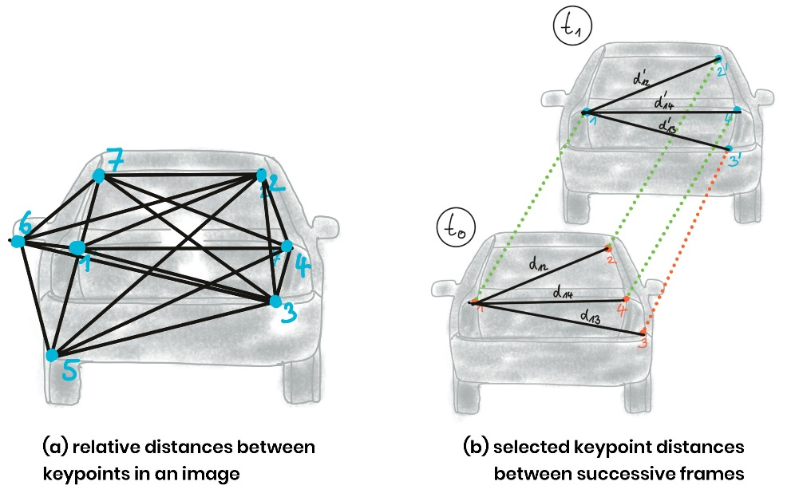

In (a), a set of keypoints has been detected and the relative distances between keypoints 1-7 have been computed. In (b), 4 keypoints have been matched between successive images (with keypoint 3 being a mismatch) using a higher-dimensional similarity measure called descriptor (more about that in the next lesson). The ratio of all relative distances between each other can be used to compute a reliable TTC estimate by replacing the height ratio ${h_{1}}/{h_{0}}$ with the mean or median of all distance ratios ${d_{k}}/{d_{k}^{'}}$.

The following figure shows several example of relative distances between keypoints as an overlay over a highway driving scene (only the preceding vehicle is highlighted).

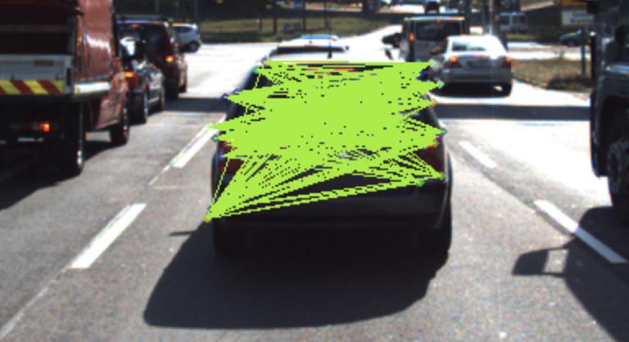

### Course Structure

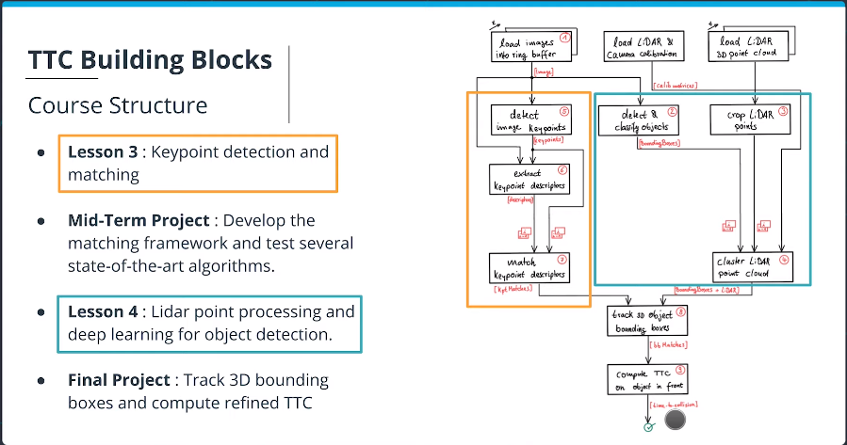

## Tracking Image Features

### Intensity Gradient and Filtering

**Locating Keypoints in an Image**

As discussed in the previous lesson, a camera is not able to measure distance to an object directly. However, for our collision avoidance system, we can compute time-to-collision based on relative distance ratios on the image sensor instead. To do so, we need a set of locations on the image plane which can serve as stable anchors to compute relative distances between them. This section discussed how to locate such anchor locations - or keypoints in an image.

Take a look at the three patches in the following figure which have been extracted from an image of a highway driving scene. The grid shows the borders of individual pixels. How would you describe meaningful locations within those patches that could be used as keypoints?

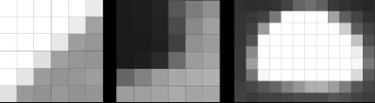

In the leftmost patch, there is a distinctive contrast between bright and dark pixels which resembles a line from the bottom-left to the upper-right. The patch in the middle resembles a corner formed by a group of very dark pixels in the upper-left. The rightmost patch looks like a bright blob that might be approximated by an ellipse.

In order to precisely locate a keypoint in an image, we need a way to assign them a unique coordinate in both x and y. Not all of the above patches lend themselves to this goal. Both the corner as well as the ellipse can be positioned accurately in x and y, the line in the leftmost image cannot.

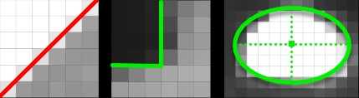

In the following, we will thus concentrate on detecting corners in an image. In a later section, we will also look at detector who are optimized for blob-like structures, such as the SIFT detector.

**The Intensity Gradient**

In the above examples, the contrast between neighboring pixels contains the information we need : In order to precisely locate e.g. the corner in the middle patch, we do not need to know its color but instead we require the color difference between the pixels that form the corner to be as high as possible. An ideal corner would consist of only black and white pixels.

The figure below shows the intensity profile of all pixels along the red line in the image as well as the intensity gradient, which is the derivative of image intensity.

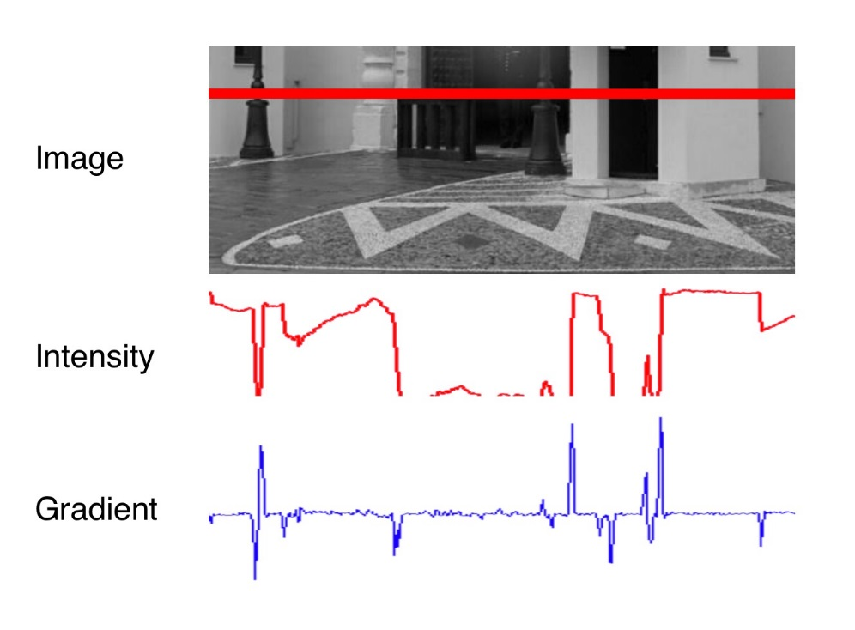

It can be seen that the intensity profile increases rapidly at positions where the contrast between neighboring pixels changes significantly. The lower part of the street lamp on the left side and the dark door show a distinct intensity difference to the light wall. If we wanted to assign unique coordinates to the pixels where the change occurs, we could do so by looking at the derivative of the intensity, which is the blue gradient profile you can see below the red line. Sudden changes in image intensity are clearly visible as distinct peaks and valleys in the gradient profile. If we were to look for such peaks not only from left to right but also from top to bottom, we could look for points which show a gradient peak both in horizontal and in vertical direction and choose them as keypoints with both x and y coordinates. In the example patches above, this would work best for the corner, whereas an edge-like structure would have more or less identical gradients at all positions with no clear peak in x and y.

Based on the above observations, the first step into keypoint detection is thus the computation of a gradient image. Mathematically, the gradient is the partial derivative of the image intensity into both x and y direction. The figure below shows the intensity gradient for three example patches. The gradient direction is represented by the arrow.

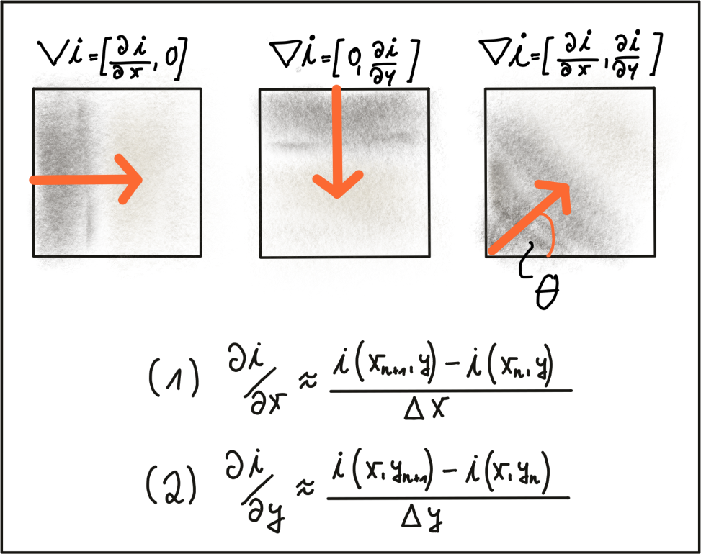

In equations (1) and (2), the intensity gradient is approximated by the intensity differences between neighboring pixels, divided by the distance between those pixels in x- and y-direction. Next, based on the intensity gradient vector, we can compute both the direction as well as the magnitude as given by the following equations:

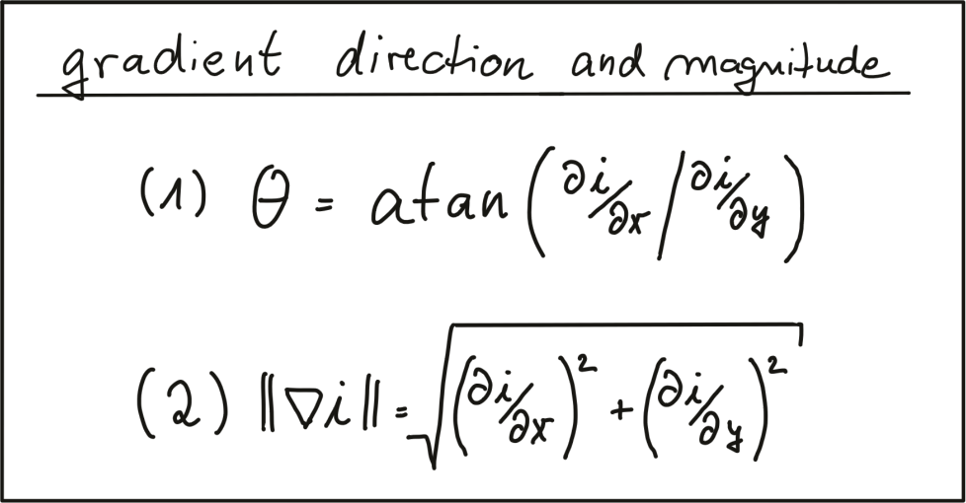

There are numerous ways of computing the intensity gradient. The most straightforward approach would be to simply compute the intensity difference between neighboring pixels. This approach however is extremely sensitive to noise and should be avoided in practice. Further down in this section, we will look at a well-proven standard approach, the Sobel operator.

**Image Filters and Gaussian Smoothing**

Before we further discuss gradient computation, we need to think about noise, which is present in all images (except artificial ones) and which decreases with increasing light intensity. To counteract noise, especially under low-light conditions, a smoothing operator has to be applied to the image before gradient computation. Usually, a Gaussian filter is used for this purpose which is shifted over the image and combined with the intensity values beneath it. In order to parameterize the filter properly, two parameters have to be adjusted:

* The standard deviation, which controls the spatial extension of the filter in the image plane. The larger the standard deviation, the wider the area which is covered by the filter.
* The kernel size, which defines how many pixels around the center location will contribute to the smoothing operation.

The following figure shows three Gaussian filter kernels with varying standard deviations.

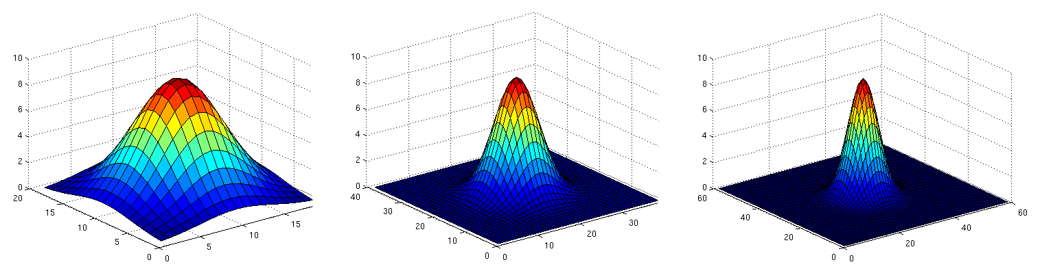

Gaussian smoothing works by assigning each pixel a weighted sum of the surrounding pixels based on the height of the Gaussian curve at each point. The largest contribution will come from the center pixel itself, whereas the contribution from the pixels surroundings will decrease depending on the height of the Gaussian curve and thus its standard deviation. It can easily be seen that the contribution of the surrounding pixels around the center location increases when the standard deviation is large (left image).

Applying the Gaussian filter (or any other filter) works in four successive steps which are illustrated by the figure below:

* Create a filter kernel with the desired properties (e.g. Gaussian smoothing or edge detection)
* Define the anchor point within the kernel (usually the center position) and place it on top of the first pixel of the image.
* Compute the sum of the products of kernel coefficients with the corresponding image pixel values beneath.
* Place the result to the location of the kernel anchor in the input image.
* Repeat the process for all pixels over the entire image.

The following figure illustrates the process of shifting the (yellow) filter kernel over the image row by row and assigning the result of the two-dimensional sum H(x,y)H(x,y) to every pixel location.

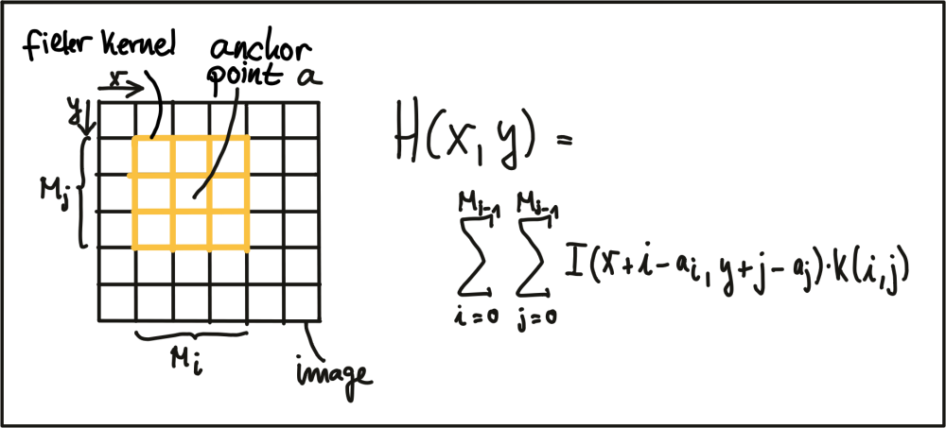

A filter kernel for Gaussian smoothing is shown in the next figure. In (a), a 3D Gaussian curve is shown and in (b), the corresponding discrete filter kernel can be seen with a central anchor point (41) corresponding to the maximum of the Gaussian curve and with decreasing values towards the edges in a (approximately) circular shape.

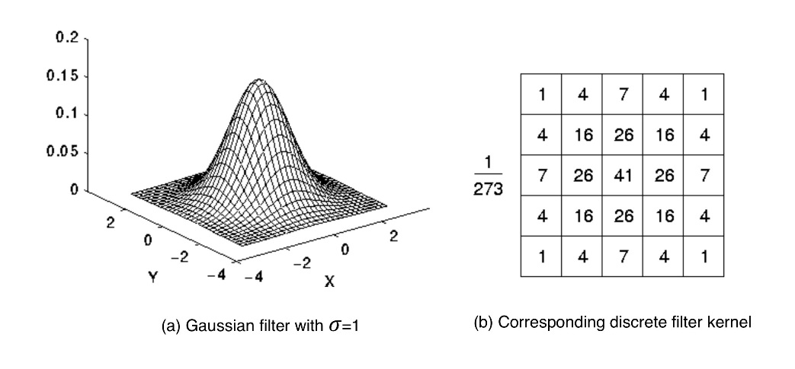

**Exercise**

The following code uses the function *cv::filter2D* to apply the filter above to an image. Run the code and figure out why the output image does not look as it is supposed to look after applying the smoothing filter. Once you know why, make the necessary changes and run the code again until you see a slightly blurred image. You can compile using *cmake* and *make* as before, and run the code using the generated *gaussian_smoothing* executable.

**Computing the Intensity Gradient**

After smoothing the image slightly to reduce the influence of noise, we can now compute the intensity gradient of the image in both x and y direction. In the literature, there are several approaches to gradient computation to be found. Among the most famous it the *Sobel* operator (proposed in 1968), but there are several others, such as the *Scharr* operator, which is optimized for rotational symmetry.

The Sobel operator is based on applying small integer-valued filters both in horizontal and vertical direction. The operators are 3x3 kernels, one for the gradient in x and one for the gradient in y. Both kernels are shown below.

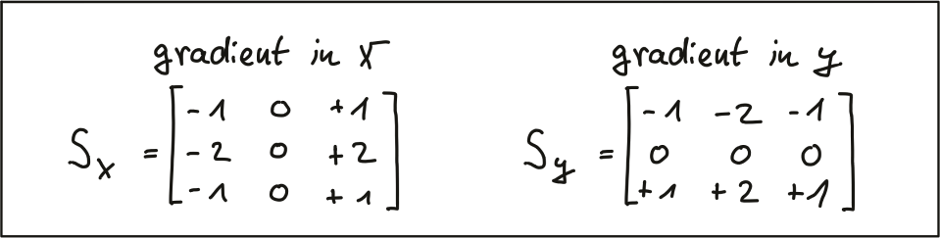

In the following code, one kernel of the Sobel operator is applied to an image. Note that it has been converted to grayscale to avoid computing the operator on each color channel. This code can be found in the *gradient_sobel.cpp* file in the desktop workspace above. You can run the code by using the *gradient_sobel* executable.

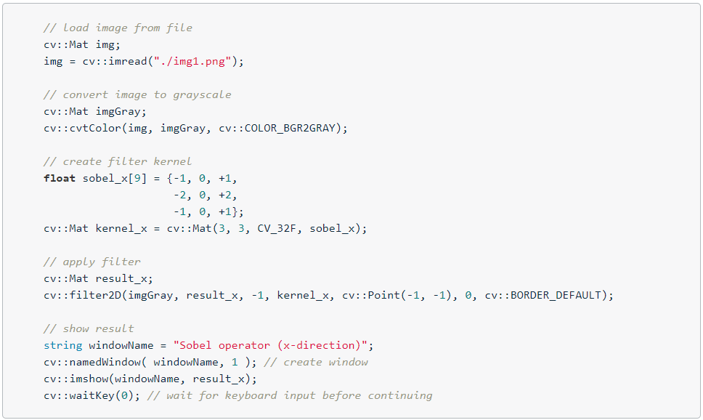

The resulting gradient image is shown below. It can be seen that areas of strong local contrast such as the cast shadow of the preceding vehicle leads to high values in the filtered image.

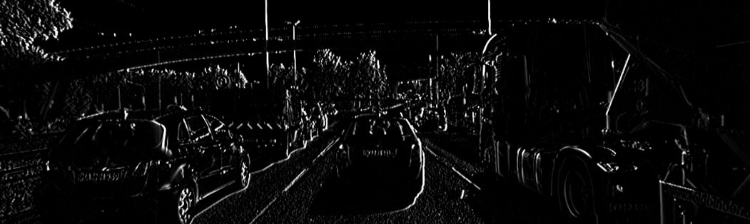

Note that in the above code, only the $S_{x}$ filter kernel has been applied for now, which is why the cast shadow only shows in x direction. Applying $S_{y}$ to the image yields the following result:

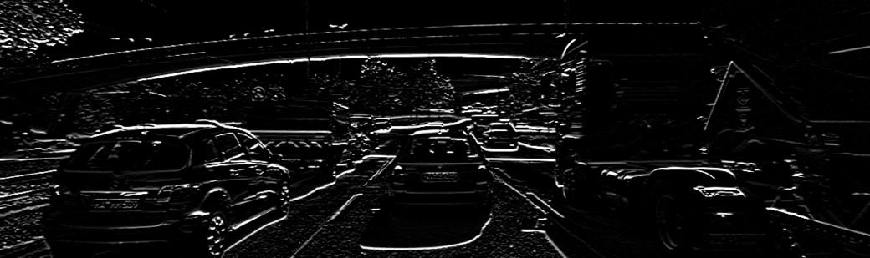

**Exercise**

Based on the image gradients in both x and y, compute an image which contains the gradient magnitude according to the equation at the beginning of this section for every pixel position. Also, apply different levels of Gaussian blurring before applying the Sobel operator and compare the results.

You can use the *magnitude_sobel.cpp* file in the desktop workspace above for your solution, and after make, you can run the code using the *magnitude_sobel* executable.

The result should look something like this, with the noise in the road surface being almost gone due to smoothing:

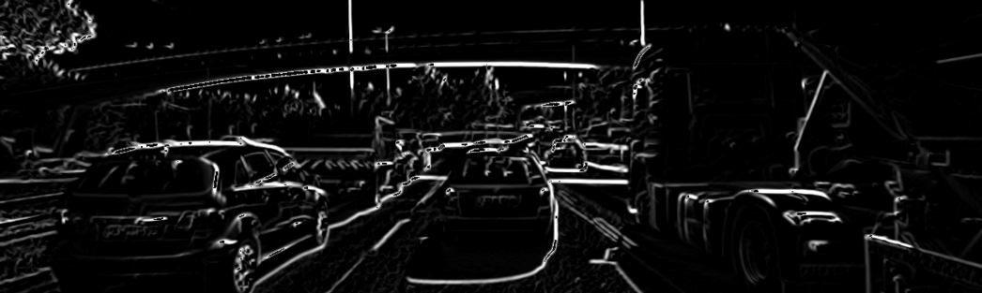

### Harris Corner Detection

**Local Measures of Uniqueness**

The idea of keypoint detection is to detect a unique structure in an image that can be precisely located in both coordinate directions. As discussed in the previous section, corners are ideally suited for this purpose. To illustrate this, the following figure shows an image patch which consists of line structures on a homogeneously colored background. A red arrow indicates that no unique position can be found in this direction. The green arrow expresses the opposite. As can be seen, the corner is the only local structure that can be assigned a unique coordinate in x and y.

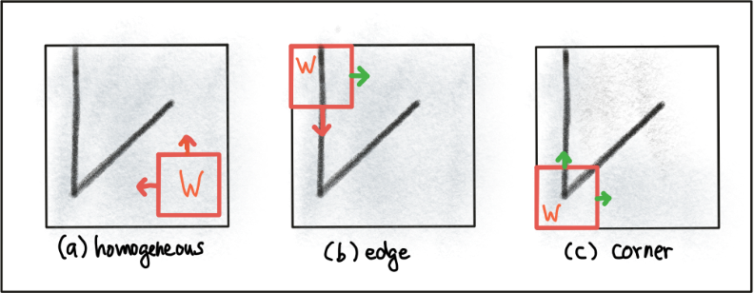

In order to locate a corner, we consider how the content of the window would change when shifting it by a small amount. For case (a) in the figure above, there is no measurable change in any coordinate direction at the current location of the red window W whereas for (b), there will be significant change into the direction orthogonal to the edge and no change when moving into the direction of the edge. In case of (c), the window content will change in any coordinate direction.

The idea of locating corners by means of an algorithm is to find a way to detect areas with a significant change in the image structure based on a displacement of a local window W. Generally, a suitable measure for describing change mathematically is the sum of squared differences (SSD), which looks at the deviations of all pixels in a local neighborhood before and after performing a coordinate shift. The equation below illustrates the concept.

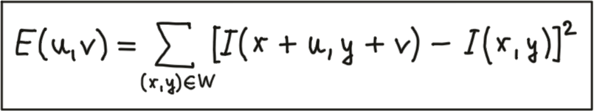

After shifting the Window W by an amount u in x-direction and v in y-direction the equation sums up the squared differences of all pixels within W at the old and at the new window position. In the following we will use some mathematical transformations to derive a measure for the change of the local environment around a pixel from the general definition of the SSD.

In the first step, based on the definition of $E(u,v)$ above, we will at first make a Taylor series expansion of $I(x+u,y+v)$. For small values of u and v, the first-order approximation is sufficient, which leads to the following expression.

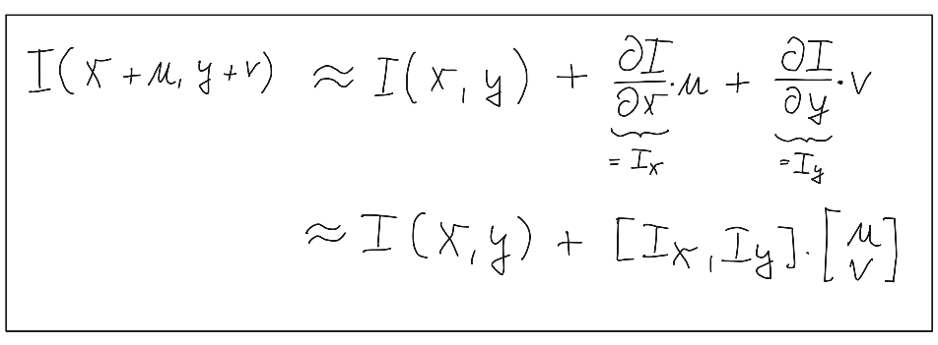

The derivation of the image intensity II both in x- and y-direction is something you have learned in the previous section already - this is simply the intensity gradient . From this point on, we will use the shorthand notation shown above to express the gradient.

In the second step, we will now insert the approximated expression of $I(x+u,y+v)$ into the SSD equation above, which simplifies to the following form:

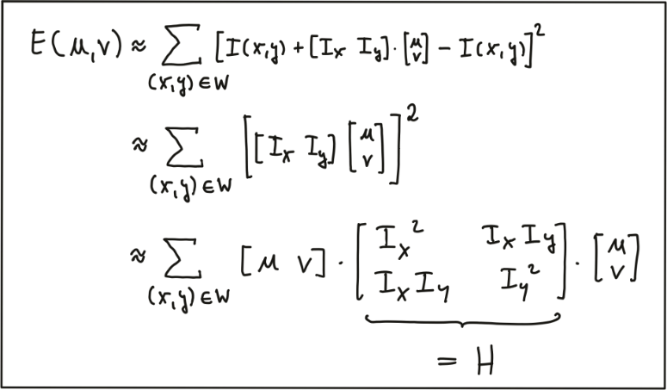

The result of our mathematical transformations is a matrix $H$, which can now be conveniently analyzed to locate structural change in a local window $W$ around every pixel position $u,v$ in an image. In the literature, the matrix HH is often referred to as covariance matrix.

To do this, it helps to visualize the matrix $H$ as an ellipse, whose axis length and directions are given by its eigenvalues and eigenvectors. As can be seen in the following figure, the larger eigenvector points into the direction of maximal intensity change, whereas the smaller eigenvector points into the direction of minimal change. So in order to identify corners, we need to find positions in the image which have two significantly large eigenvalues of $H$.

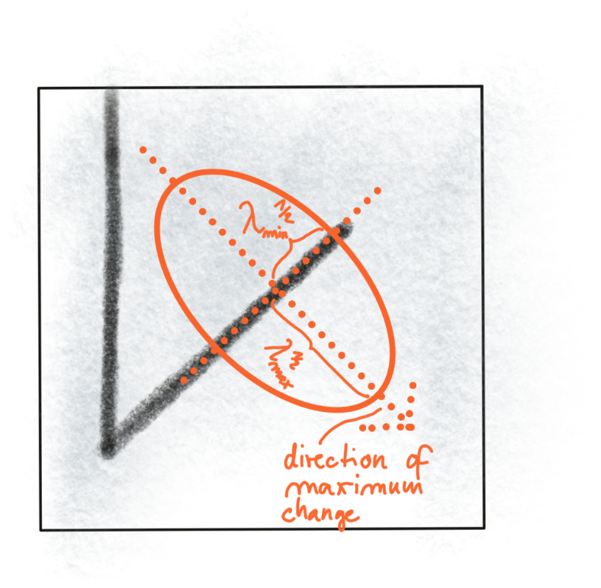

Without going into details on eigenvalues in this course, we will look at a simple formula of how they can be computed from $H$:

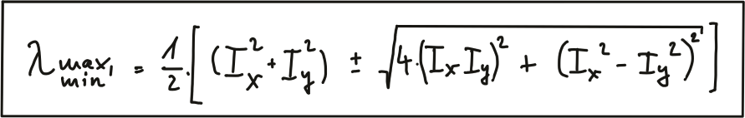

In addition to the smoothing of the image before gradient computation, the Harris detector uses a Gaussian window $w(x,y)$ to compute a weighted sum of the intensity gradients around a local neighborhood. The size of this neighborhood is called scale in the context of feature detection and it is controlled by the standard deviation of the Gaussian distribution.

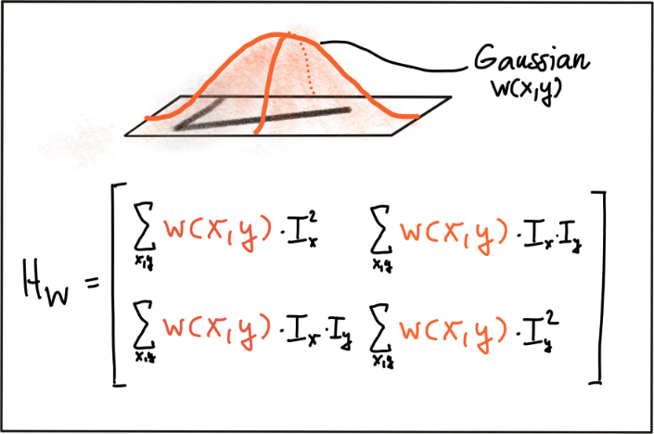

As can be seen, the larger the scale of the Gaussian window, the larger the feature below that contributes to the sum of gradients. By adjusting scale, we can thus control the keypoints we are able to detect.

**The Harris Corner Detector**

Based on the eigenvalues of $H$, one of the most famous corner detectors is the Harris detector. This method evaluates the following expression to derive a corner response measure at every pixel location with the factor k being an empirical constant which is usually in the range between k = 0.04 - 0.06.

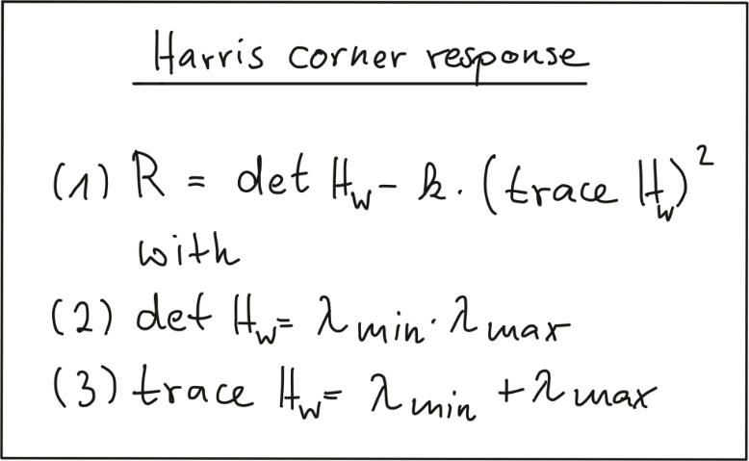

Based on the concepts presented in this section, the following code computes the corner response for a given image and displays the result.

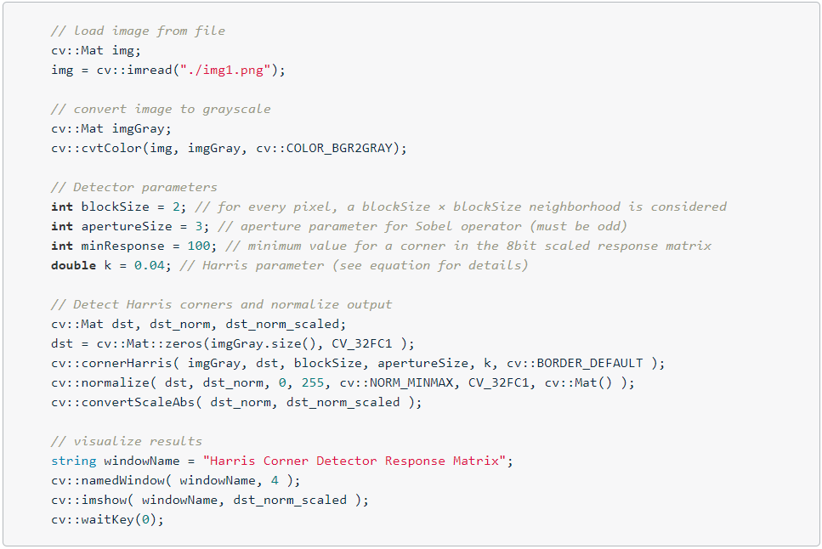

The result can be seen below : The brighter a pixel, the higher the Harris corner response.

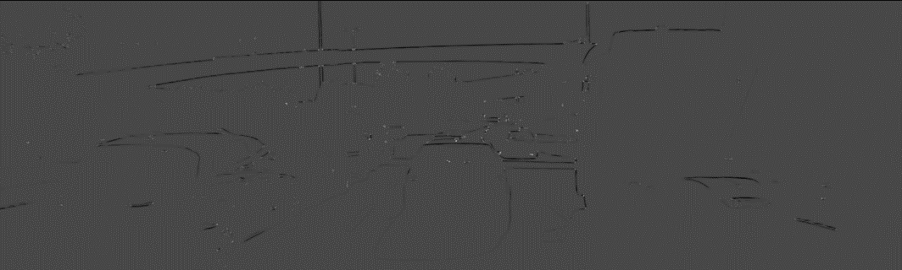

**Exercise**

In order to locate corners, we now have to perform a non-maxima suppression to (a) ensure that we get the pixel with maximum cornerness in a local neighborhood and (b) to prevent corners from being too close to each other as we prefer an even spread of corners throughout the image.

Your task is to locate local maxima in the Harris response matrix and perform a non-maximum suppression (NMS) in a local neighborhood around each maximum. The resulting coordinates shall be stored in a list of keypoints of the type *vector<cv::KeyPoint>*. The result should look like this, with each circle denoting the position of a Harris corner. You can write your code in the cornerness_harris.cpp file.

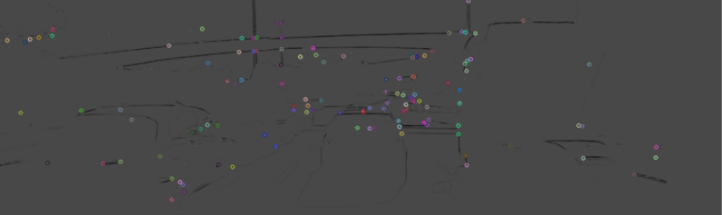

### Overview of Popular Keypoint Detectors

**Invariance to Photometric and Geometric Changes**

In the literature (and in the OpenCV library), there is a large number of feature detectors (including the Harris detector), we can choose from. Depending on the type of keypoint that shall be detected and based on the properties of the images, the robustness of the respective detector with regard to both photometric and geometric transformations needs to be considered.

There are four basic transformation types we need to think about when selecting a suitable keypoint detector:

* Rotation
* Scale change
* Intensity change
* Affine transformation

The following figure shows two images in frame i of a video sequence (a) who have been subjected to several transformations in frame i + n (b).

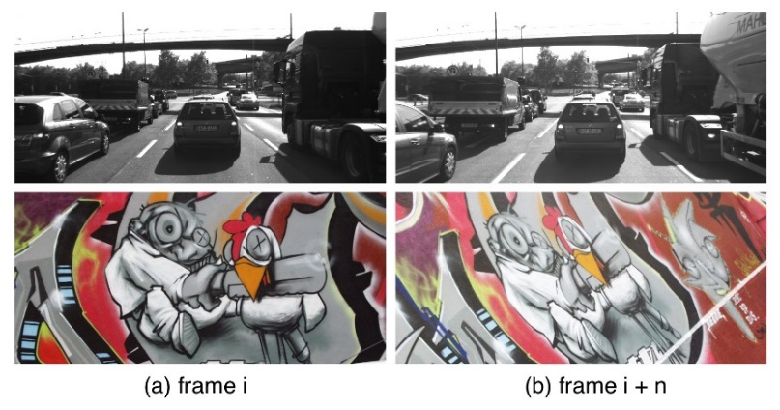

For the graffiti sequence, which is one of the standard image sets used in computer vision (also see http://www.robots.ox.ac.uk/~vgg/research/affine/), we can observe all of the transformations listed above whereas for the highway sequence, when focusing on the preceding vehicle, there is only a scale change as well as an intensity change between frames i and i+n.

In the following, the above criteria are used to briefly assess the Harris corner detector.

Rotation R :

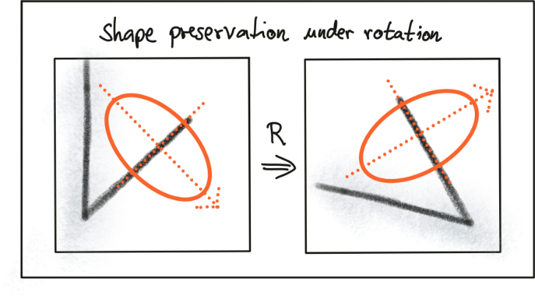

Intensity change:

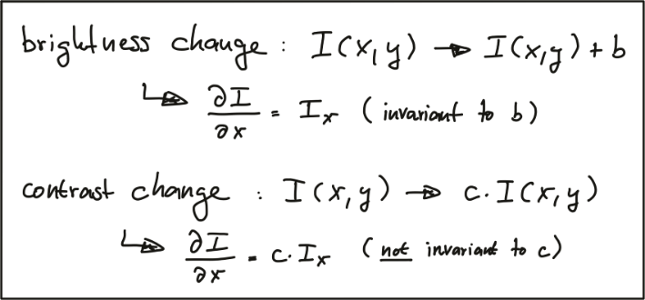

Scale change:

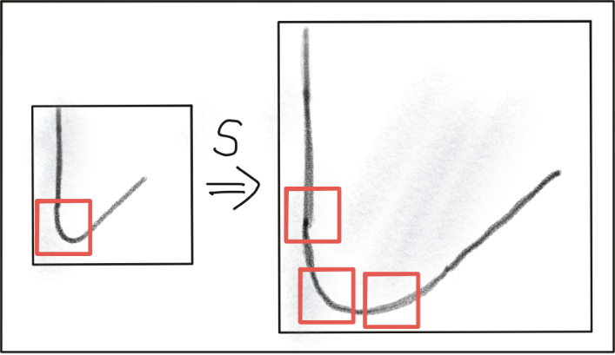

Summarizing, the Harris detector is robust under rotation and additive intensity shifts, but sensitive to scale change, multiplicative intensity shifts (i.e. changes in contrast) and affine transformations. However, if it were possible to modify the Harris detector in a way such that it were able to account for changes of the object scale, e.g. when the preceding vehicle approaches, it might be (despite its age), a suitable detector for our purposes.

**Automatic Scale Selection**

In order to detect keypoints at their ideal scale, we must know (or find) their respective dimensions in the image and adapt the size of the Gaussian window $w\left(x,y\right)$ as introduced earlier in this section. If the keypoint scale is unknown or if keypoints with varying size exist in the image, detection must be performed successively at multiple scale levels.

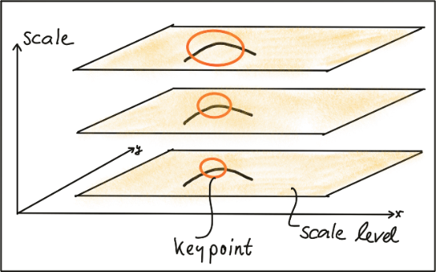

Based on the increment of the standard deviation between two neighboring levels, the same keypoint might be detected multiple times. This poses the problem of choosing the „correct“ scale which best represents the keypoint.

In a landmark paper from 1998, Tony Lindeberg published a method for "Feature detection with automatic scale selection". In this paper, he proposed a function $F(x,y,scale)$, which could be used to select those keypoints that showed a stable maximum of $F$ over scale. The scale for which $F$ was maximized was termed the "characteristic scale“ of the respective keypoint.

The following image shows such a function $F$ which has been evaluated for several scale levels and exhibits a clear maximum that can be seen as the characteristic scale of the image content within the circular region.

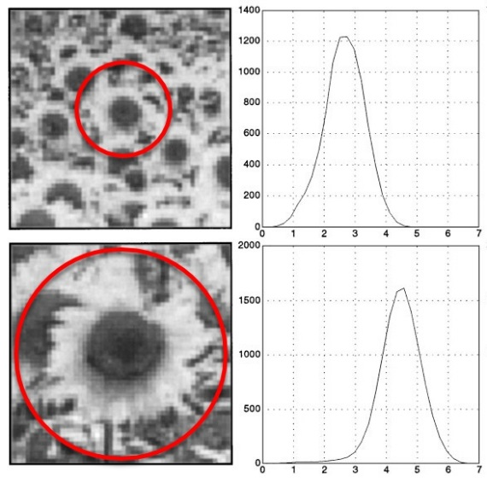

Details of how to properly design a suitable function $F$ are not in the focus of this course however. The major take-away is the knowledge that a good detector is able to automatically select the characteristic scale of a keypoint based on structural properties of its local neighborhood. Modern keypoint detectors usually possess this ability and are thus robust under changes of the image scale.

**Overview of Popular Keypoint Detectors**

Keypoint detectors are a very popular research area and thus a large number of powerful algorithms have been developed over the years. Applications of keypoint detection include such things as object recognition and tracking, image matching and panoramic stitching as well as robotic mapping and 3D modeling. In addition to invariance under the transformations mentioned above, detectors can be compared for their detection performance and their processing speed.

The Harris detector along with several other "classics" belongs to a group of traditional detectors, which aim at maximizing detection accuracy. In this group, computational complexity is not a primary concern. The following list shows a number of popular classic detectors :

* 1988 Harris Corner Detector (Harris, Stephens)
* 1996 Good Features to Track (Shi, Tomasi)
* 1999 Scale Invariant Feature Transform (Lowe)
* 2006 Speeded Up Robust Features (Bay, Tuytelaars, Van Gool)

In recent years, a number of faster detectors has been developed which aims at real-time applications on smartphones and other portable devices. The following list shows the most popular detectors belonging to this group:

* 2006 Features from Accelerated Segment Test (FAST) (Rosten, Drummond)
* 2010 Binary Robust Independent Elementary Features (BRIEF) (Calonder, et al.)
* 2011 Oriented FAST and Rotated BRIEF (ORB) (Rublee et al.)
* 2011 Binary Robust Invariant Scalable Keypoints (BRISK) (Leutenegger, Chli, Siegwart)
* 2012 Fast Retina Keypoint (FREAK) (Alahi, Ortiz, Vandergheynst)
* 2012 KAZE (Alcantarilla, Bartoli, Davidson)

In this course, we will be using the Harris detector as well as the Shi-Tomasi detector (which is very similar to Harris) as representatives from the first group of "classic“ detectors. From the second group, we will be leveraging the OpenCV to implement the entire list of detectors.

**Exercise**

Before we go into details on the above-mentioned detectors in the next section, use the OpenCV library to add the FAST detector in addition to the already implemented Shi-Tomasi detector and compare both algorithms with regard to (a) number of keypoints, (b) distribution of keypoints over the image and (c) processing speed. Describe your observations with a special focus on the preceding vehicle.

### Gradient-based vs. Binary Descriptors

**Detectors and Descriptors**

Before we go into details on how some of the keypoint detectors discussed in the previous section work, let us take a look at the problem ahead of us. Our task is to find corresponding keypoints in a sequence of images that we can use to compute the TTC to a preceding object, e.g. a vehicle. We therefore need a way to robustly assign keypoints to each other based on some measure of similarity. In the literature, a large variety of similarity measures (called descriptors) have been proposed and in many cases, authors have published both a new method for keypoint detection as well as similarity measure which has been optimized for their type of keypoints.

Let us refine our terminology at this point :

* A keypoint (sometimes also interest point or salient point) detector is an algorithm that chooses points from an image based on a local maximum of a function, such as the "cornerness" metric we saw with the Harris detector.
* A descriptor is a vector of values, which describes the image patch around a keypoint. There are various techniques ranging from comparing raw pixel values to much more sophisticated approaches such as histograms of gradient orientations.

Descriptors help us to assign similar keypoints in different images to each other. As shown in the figure below, a set of keypoints in one frame is assigned keypoints in another frame such that the similarity of their respective descriptors is maximized and (ideally) the keypoints represent the same object in the image. In addition to maximizing similarity, a good descriptor should also be able to minimize the number of mismatches, i.e. avoid assigning keypoints to each other that do not correspond to the same object.

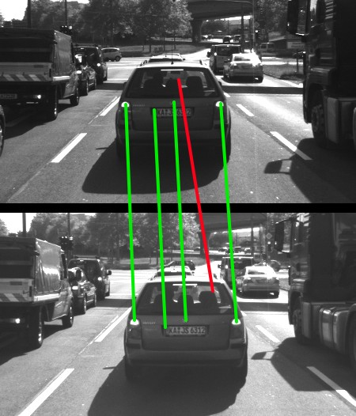

Before we go into details on a powerful class of detector / descriptor combinations (i.e. binary descriptors such as BRISK), let us briefly revisit one of the most famous descriptors of all time - the Scale Invariant Feature Transform. The reason we are doing this is two-fold : First, this method is still relevant and being used in a large number of applications. And second, we need to lay some foundations so that you will be able to better understand and appreciate the contributions of binary descriptors.

**HOG Descriptors and SIFT**

In the following, we will take a brief look at the family of descriptors based on Histograms of Oriented Gradients (HOG). The basic idea behind HOG is to describe the structure of an object by the distribution its intensity gradients in a local neighborhood. To achieve this, an image is divided into cells in which gradients are computed and collected in a histogram. The set of histogram from all cells is then used as a similarity measure to uniquely identify an image patch or object.

One of the best-known examples of the HOG family is the Scale-Invariant Feature Transform (SIFT), introduced in 1999 by David Lowe. The SIFT method includes both a keypoint detector as well as a descriptor and it follows a five-step process, which is briefly outlined in the following.

* First, keypoints are detected in the image using an approach called „Laplacian-Of-Gaussian (LoG)“, which is based on second-degree intensity derivatives. The LoG is applied to various scale levels of the image and tends to detect blobs instead of corners. In addition to a unique scale level, keypoints are also assigned an orientation based on the intensity gradients in a local neighborhood around the keypoint.
* Second, for every keypoint, its surrounding area is transformed by removing the orientation and thus ensuring a canonical orientation. Also, the size of the area is resized to 16 x 16 pixels, providing a normalized patch.

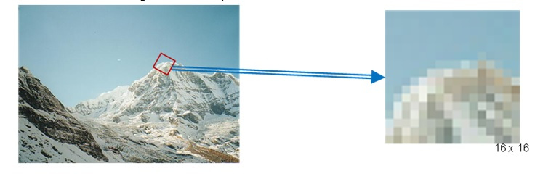

* Third, the orientation and magnitude of each pixel within the normalized patch are computed based on the intensity gradients Ix and Iy.
* Fourth, the normalized patch is divided into a grid of 4 x 4 cells. Within each cell, the orientations of pixels which exceed a threshold on magnitude are collected in a histogram consisting of 8 bins.

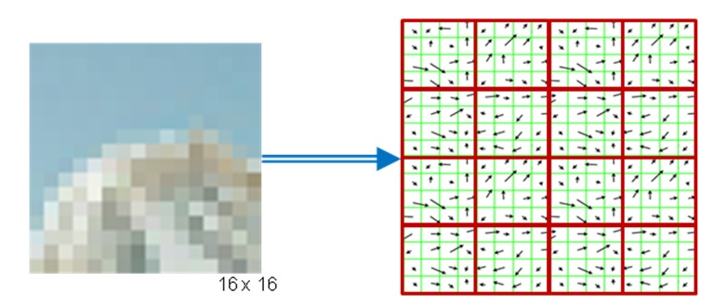

* Last, the 8-bin histograms of all 16 cells are concatenated into a 128-dimensional vector (the descriptor) which is used to uniquely represent the keypoint.

The SIFT detector / descriptor is able to robustly identify objects even among clutter and under partial occlusion. It is invariant to uniform changes in scale, to rotation, to changes in both brightness and contrast and it is even partially invariant to affine distortions.

The downside of SIFT is its low speed, which prevents it from being used in real-time applications on e.g. smartphones. Other members of the HOG family (such as SURF and GLOH), have been optimized for speed. However, they are still too computationally expensive and should not be used in real-time applications. Also, SIFT and SURF are heavily patented, so they can’t be freely used in a commercial context. In order to use SIFT in the OpenCV, you have to *#include <opencv2/xfeatures2d/nonfree.hpp>*, which further emphasizes this issue.

A much faster (and free) alternative to HOG-based methods is the family of binary descriptors, which provide a fast alternative at only slightly worse accuracy and performance. Let us take a look at those in the next section.

**Binary Descriptors and BRISK**

The problem with HOG-based descriptors is that they are based on computing the intensity gradients, which is a very costly operation. Even though there have been some improvements such as SURF, which uses the integral image instead, these methods do not lend themselves to real-time applications on devices with limited processing capabilities (such as smartphones).

The central idea of binary descriptors is to rely solely on the intensity information (i.e. the image itself) and to encode the information around a keypoint in a string of binary numbers, which can be compared very efficiently in the matching step, when corresponding keypoints are searched. Currently, the most popular binary descriptors are BRIEF, BRISK, ORB, FREAK and KAZE (all available in the OpenCV library).

From a high-level perspective, binary descriptors consist of three major parts:

* A sampling pattern which describes where sample points are located around the location of a keypoint.
* A method for orientation compensation, which removes the influence of rotation of the image patch around a keypoint location.
* A method for sample-pair selection, which generates pairs of sample points which are compared against each other with regard to their intensity values. If the first value is larger than the second, we write a '1' into the binary string, otherwise we write a '0'. After performing this for all point pairs in the sampling pattern, a long binary chain (or ‚string‘) is created (hence the family name of this descriptor class).

In the following, the "Binary Robust Invariant Scalable Keypoints (BRISK)" keypoint detector / descriptor is used as a representative for the binary descriptor family. Proposed in 2011 by Stefan Leutenegger et al., BRISK is a FAST-based detector in combination with a binary descriptor created from intensity comparisons retrieved by dedicated sampling of each keypoint neighborhood.

The sampling pattern of BRISK is composed out of a number of sample points (blue), where a concentric ring (red) around each sample point denotes an area where Gaussian smoothing is applied. As opposed to some other binary descriptors such as ORB or BRIEF, the BRISK sampling pattern is fixed. The smoothing is important to avoid aliasing (an effect that causes different signals to become indistinguishable - or aliases of one another - when sampled).

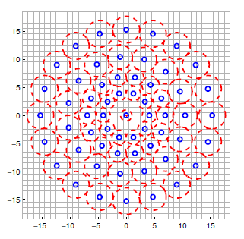

During sample pair selection, the BRISK algorithm differentiates between long- and short-distance pairs. The long-distance pairs (i.e. sample points with a minimal distance between each other on the sample pattern) are used for estimating the orientation of the image patch from intensity gradients, whereas the short-distance pairs are used for the intensity comparisons from which the descriptor string is assembled. Mathematically, the pairs are expressed as follows:

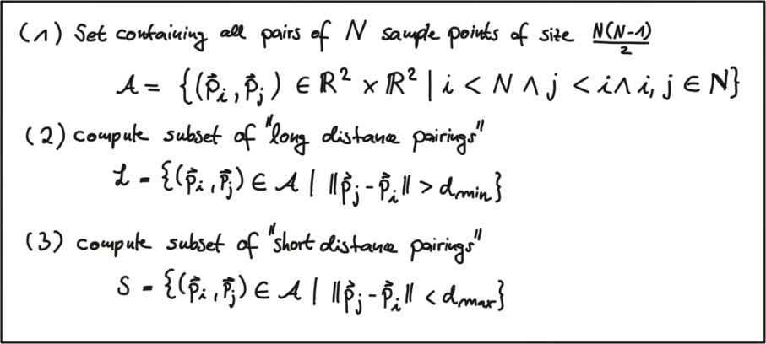

First, we define the set A of all possible pairings of sample points. Then, we extract the subset L from A for which the Euclidean distance is above a pre-defined upper threshold. This set are the long-distance pairs used for orientation estimation. Lastly, we extract those pairs from A whose Euclidean distance is below a lower threshold. This set S contains the short-distance pairs for assembling the binary descriptor string.

The following figure shows the two types of distance pairs on the sampling pattern for short pairs (left) and long pairs (right).

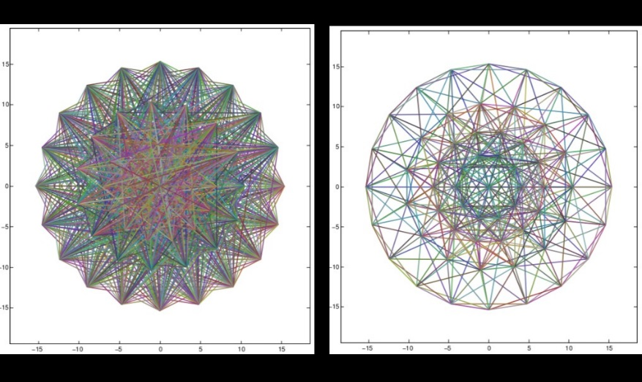

From the long pairs, the keypoint direction vector $\vec{g}$ is computed as follows:

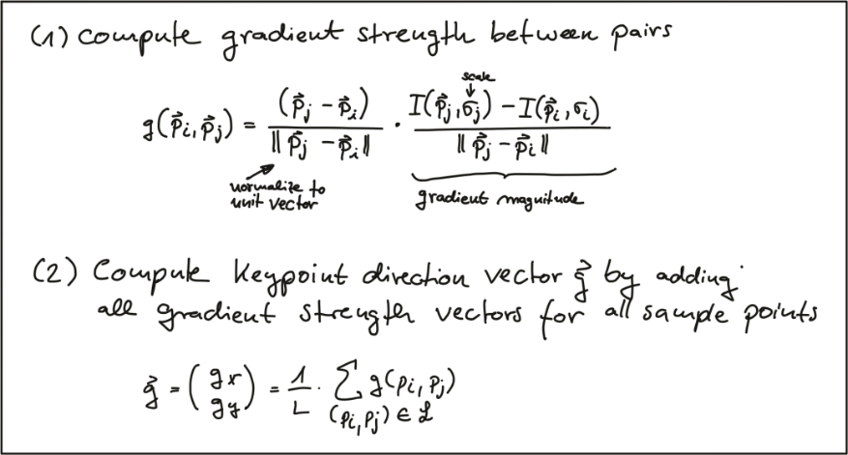

First, the gradient strength between two sample points is computed based on the normalized unit vector that gives the direction between both points multiplied with the intensity difference of both points at their respective scales. In (2), the keypoint direction vector $\vec{g}$ is then computed from the sum of all gradient strengths.

Based on $\vec{g}$, we can use the direction of the sample pattern to rearrange the short-distance pairings and thus ensure rotation invariance. Based on the rotation-invariant short-distance pairings, the final binary descriptor can be constructed as follows:

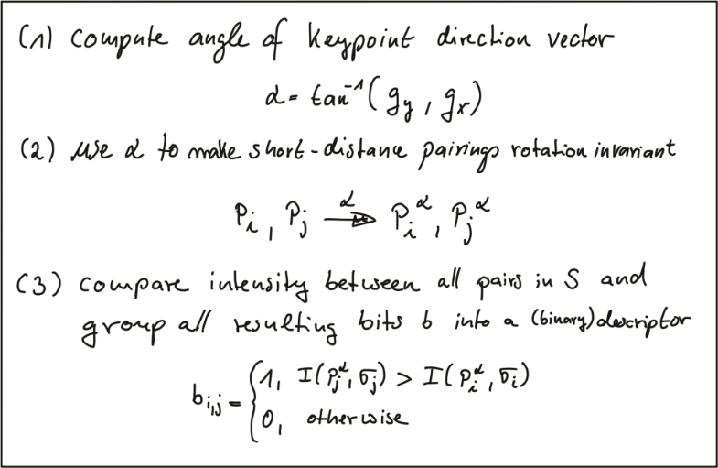

After computing the orientation angle of the keypoint from g, we use it to make the short-distance pairings invariant to rotation. Then, the intensity between all pairs in $S$ is compared and used to assemble the binary descriptor we can use for matching.

**HOG vs. Binary Exercise**

In the code at the end of this section, keypoints and descriptors are computed using the BRISK method. The time for both keypoint detection and descriptor computation is printed to the console. For the BRISK detector, the keypoints can be seen in the following figure with the center of a circle denoting its location and the size of the circle reflecting the characteristic scale.

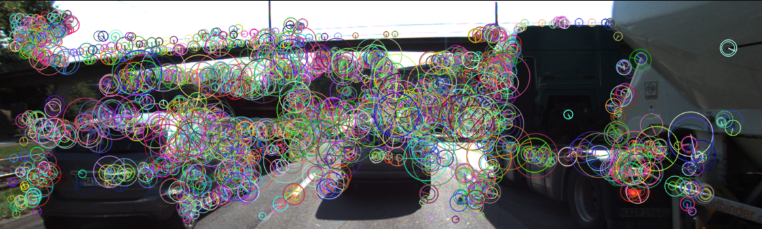

Given the code in describe_keypoints.cpp of the workspace below, add the SIFT detector / descriptor, compute the time for both steps and compare both BRISK and SIFT with regard to processing speed and the number and visual appearance of keypoints.

### Descriptor Matching

**Distance between descriptors**

In the last section, you have learned that keypoints can be described by transforming their local neighborhood into a high-dimensional vector that captures the unique characteristics of the gradient or intensity distribution. In this section, we want to look at several ways to compute the distance between two descriptors such that the differences between them are transformed into a single number which we can use as a simple measure of similarity.

The first distance function is the "Sum of Absolute Differences (SAD)". As you can see in the equation below, the SAD takes as input two descriptor vectors $d_{a}$ and $d_{b}$. The SAD is computed by subtracting from every component in $d_{a}$ the corresponding component at the same position in $d_{b}$. Then, the absolute value of the respective result is summed up. The SAD norm is also referred to as L1-norm in the literature.

The second distance function is the "Sum of Squared Differences (SSD)", which is similar to the SAD in the sense that differences between individual components of two descriptor vectors are computed. However, the key difference between SAD and SSD is that the latter sums the squared differences instead of the absolute differences. In the literature, the SSD norm is also referred to as L2-norm. Both norms are given in the following figure.

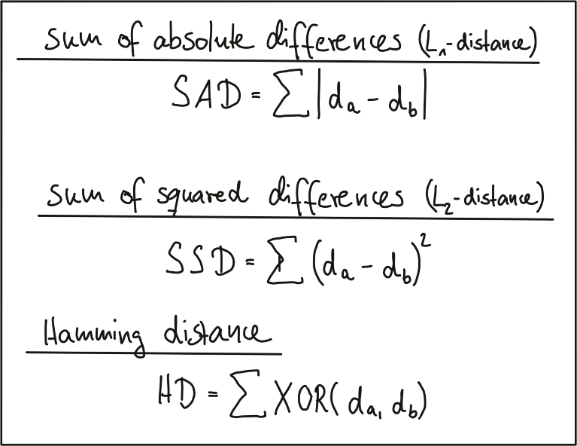

There are several ways of explaining the differences between SAD and SSD. One helpful approach, as we want to keep this aspect short, is to look at both norms from a geometrical perspective. In the following figure, a two-dimensional feature space is considered. In it, there are two feature vectors d1 and d2, each of which consists of an (a,b) coordinate pair.

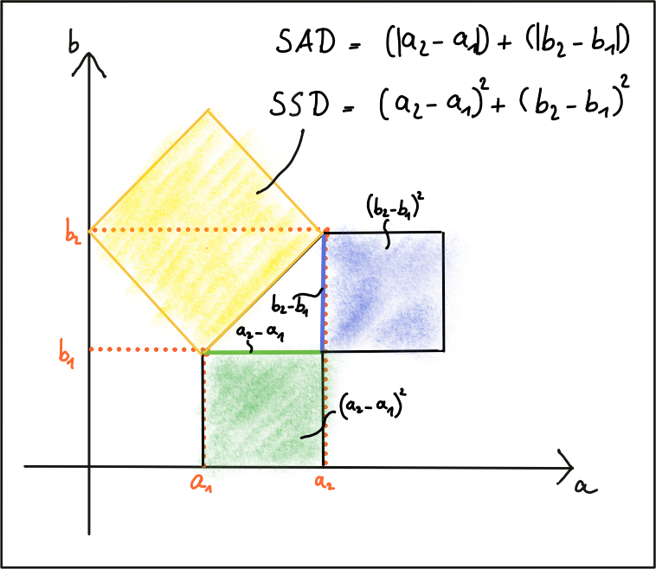

The shortest distance between both is a straight line. Given the two components of each vector, the SAD computes the sum of the length differences, which is a one-dimensional process. The SSD on the other hand, computes the sum of squares, which obeys the law of Pythagoras. This law says that In a rectangular triangle, the sum of the side squares is equal to the square of the hypotenuse. So in terms of the geometric distance between both vectors, the L2-norm is a more accurate measure. Note that the same rationale applies to higher-dimensional descriptors in the same manner.

In the case of a binary descriptor who consists only of ones and zeros, the best (and fastest) measure to use is the Hamming distance, which computes the difference between both vectors by using an XOR function, which returns zero if two bits are identical and one if two bits are different. So the sum of all XOR operations is simply the number of differing bits between both descriptors.

The key takeaway here is that you have to adapt the distance measure to the type of descriptor you are using. In case of gradient-based methods such as SIFT, the L2-norm would be most appropriate. In case of all binary descriptors, the Hamming distance should be used.

**Finding Matches**

Let us assume we have N keypoints and their associated descriptors in one image and M keypoints in another image. The most obvious method to look for corresponding pairs would be to compare all features with each other, i.e. perform N x M comparisons. For a given keypoint from the first image, it takes every keypoint in the second image and calculates the distance. The keypoint with the smallest distance will be considered its pair. This approach is referred to as Brute Force Matching or Nearest Neighbor Matching and is available in the OpenCV under the name BFMatcher. The output of brute force matching in OpenCV is a list of keypoint pairs sorted by the distance of their descriptors under the chosen distance function. Brute force matching works well for small keypoint numbers but can be computationally expensive as the number of keypoints increases.

In 2014, David Lowe (the father of SIFT) and Marius Muja released an open-source library called "fast library for approximate nearest neighbors" (FLANN). FLANN trains an indexing structure for walking through potential matching candidates that is created using concepts from machine learning. The library builds a very efficient data structure (a KD-tree) to search for matching pairs and avoids the exhaustive search of the brute force approach. It is therefore faster while the results are still very good, depending on the matching parameters. As FLANN-based matching entails a whole new body of knowledge with several concepts that have limited relevancy for this course, there is no detailed description of the method given here. The FLANN-based matching is available in the OpenCV and you will see it again in the code example below. At the time of writing (May 2019), there is a potential bug in the current implementation of the OpenCV, which requires a conversion of the binary descriptors into floating point vectors, which is inefficient. Yet still there is an improvement in speed, albeit not as large as it potentially could be.

Both BFMatching and FLANN accept a descriptor distance threshold T which is used to limit the number of matches to the ‚good‘ ones and discard matches where the respective pairs are no correspondences. Corresponding ‚good‘ pairs are termed ‚True Positives (TP)‘ whereas mismatches are called ‚False Positives (FP)‘. The task of selecting a suitable value for T is to allow for as many TP matches as possible while FP matches should be avoided as far as possible. Depending on the image content and on the respective detector / descriptor combination, a trade-off between TP and FP has to be found that reasonably balances the ratio between TP and FP. The following figure shows two distributions of TP and of FP over the SSD to illustrate threshold selection.

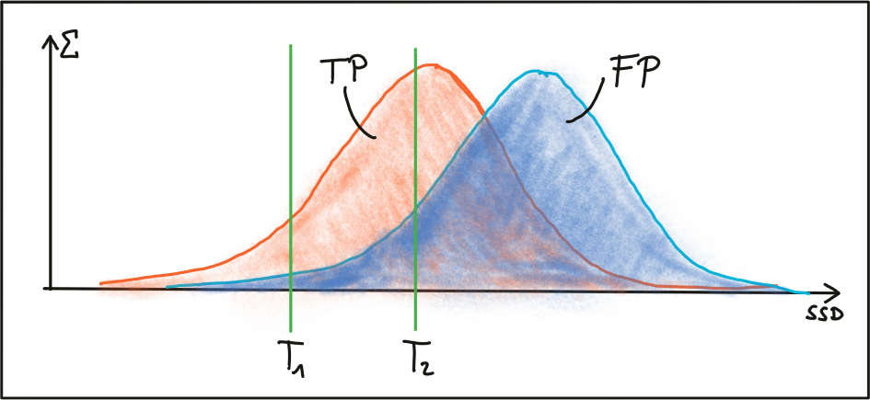

The first threshold T1 is set to a maximally permissible SSD between two features in a way that some true positive matches are selected, while false positive matches are almost entirely avoided . However, most TP matches are also discarded with this setting. By increasing the matching threshold to T2, more TP matches are selected but the number of FP matches also increases significantly. In practice, a clear and concise separation of TP and FP is almost never found and therefore, setting a matching threshold is always a compromise between balancing 'good' vs. 'bad' matches. While FP matches cannot be avoided in most cases, the goal always is to lower their number as much as possible. In the following, two strategies to achieve this are presented.

**Selecting Matches**

As long as the selected threshold T is not exceeded, brute force matching will always return a match for a keypoint in the first image, even if the keypoint is not present in the second image. This inevitably leads to a number of false matches. A strategy to counteract this is called cross check matching, which works by applying the matching procedure in both directions and keeping only those matches whose best match in one direction equals the best match in the other direction. The steps of the cross check approach are:s

* For each descriptor in the source image, find one or more best matches in the reference image.
* Switch the order of source and reference image.
* Repeat the matching procedure between source and reference image from step 1.
* Select those keypoint pairs whose descriptors are best matches in both directions.
* Although cross check matching increases the processing time, it usually removes a significant number of false matches and should thus always be performed when accuracy is preferred over speed.

A very efficient way of lowering the number of false positives is to compute the nearest neighbor distance ratio for each keypoint. This method has been originally proposed by D. Lowe in the 1999 paper on SIFT. The main idea is to not apply the threshold on the SSD directly. Instead, for each keypoint in the source image, the two best matches are located in the reference image and the ratio between the descriptor distances is computed. Then, a threshold is applied to the ratio to sort out ambiguous matches. The figure below illustrates the principle.

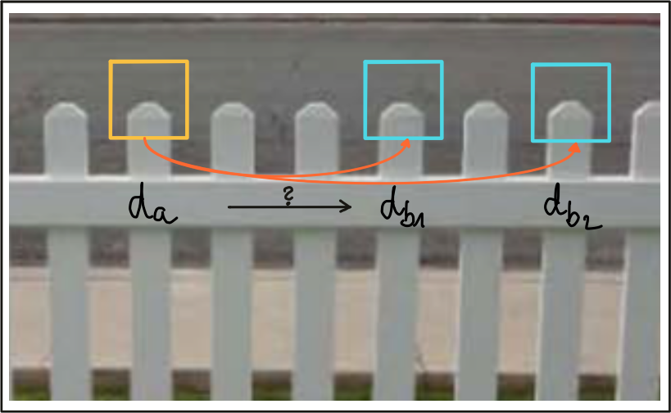

In the example, an image patch with an associated descriptor da is compared to two other image patches with descriptors $d_{b_{1}}$ and $d_{b_{2}}$. As can be seen, the patches look very similar and would result in ambiguous and thus unreliable matches. By computing the SSD ratio between best and second-best match, such weak candidates can be filtered out.

In practice, a threshold value of 0.8 has proven to provide a good balance between TP and FP. In the image sequences examined in the original SIFT paper, 90% of the false matches were eliminated with this setting while less than 5% of correct matches were lost.

**Exercise: Distance between descriptors**

In the following code example, a set of binary BRISK descriptors is pre-loaded and matched using the brute force approach described earlier in this section. Note that the number of matches has been limited to the 100 best candidates for educational purposes, as it is much easier to visually spot mismatches when drawing a reduced number of keypoint pairs as an overlay. Note that once the matches have been computed, the function can be set to either nearest-neighbor (keeping only the best match) or k-nearest-neighbor selection (keeping the best k matches per keypoint).

Before we take a look at how to estimate the performance of keypoints and descriptors further down below in this section, please complete the following tasks using the desktop workspace below:

* Load the 'BRISK_small' dataset with cross-check first turned off, then on. Look at the visualized keypoint matches and at the number of matched pairs and describe your results.
* Add the k-nearest-neighbor matching (using cv::knnMatch) with k=2 and implement the above-described descriptor distance ratio to filter out ambiguous matches with the threshold set to 0.8. Visualize the results, count the percentage of discarded matches (for both the 'BRISK_small' and the 'BRISK_large' dataset) and describe your observations.
* Use both BF matching and FLANN matching on the 'BRISK_large' dataset and on the SIFT dataset and describe your observations.

**Evaluating Matching Performance**

There exists a large number of detector and descriptor types and based on the problem to be solved, a suitable pair of algorithms has to be chosen based on requirements such as the accuracy of keypoints or the number of matched pairs. In the following, an overview of the most common measures is presented.

The True Positive Rate (TPR) is the ratio between keypoints that have been matched correctly (true positives - TP) and the sum of all potential matches, including ones missed by the detector/descriptor (false negatives - FN). A perfect matcher would have a TPR of 1.0 as there would be no false matches. In the literature, the TPR is also referred to as recall and can be used to quantify how many of the possible correct matches were actually found.

The False Positive Rate (FPR) is the ratio between keypoints that have been incorrectly matched (false positives - FP) and the sum of all features that should have been without a match. A perfect matcher would have a FPR of 0.0. The FPR is also referred to as false alarm rate and describes how likely it is that a detector / descriptor selects a wrong keypoint pair.

The Precision of a matcher is the number of correctly matched keypoints (TP) divided by the number of all matches. This measure is also referred to as inlier ratio.

The following table gives an overview of some of the measures just introduced.

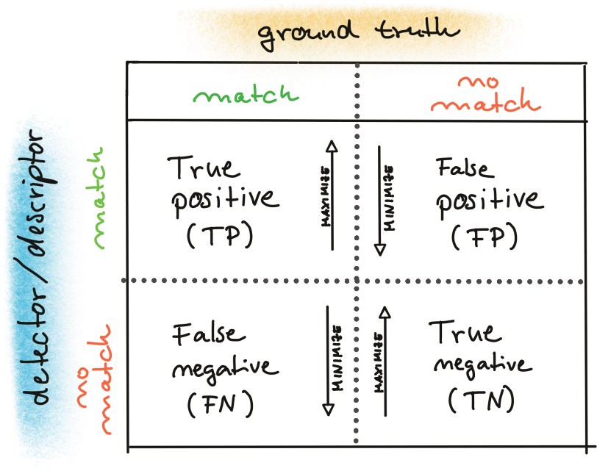

In order to decide whether a match or non-match is correct, ground-truth information of the image material used for assessment is needed. In many publications, image sequences have been used where all keypoints are located on a planar surface. In such a case, a model-based estimation can be used to differentiate between TP / TN and FP / FN. For the image sequences we use in this course, this approach can not be used as "our" keypoints are distributed in a complex three-dimensional scene, in which the objects move dynamically with unknown motion parameters. However, we can use a large number of available comparisons in the literature and transfer the results to our application scenario. At the end of this section, a small selection of such results is shown.

The Receiver Operating Characteristic (ROC) is a graphical plot that shows how well a detector / descriptor is able to differentiate between true and false matches as its discrimination threshold is varied. The ROC can be used to visually compare different detectors / descriptors and also select a suitable discrimination threshold for each. The name ROC dates back to WW II, where the method has been introduced by radar operators in the context of identifying enemy targets.

The following figure shows how the ROC is constructed from the distribution of true positives and false positives by varying the discrimination threshold on the SSD. An ideal detector / descriptor would have a TPR of 1.0 while the FPR would be close to 0.0 at the same time.

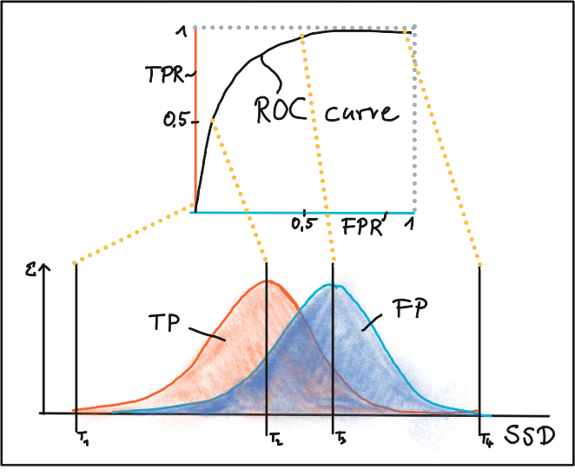

In the following figure, two examples for good and bad detectors / descriptors are shown. In the first example, there is no way of safely differentiating between TP and FP as both curves match and changes in the discrimination threshold would affect them in the same way. In the second example, the TP and FP curve do not overlap significantly and therefore, a suitable discriminator threshold can be selected.

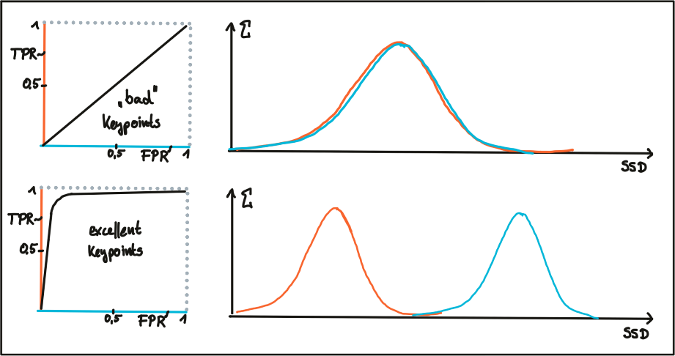

There are several other ways of assessing detectors and descriptors such as the Precision-Recall Curve which we will not discuss in this course in order to stay focused on the task ahead - which is the development of our collision avoidance system.

To conclude this section, an overview of results is given, where several descriptors have been compared against each other and which can be used to facilitate the selection process when detectors / descriptors have to be chosen for an application. In the graph, you can see the ROC curves of different descriptors such as SIFT, BRISK and several others and visually compare them against each other. Note that those results are only valid for the image sequences actually used for the comparison - for a different image set, e.g. a traffic scene, results may vary significantly.



## Camera Based 2D Feature Tracking

### Mid-Term Project Introduction

**Code Walkthrough**

The next video is a detailed walkthrough of the source code for the project. You can find the Github Repo for the code [here](https://github.com/udacity/SFND_2D_Feature_Tracking) to follow along, or you can find the project code in the workspace at the end of this lesson.

### The Data Buffer

**TASK MP.1**

Your first task is to set up the loading procedure for the images, which is currently not optimal. In the student version of the code, we push all images into a vector inside a for-loop and with every new image, the data structure grows. Now imagine you want to process a large image sequence with several thousand images and Lidar point clouds over night - in the current implementation this would push the memory of your computer to its limit and eventually slow down the entire program. So in order to prevent this, we only want to hold a certain number of images in memory so that when a new one arrives, the oldest one is deleted from one end of the vector and the new one is added to the other end. The following figure illustrates the principle.

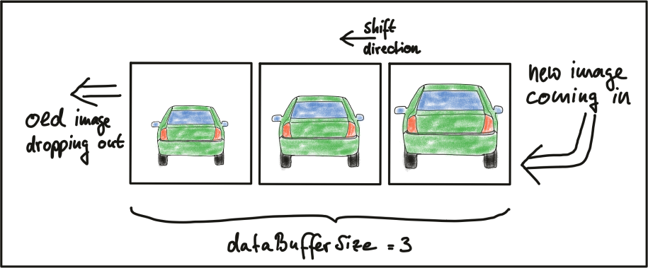

Please replace the code in section 'TASK MP.1' with an implementation of this principle.

### Keypoint Detection

**TASK MP.2**

Your second task is to focus on keypoint detection. In the student version of the code you will find an existing implementation of the Shi-Tomasi detector. Please implement a selection of alternative detectors, which are HARRIS, FAST, BRISK, ORB, AKAZE, and SIFT. The following figure shows keypoints detected with the SIFT method.

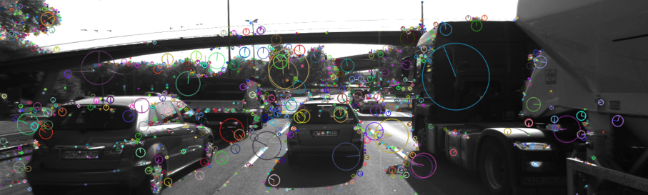

The Harris detector is already familiar to you from a previous exercise and the other methods are available in the OpenCV. Also, please adjust the project code in a way that each detector can be selected by setting the string 'detectorType' to the respective name. Please note that all detectors should be added to the file 'matching2D_student.cpp'. Take a look at the header file 'matching2D.hpp' for details on the call parameters for the functions you need to implement.

**TASK MP.3**

In a later part of the mid-term project, you will be evaluating the various detectors and descriptors with regard to a set of performance metrics. As we are focusing on a collision detection system in this course, keypoints on the preceding vehicle are of special interest to us. Therefore, in order to enable a more targeted evaluation, we want to discard feature points that are not located on the preceding vehicle.

Your third task therefore is to remove all keypoints outside of a bounding box around the preceding vehicle. Box parameters you should use are : cx = 535, cy = 180, w = 180, h = 150.

Please note that this cropping of feature points should only be used for evaluation purposes in the mid-term project. For later sections of this course, especially in the final project, please disable keypoint cropping using this method. Also, there will be keypoints within the box that are e.g. on the road surface or on other vehicles. Please keep an eye on their number in relation to keypoints on the actual vehicle and discuss this later in the evaluation part of the mid-term project.

### Descriptor Extraction and Matching

**TASK MP.4**

Your fourth task is to implement a variety of keypoint descriptors to the already implemented BRISK method and make them selectable using the string 'descriptorType'. The methods you must integrate are BRIEF, ORB, FREAK, AKAZE and SIFT.

**TASK MP.5**

Your fifth task will focus on the matching part. The current implementation uses Brute Force matching combined with Nearest-Neighbor selection. You must now add FLANN as an alternative to brute-force as well as the K-Nearest-Neighbor approach.

**TASK MP.6**

As your sixth task, you will then implement the descriptor distance ratio test as a filtering method to remove bad keypoint matches.

### Performance Evaluation

In this last part of the mid-term project you will document speed and number of matched keypoints for all detector / descriptor combinations with a focus on the preceding vehicle over a sequence of ten images.

**TASK MP.7**

Your seventh task is to count the number of keypoints on the preceding vehicle for all 10 images and take note of the distribution of their neighborhood size. Do this for all the detectors you have implemented.

**TASK MP.8**

Your eighth task is to count the number of matched keypoints for all 10 images using all possible combinations of detectors and descriptors. In the matching step, use the BF approach with the descriptor distance ratio set to 0.8.

**TASK MP.9**

Your ninth task is to log the time it takes for keypoint detection and descriptor extraction. The results must be entered into a spreadsheet and based on this information you will then suggest the TOP3 detector / descriptor combinations as the best choice for our purpose of detecting keypoints on vehicles. Finally, in a short text, please justify your recommendation based on your observations and on the data you collected.

## Combing Camera and Lidar

### Lidar to Camera Point Projection

**Displaying and Cropping Lidar Points**

In this section, we will load a set of Lidar points from file and display it from a top view perspective. Also, we will manually remove points that are located in the road surface. This is an important step which is needed to correctly compute the time-to-collision in the final project. The Lidar points have been obtained using a Velodyne HDL-64E sensor spinning at a frequency of 10Hz and capturing approximately 100k points per cycle. Further information on the KITTI sensor setup can be found here : <http://www.cvlibs.net/datasets/kitti/setup.php>

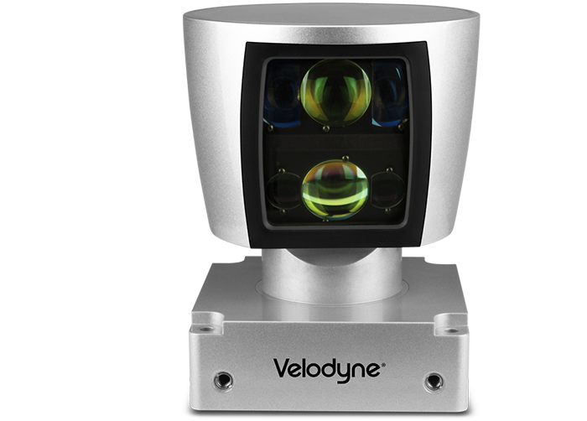

As will be detailed later, the Velodyne sensor has been synchronized with a forward-looking camera, which, at the time of capturing the Lidar data used in this section, was showing the following (by now very familiar) scene.

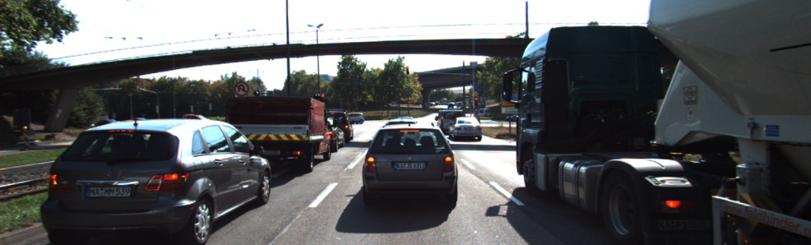

The Lidar points corresponding to the scene are displayed in the following figure, together with the Velodyne coordinate system and a set of distance markers. While the top view image has been cropped at 20m, the farthest point for this scene in the original dataset is at ~78m.

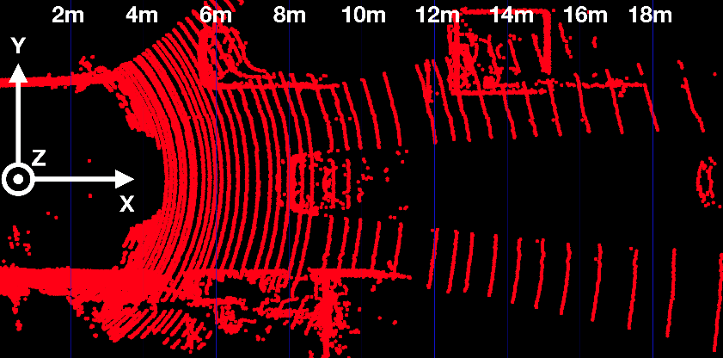

**Exercise**

The following code in show_lidar_top_view.cpp loads and displays the Lidar points in a top view perspective. When you run the code example, you will see that all Lidar points are displayed, including the ones on the road surface. Please complete the following exercises before continuing:

* Change the color of the Lidar points such that X=0.0m corresponds to red while X=20.0m is shown as green with a gradual transition in between. The output of the Lidar point cloud should look like this:

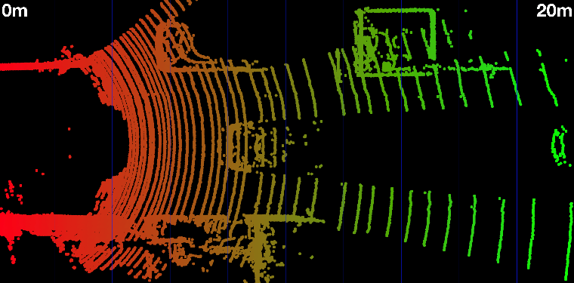

* Remove all Lidar points on the road surface while preserving measurements on the obstacles in the scene. Your final result should look something like this:

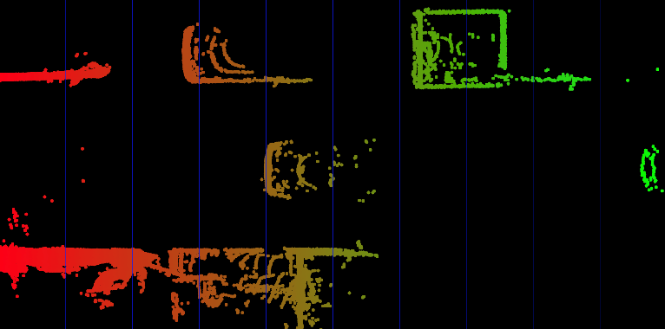

Now that we can display Lidar data as 3D points in the sensor coordinate system, let us move on to the next section, where we want to start working on a way to project these points into the camera image.

**Homogeneous Coordinates**

In this section, our goal is to project points from 3D space onto the image plane. In order to do this, we can use the equations discussed in lesson 1 of this course:

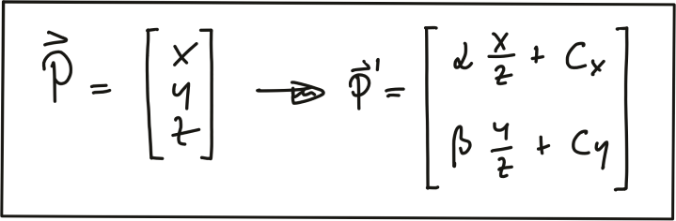

In addition to the intrinsic camera parameters which make up the geometry of the projection, we need additional information about the position and alignment of both camera and Lidar in a common reference coordinate system. To move from Lidar to camera involves translation and rotation operations, which we need to apply to every 3D point. So our goal here is to simplify the notation with which we can express the projection. Using a linear transformation (or mapping), 3D points could be represented by a vector and operations such as translation, rotation, scaling and perspective projection could be represented as matrices by which the vector is multiplied. The problem with the projection equations we have so far is that they involve a division by Z, which makes them non-linear and thus prevents us from transforming them into the much more convenient matrix-vector form.

A way to avoid this problem is to change the coordinate system and go from the original Euclidean coordinate system to a form called the Homogenous coordinate system. Moving back and forth between both coordinate systems is a non-linear operation, but once we are in the homogenous coordinate system, projective transformations such as the one given above become linear and can thus be expressed as simple matrix-vector multiplications. Transformations between both coordinate systems work as shown in the following figure.

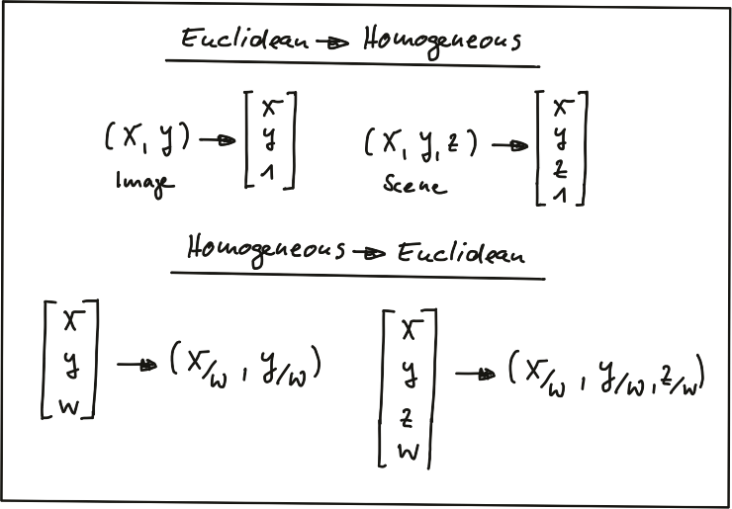

A point in the n-dimensional Euclidian coordinate system is represented by a vector with n components. The transformation into (n+1)-dimensional homogeneous coordinates can be achieved by simply adding the number 1 as an additional component. The transformation can be applied to both image coordinates as well as scene coordinates.

Converting back from homogeneous coordinates to Euclidean then works by suppressing the last coordinate and dividing the first n coordinates by the (n+1)-th coordinate as shown in the figure above. As discussed earlier in this section, this is a non-linear operation and once we are back in Euclidean space, the neat separation of the different parameters into individual matrix components is lost. In the following, we will take a look at those matrix components.

**Intrinsic Parameters**

Now we are ready to express the projection equations in matrix-vector form:

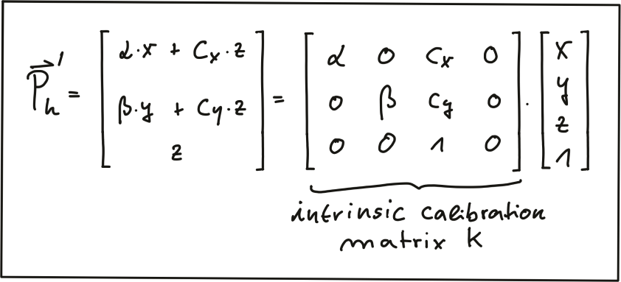

As can be seen, the camera parameters are arranged in a matrix, which conveniently expresses the properties of our pinhole camera model in a compact way. Additional properties of a more complex camera model such as skewness or shear can easily be added. The following video animation shows the effect of the individual intrinsic parameters of the camera on the appearance of objects on the image plane. [source: <http://ksimek.github.io/2013/08/13/intrinsic>]

**Extrinsic Parameters**

The mapping between a point P in 3D space to a point P’ in the 2D image plane has so far been described in the camera coordinate system with the pinhole as its center . But what if the information we have about points in 3D (or in general about any physical object) is available in another coordinate system, such as the vehicle coordinate system common in many automotive applications? As shown in the figure below, the origin of the vehicle coordinate system is placed directly on the ground below the midpoint of the rear axle with the x-axis pointing into driving direction. In addition to the axis naming convention, the figure also shows the typically used names for rotation around X, Y and Z which are 'roll', 'pitch' and 'yaw'.

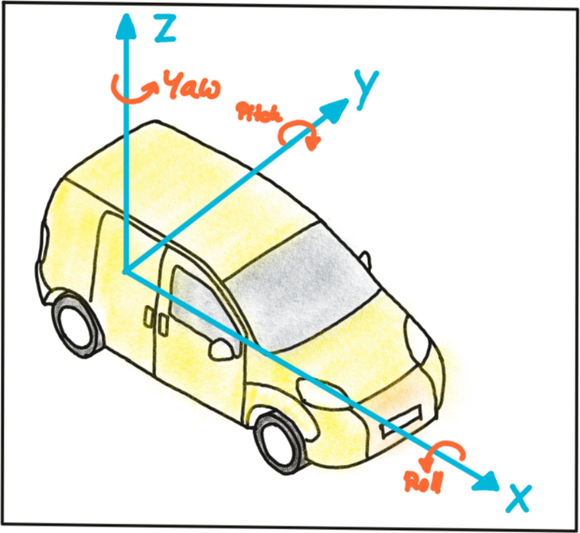

Let us assume the vehicle were equipped with a Lidar sensor and a camera, who would both be calibrated in the vehicle coordinate system. In order to project points measured in the Lidar sensor coordinate system into the camera, we need to add an additional transformation to our mapping operation that allows us to relate points from the vehicle coordinate system to the camera coordinate system and vice versa. Generally, such a mapping operation can be broken down into three components: translation, rotation and scaling. Let’s look at each of them in turn:

*Translation* : As seen in the following figure, translation describes the linear shift of a point $\vec{P}$ to a new location $\vec{P^{'}}$ by adding the components of a translation vector $\vec{t}$ to the components of $\vec{P}$.

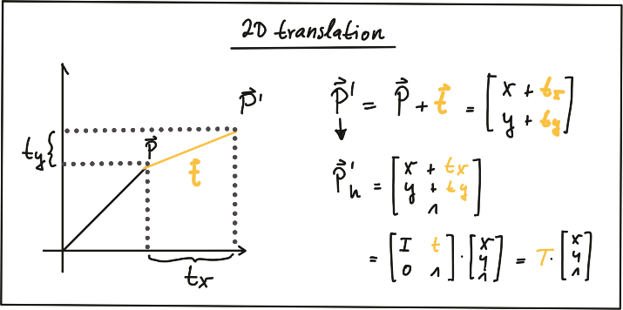

In homogeneous coordinates, this can be expressed by concatenating an identity matrix $I$ of size $N$ (where span class="mathquill">N is the number of components in $\vec{P}$) and the translation vector $\vec{t}$. The translation operation then becomes a simple matrix-vector multiplication as shown in the figure above.

*Scale* : While translation involves adding a translation vector $\vec{t}$ to the components of $\vec{P}$, scaling works by multiplying the components with a scale vector $\vec{s}$ instead. In homogeneous coordinates, this can be expressed as a matrix-vector multiplication as seen in the figure below.

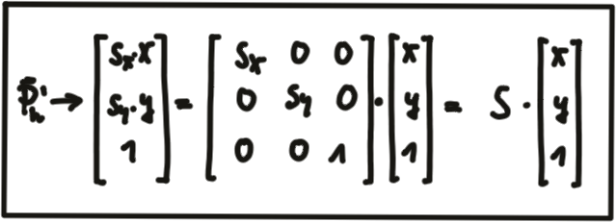

*Rotation* : A point $\vec{P^{'}}$ is rotated in counter-clockwise direction (mathematically positive) by using the following equations for $x$ and $y$.

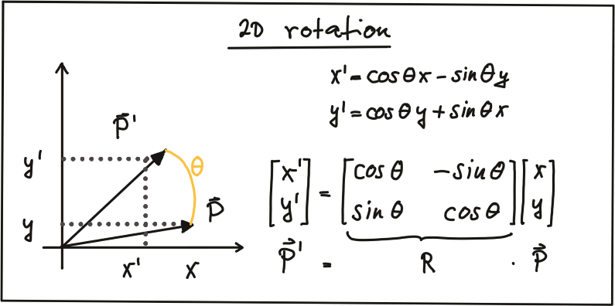

As before, the operation can be expressed as a matrix-vector multiplication with $R$ being called the 'rotation matrix‘. In 3D space, a point $P$ can be rotated around all three axes using the following rotation matrices:

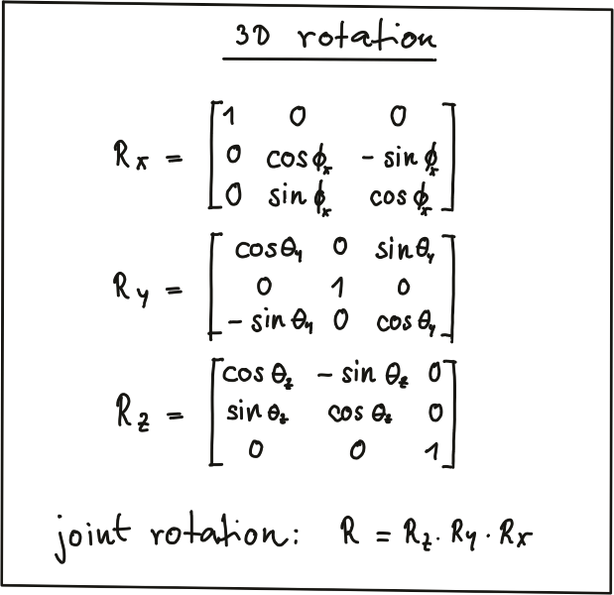

Note that the three individual rotations can be combined into a joint rotation matrix R by successive application in the order $R=R_{z}*R_{y}*R_{x}$.

One of the advantages of homogeneous coordinates is that they allow for an easy combination of multiple transformations by concatenating several matrix-vector multiplications.

The combined matrix consisting of $R$ and $\vec{t}$ is also referred to as the extrinsic matrix, as it models how points are transformed between coordinate system. Once a point in the Lidar coordinate system has been expressed in camera coordinates, we need to project it onto the image plane. For this purpose, we need to additionally integrate the intrinsic parameters discussed above. With homogeneous coordinates, we can simply do this by concatenating the individual matrices in the following manner:

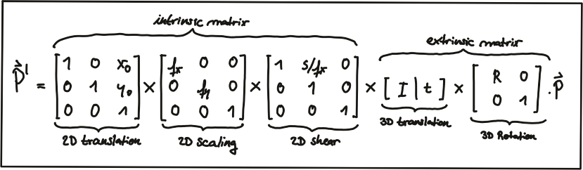

Note that the scale component has been integrated into the intrinsic matrix KK (with the focal length being the relevant parameter) and is no longer part of the extrinsic matrix. In the following video, the influence of the extrinsic parameters on the appearance of an object on the image plane is simulated. [source: <http://ksimek.github.io/perspective_camera_toy.html>]

**Overview of the KITTI sensor setup**

Now that we have an understanding of how points in 3D space can be projected onto the image plane of a camera, let us take a look at the sensor setup of the KITTI vehicle that was used to generate the data sequences. In the following figure, the vehicle is shown, equipped with two forward-facing cameras, a roof-mounted Velodyne Lidar as well as an inertial measurement unit or IMU (which we will not be using in this course).

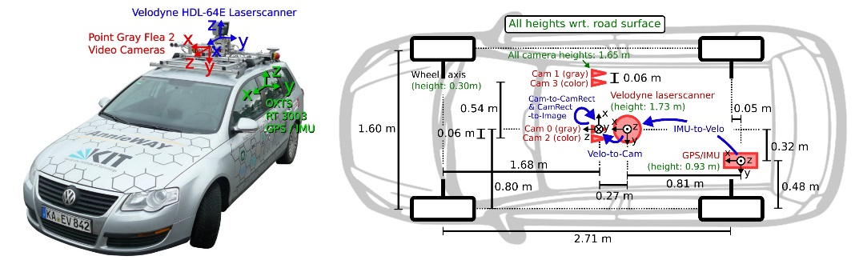

For all datasets, calibration files with intrinsic and extrinsic parameters are available once you download them from the KITTI website. In the following, the content of the file "calib_velo_to_cam.txt“ is shown, which relates the Velodyne sensor and the left camera of the stereo rig (valid for the highway sequence we are using):

*calib_time: 15-Mar-2012 11:37:16*

*R: 7.533745e-03 -9.999714e-01 -6.166020e-04 1.480249e-02 7.280733e-04 -9.998902e-01 9.998621e-01 7.523790e-03 1.480755e-02*

*T: -4.069766e-03 -7.631618e-02 -2.717806e-01*

*…*

The matrices R and T provide us with the extrinsic parameters of the sensor setup. As we know, we also need information about the intrinsic parameters in order to perform the projection. These are stored in the file "calib_cam_to_cam.txt", which is given as an excerpt in the following:

*calib_time: 09-Jan-2012 13:57:47*

*…*

*R_rect_00: 9.999239e-01 9.837760e-03 -7.445048e-03 -9.869795e-03 9.999421e-01 -4.278459e-03 7.402527e-03 4.351614e-03 9.999631e-01*

*P_rect_00: 7.215377e+02 0.000000e+00 6.095593e+02 0.000000e+00 0.000000e+00 7.215377e+02 1.728540e+02 0.000000e+00 0.000000e+00 0.000000e+00 1.000000e+00 0.000000e+00*

*…*

The matrix *R_rect_00* is the 3x3 rectifying rotation to make image planes co-planar, i.e. to align both cameras of the stereo rig (there are two Point Gray cameras in the KITTI vehicle) in a way that one row of pixels in the left camera directly corresponds to another row of pixels in the right camera (as opposed to a slanted line crossing over the image plane). As we are focussing on the mono camera here, we did not go into details on the underlying concepts - but If you want to learn more about this, research "epipolar geometry". The matrix P_rect_00 contains the intrinsic camera parameters as discussed above (we called it K). The following equation shows how to project a 3D Lidar point X in space to a 2D image point Y (using the notation in the Kitti readme file) on the image plane of the left camera using homogeneous coordinates:



**Exercise: Projecting Lidar Points into the Camera**

In the code sample in project_lidar_to_camera.cpp of the workspace above, a framework for projecting Lidar points has been prepared. Please use your new knowledge to complete the following exercises:

* In the loop over all Lidar points, convert each 3D point into homogeneous coordinates and store it in a 4D variable X.
* Then, apply the projection equation as detailed in lesson 5.1 to map X onto the image plane of the camera. Store the result in Y.
* Once this is done, transform Y back into Euclidean coordinates and store the result in the variable pt.

Once you have completed all three steps, the output of the code sample should look like the figure below.

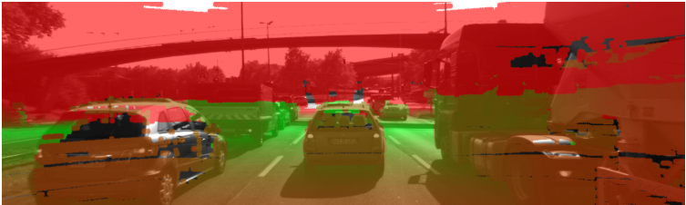

Cleary, something is not working here. The idea of coloring the individual pixels was that red should represent close 3D points while green should be used for far-away points. The image looks good up until the horizon is reached. The bright red sky is not correct though. So let’s take a look at what is wrong here.

**Filtering Lidar Points**

Earlier on in this section, you learned how to convert the Lidar point cloud into a top view perspective. The conversion process implicitly assumed that we would only be interested in points directly in front of the vehicle. In the code, the following lines show how the conversion into the top view image was performed: 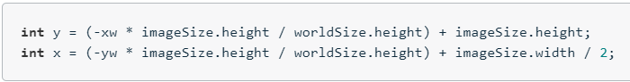

As you now know, the Velodyne Lidar is roof-mounted and spins in a 360° circle at 10 Hz. That means, it also measures 3D points behind the vehicle facing away from the camera. Those points are also contained in the data set but they do not show up in the top view image. But when projected into the camera, they produce a valid image plane coordinate, even though they are not visible to the camera (the projecting line intersects the image plane from behind). The associated Lidar points have a negative x-coordinate which causes the respective pixel color to appear in red on the image plane. So in order to avoid this from happening, let’s take a look at some filtering options we have to thin out the point cloud.

The code below shows how a filter can be applied to remove Lidar points that do not satisfy a set of constraints, i.e. they are:

* positioned behind the Lidar sensor and thus have a negative x coordinate.
* too far away in x-direction and thus exceeding an upper distance limit.
* too far off to the sides in y-direction and thus not relevant for collision detection
* too close to the road surface in negative z-direction.
* showing a reflectivity close to zero, which might indicate low reliability.

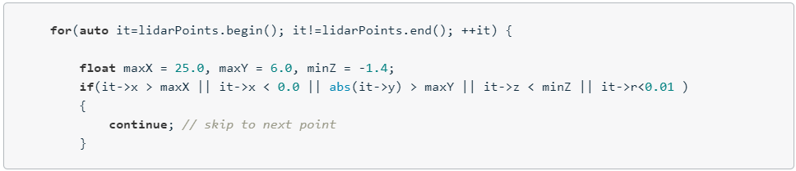

After applying these filters to the Lidar point cloud, the resulting overlay image shows a significantly reduced number of points. From the perspective of collision detection, measurement quality is of highest importance and the filtering step, aside from increasing the processing speed further down the pipeline, can help improve reliability. Try this now in your project_lidar_to_camera.cpp file in the workspace above!

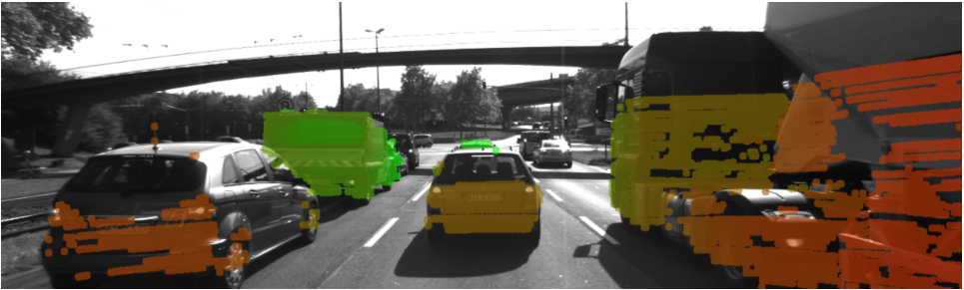

### Object Detection with YOLO

**Why Object Detection**

As mentioned in the introductory video, we need a way to detect vehicles in our images so that we can isolate matched keypoints as well as projected Lidar points and associate them to a specific object. Let us take a look at the program flow schematic we already discussed in the lesson on engineering a collision detection system.

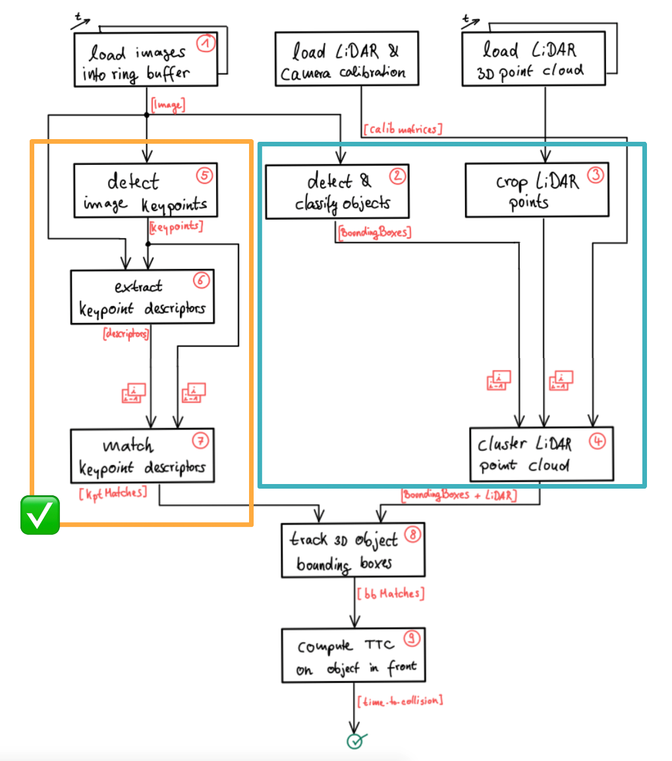

Based on what you learned in the previous lesson, you are now able to detect and match keypoints using a variety of detectors and descriptors. In order to compute the time-to-collision for a specific vehicle however, we need to isolate the keypoints on that vehicle so that TTC estimation is not distorted due to the inclusion of matches on e.g. the road surface, stationary objects or other vehicles in the scene. One way to achieve this is to automatically identify the vehicles in the scene using object detection. The output of such an algorithm would (ideally) be a set of 2D bounding boxes around all objects in the scene. Based on these bounding boxes, we could then easily associate keypoint matches to objects and achieve a stable TTC estimate.

For the Lidar measurements, the same rationale can be applied. As you have learned in the previous course on Lidar, you already know that 3D points can be successfully clustered into individual objects, e.g. by using algorithms from the Point Cloud Library (PCL), which can be seen as an equivalent to the OpenCV library for 3D applications. In this section, let us look at yet another approach to group Lidar points into objects. Based on what you learned in the previous section, you now know how to project Lidar points onto the image plane. Given a set of bounding boxes from object detection, we could thus easily associate a 3D Lidar point to a specific object in a scene by simply checking whether it is enclosed by a bounding box when projected into the camera.

We will look in detail at both of the described approaches later in this section but for now, let us look at a way to detect objects in camera images - which is a prerequisite for grouping keypoint matches as well as Lidar points. in the schematic shown above, the content of the current lesson is highlighted by a blue rectangle and in this section we will be focusing on 'detecting & classifying objects‘.

**Introduction into YOLO**

The aim of this section is to enable you to quickly leverage a powerful and state-of-the-art tool for object detection. It is not the purpose to perform a theoretical deep-dive into the inner workings of such algorithms, but rather you should be enabled to integrate object detection into the code framework of this course quickly and seamlessly. The following image shows the an example output of the code we will be developing in this section.

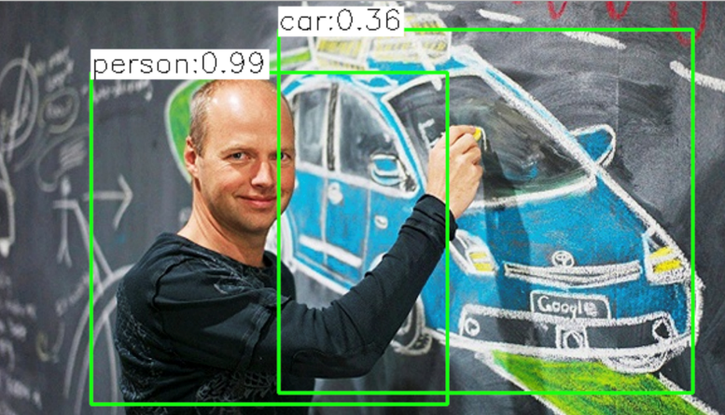

In the past, methods for object detection were often based on histograms of oriented gradients (HOG) and support vector machines (SVM). Until the advent of deep-learning, the HOG/SVM approach was long considered the state-of-the-art approach to detection. While the results of HOG/SVM are still acceptable for a large variety of problems, its use on platforms with limited processing speed is limited. As with SIFT, one of the major issues is the methods reliance on the intensity gradient - which is a costly operation.

Another approach to object detection is the use of deep-learning frameworks such as TensorFlow or Caffe. However, the learning curve for both is very steep and would warrant an entire course on its own. An easy-to-use alternative that works right out of the box and is also based on similar underlying concepts is YOLO, a very fast detection framework that is shipped with the OpenCV library. Developed by Joseph Redmon, Santosh Divvala, Ross Girshick, and Ali Farhadi at Cornell University, YOLO uses a different approach than most other methods: Here, a single neural network is applied to the full image. This network divides the image into regions and predicts bounding boxes and probabilities for each region. These bounding boxes are weighted by the predicted probabilities. The following figure illustrates the principle:

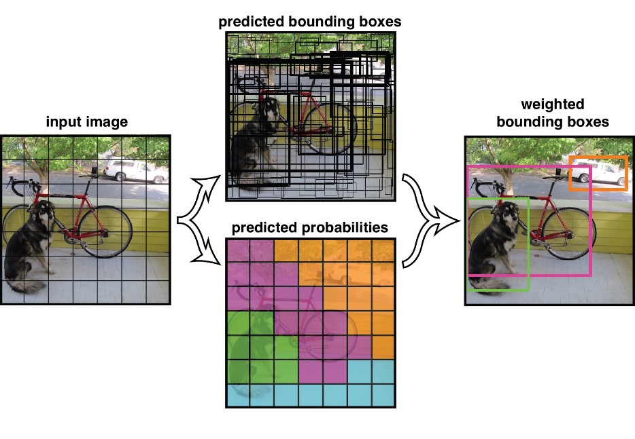

Other than classifier-based systems such as HOG/SVM, YOLO looks at the whole image so its predictions are informed by global context in the image. It also makes predictions with a single network pass unlike systems like R-CNN which require thousands of passes for a single image. This makes it extremely fast while at the same time generating similar results as other state-of-the-art methods such as the Single Shot MultiBox Detector (SSD).

The makers of YOLO have also made available a set of pre-trained weights that enable the current version YOLOv3 to recognize 80 different objects in images and videos based on COCO (http://cocodataset.org/#home) , which is a is large-scale object detection, segmentation, and captioning dataset. In the context of this course this means, that we can use YOLOv3 as an out-of-the-box classifier which is able to detect vehicles (and many other obstacles) with reasonable accuracy.

**The YOLOv3 Workflow**

In this section, we will take a look at the different steps involved to execute YOLO on the course image set. The parameters used below are mainly the ones suggested by the authors. In the following, a short overview of the main algorithmic steps is given:

* First, the image is divided into a 13x13 grid of cells. Based on the size of the input image, the size of these cells in pixels varies. In the code below, a size of 416 x 416 pixels was used, leading to a cell size of 32 x 32 pixels.
* As seen in the schematic above, each cell is then used for predicting a set of bounding boxes. For each bounding box, the network also predicts the confidence that the bounding box encloses a particular object as well as the probability of the object belonging to a particular class (taken from the COCO dataset).
* Lastly, a non-maximum suppression is used to eliminate bounding boxes with a low confidence level as well as redundant bounding boxes enclosing the same object.

In the following, the main workflow as well as the respective code is presented.

Step 1: Initialize the Parameters

Every bounding box predicted by YOLOv3 is associated with a confidence score. The parameter 'confThreshold' is used to remove all bounding boxes with a lower score value.

Then, a non-maximum suppression is applied to the remaining bounding boxes. The NMS procedure is controlled by the parameter ‚nmsThreshold‘.

The size of the input image is controlled by the parameters ‚inpWidth‘ and ‚inpHeight‘, which is set to 416 as proposed by the YOLO authors. Other values could e.g. be 320 (faster) or 608 (more accurate).

Step 2: Prepare the Model

The file 'yolov3.weights' contains the pre-trained network’s weights and has been made available by the authors of YOLO [here](https://pjreddie.com/media/files/yolov3.weights).

The file 'yolov3.cfg' containing the network configuration is available [here](https://github.com/pjreddie/darknet/blob/master/cfg/yolov3.cfg) and the coco.names file which contains the 80 different class names used in the COCO dataset can be downloaded [here](https://github.com/pjreddie/darknet/blob/master/data/coco.names).

The following code shows how to load the model weights as well as the associated model configuration:

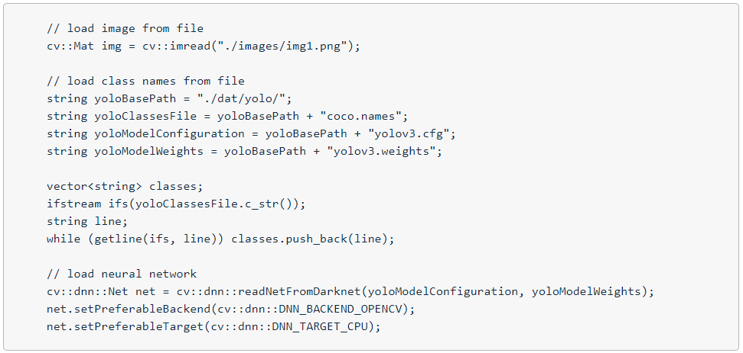

After loading the network, the DNN backend is set to DNN_BACKEND_OPENCV. If OpenCV is built with Intel’s Inference Engine, DNN_BACKEND_INFERENCE_ENGINE should be used instead. The target is set to CPU in the code, as opposed to using DNN_TARGET_OPENCL, which would be the method of choice if a (Intel) GPU was available.

Step 3: Generate 4D Blob from Input Image

As data flows through the network, YOLO stores, communicates, and manipulates the information as "blobs": the blob is the standard array and unified memory interface for many frameworks, including Caffe. A blob is a wrapper over the actual data being processed and passed along and also provides synchronization capability between the CPU and the GPU. Mathematically, a blob is an N-dimensional array stored in a C-contiguous fashion. The conventional blob dimensions for batches of image data are number N x channel C x height H x width W. In this nomenclature, N is the batch size of the data. Batch processing achieves better throughput for communication and device processing. For a training batch of 256 images, N would be 256. The parameter C represents the feature dimension, e.g. for RGB images C = 3. In OpenCV, blobs are stored as 4-dimensional cv::Mat array with NCHW dimensions order. More details on blobs can be found here: <http://caffe.berkeleyvision.org/tutorial/net_layer_blob.html>

The following example illustrates the memory structure of a blob with N=2, C=16 channels and height H=5 / width W=4.

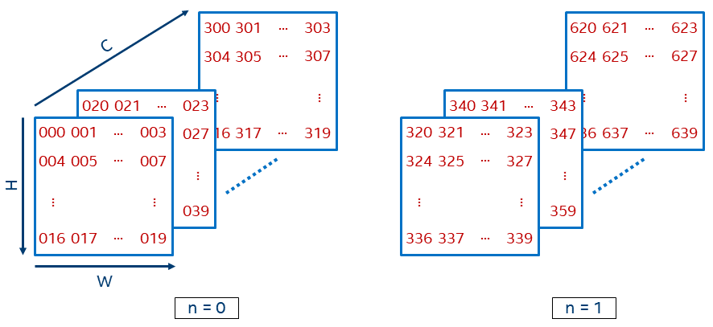

In a blob data structure, a value at position (n, c, h, w) can be accessed (if needed) using the following formula: b (n, c, h, w) = ((n C + c) H + h) * W + w.

The code below shows how an image loaded from the file is passed through the blobFromImage function to be converted into an input block for the neural network. The pixel values are scaled with a scaling factor of 1/255 to a target range of 0 to 1. It also adjusts the size of the image to the specified size of (416, 416, 416) without cropping.

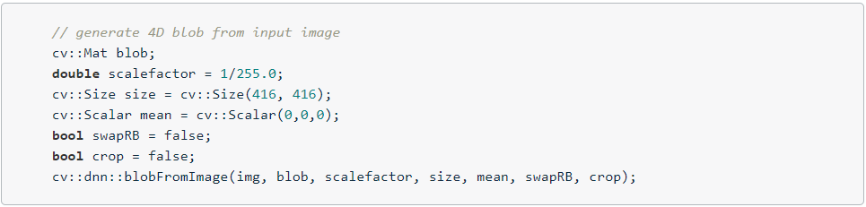

Later in the code, the output blob will be passed as input to the network. Then, a forward pass will be executed to obtain a list of predicted bounding boxes as output from the network. These boxes go through a post-processing step to filter out those with low confidence values. Let’s look at those steps in more detail.

Step 4: Run Forward Pass Through the Network

As the next step, we have to pass the blob we just created to the network as its input. Then, we run the forward-function of OpenCV to perform a single forward-pass through the network. In order to do that, we need to identify the last layer of the network and provide the associated internal names to the function. This can be done by using the OpenCV function 'getUnconnectedOutLayers', which gives the names of all unconnected output layers, which are in fact the last layers of the network. The following code shows how this can be achieved:

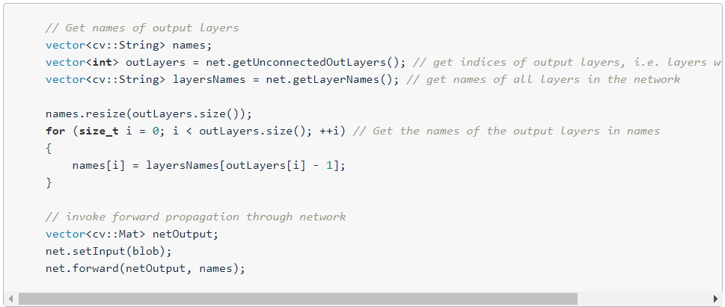

The result of the forward pass and thus the output of the network is a vector of size C (the number of blob classes) with the first four elements in each class representing the center in x, the center in y as well as the width and height of the associated bounding box. The fifth element represents the trust or confidence that the respective bounding box actually encloses an object. The remaining elements of the matrix are the confidence associated with each of the classes contained in the coco.cfg file. Further on in the code, each box is assigned to the class corresponding to the highest confidence.

The following code shows how to scan through the network results and assemble the bounding boxes with a sufficiently high confidence score into a vector. The function cv::minMaxLoc finds the minimum and maximum element values and their positions with extremums searched across the whole array.

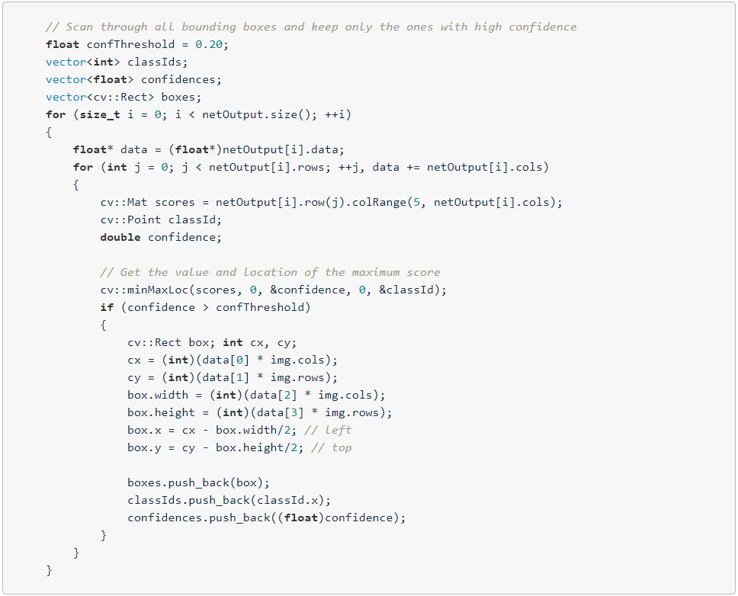

Applying the YOLOv3 algorithm to our highway image provides the following result:

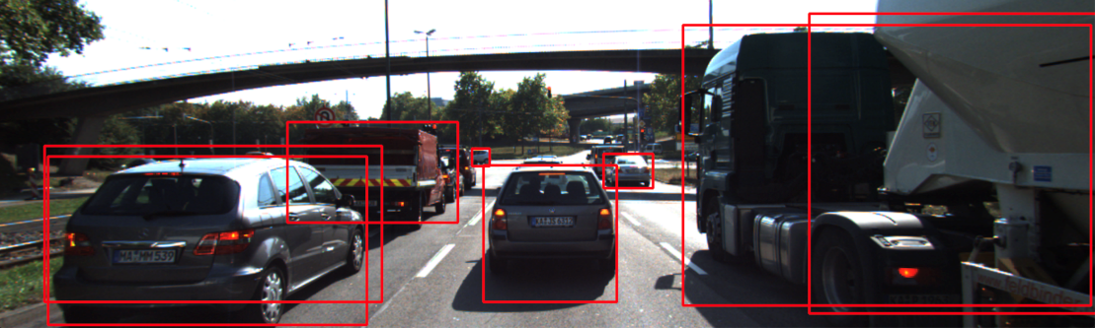

As can be seen, the car in the left lane is covered by two bounding boxes of similar size. To avoid the occurrence of redundant boxes, the last step performs a non-maximum suppression which aims at keeping only the bounding box with the highest confidence score.

Step 5: Post-Processing of Network Output

The OpenCV library offers a ready-made function for the suppression of overlapping bounding boxes. This function is called NMSBoxes and it can be used as illustrated by the following short code sample:

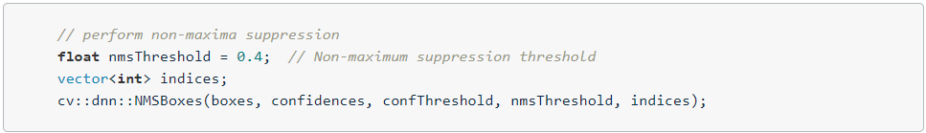

After applying non-maximum suppression, redundant bounding boxes will have been successfully removed. The following figure shows the results, where green indicates preserved bounding boxes while red bounding boxes have been removed during NMS.

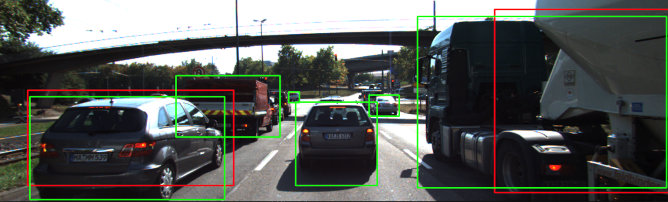

**Exercise**

In this exercise, please conduct the following experiments with the code given below:

* Look at the coco.cfg file and find out which object classes the YOLO network is able to detect. Then, find some interesting images containing some of those objects and load them into the framework. Share some of the results with us if you like.
* Experiment with the size of the blob image and use some other settings instead of 416 x 416. Measure the execution time for varying sizes of the blob image.
* Experiment with the confidence threshold and the NMS threshold. How do the detection results change for different settings of both variables?

Note that we are now using a proprietary structure called 'BoundingBoxes' to store the results of the object detection step. In the course of this lesson, further information will be added to this structure, such as Lidar points or image keypoints associated with the respective object.

### Creating 3D-Objects

**Grouping Lidar Points Using Region of Interest**

The goal of this section is to group Lidar points that belong to the same physical object in the scene. To do this, we will make use of the camera-based object detection method we investigated in the last section. By using the YOLOv3 framework, we can extract a set of objects from a camera image that are represented by an enclosing rectangle (a "region of interest" or ROI) as well as a class label that identifies the type of object, e.g. a vehicle.

In the following, we will make use of the ROI to associate 3D Lidar points in space with 2D objects in the camera image. As can be seen in the following image, the idea is to project all Lidar points onto the image plane using calibration data and camera view geometry. By cycling through all Lidar points contained in the current data buffer in an outer loop and through all ROI in an inner loop, a test can be performed to check whether a Lidar point belongs to a specific bounding box.

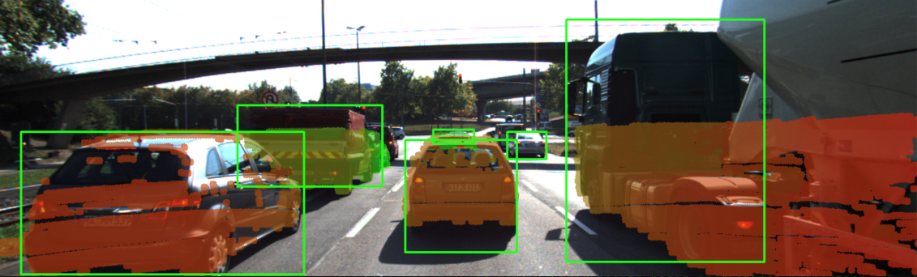

If a Lidar point has been found to be within a ROI, it is added to the BoundingBox data structure we have seen in the previous section on object detection with YOLO. The BoundingBox structure introduced there now contains the following elements:

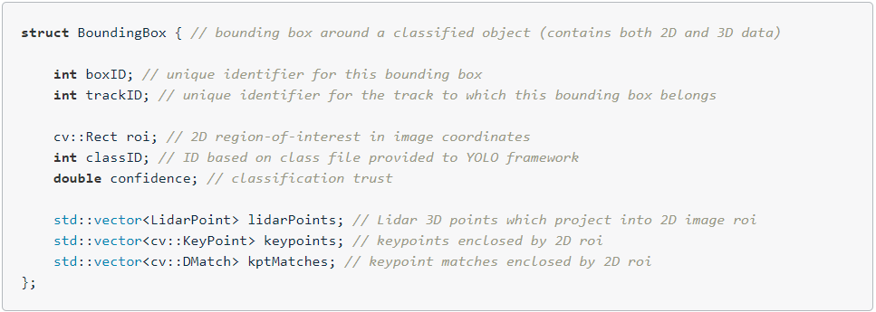

During object detection, the members "boxID", "roi", "classID" and "confidence" have been filled with data. During Lidar point grouping in this section, the member "lidarPoints" is filled with all points within the boundaries of the respective ROI rectangle. In terms of the image shown above, this means that all colored Lidar points which have been projected into the camera image are associated with the green rectangle which encloses them. Lidar points not enclosed by a rectangle are ignored.

In some cases, object detection returns ROI that are too large and thus overlap into parts of the scene that are not a part of the enclosed object (e.g. a neighboring vehicle or the road surface). It is therefore advisable to adjust the size of the ROI slightly so that the number of Lidar points which are not physically located on the object is reduced. The following code shows how this can be achieved without much effort.

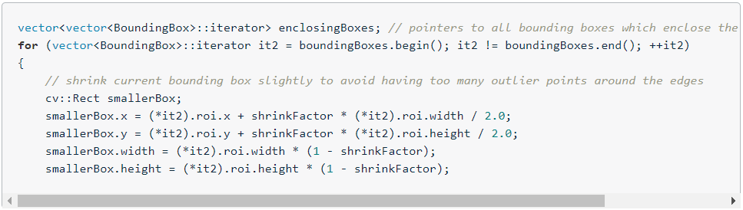

By providing a factor "shrinkFactor" which denotes the amount of resizing in [% ], a smaller box is created from the original bounding box. Further down in the code (see final project student code for details), a check is performed for each keypoint wether it belongs to the smaller bounding box. The figure below shows two different settings for "shrinkFactor". It can be seen that for second figure, the projected Lidar points are concentrated on the central area of the preceding vehicle whereas Lidar points close to the edges are ignored.

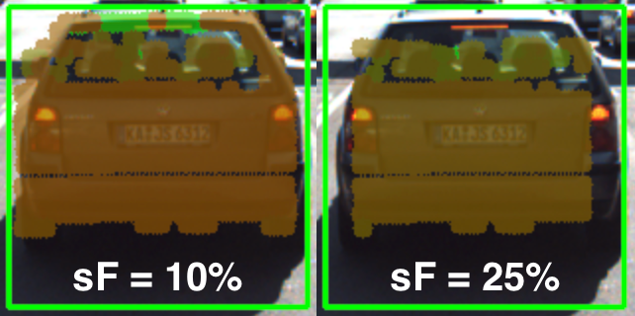

In practice, a moderate setting of 5-10% should be used to avoid discarding too much data. In some cases, when the bounding boxes returned by object detection are severely oversized, this process of boundary frame shrinkage can be an important tool to improve the quality of the associated Lidar point group.

**Exercise: Avoiding Grouping Errors**

Another potential problem in addition to oversized regions of interest is their strictly rectangular shape, which rarely fits the physical outline of the enclosed objects. As can be seen in the figure at the very top of this section, the two vehicles in the left lane exhibit a significant overlap in their regions of interest.

During point cloud association, Lidar points located on one vehicle might inadvertently be associated to another other vehicle. In the example illustrated in the figure below, a set of Lidar points in the upper right corner of the green ROI that actually belong to the red truck are associated with the blue vehicle. In the top view perspective on the left, this error becomes clearly visible.

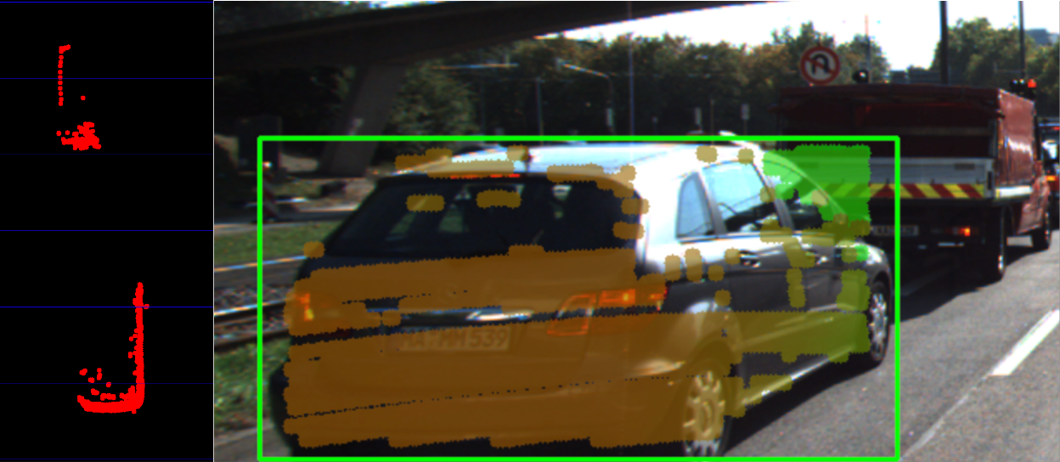

In the following code example you will find the algorithm that is responsible for this incorrect behavior.

Your task now is to make changes to this code in such a way that Lidar points enclosed within multiple bounding boxes are excluded from further processing. Visualize your result to ensure that everything works correctly before you proceed to the next section.

You can find the code in the workspace below in cluster_with_roi.cpp, and after making, you can run the code using the executable cluster_with_roi.

**Creating 3D Objects**

At this stage, we have successfully linked 2D camera data with 3D Lidar points. For (almost) every object in the image, there is now a set of Lidar points belonging to this object which we can easily access in the code.

The aim of this section is to augment our top-view image by displaying information about all bounding boxes (i.e. our 3D objects). In the code sample below, the following properties are extracted from each 3D object :

* distance to closest point in x-direction
* object width and height
* number of supporting Lidar points

As you can see in the resulting top-view image below, Lidar points have been grouped together into several distinct 3D objects.

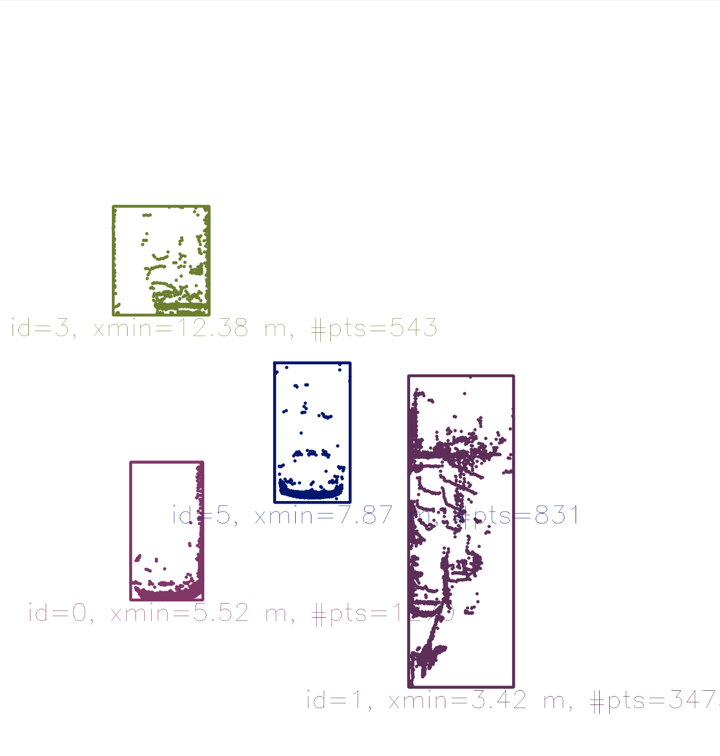

So by combining Lidar and camera information, an augmented view on the objects in the observed scene can be obtained. However, a computation of the time-to-collision is not yet possible as there is currently no link in time between 3D objects. It will be your task in the upcoming final project to implement this link and to finally compute TTC measurements based on both Lidar and camera.

## Track an Object in 3D Space

### Match 3D Objects

**FP.1 : Match 3D Objects**

In this task, please implement the method "matchBoundingBoxes", which takes as input both the previous and the current data frames and provides as output the ids of the matched regions of interest (i.e. the boxID property)“. Matches must be the ones with the highest number of keypoint correspondences.

The task is complete once the code is functional and returns the specified output, where each bounding box is assigned the match candidate with the highest number of occurrences.

### Compute Lidar based TTC

**FP.2 : Compute Lidar-based TTC**

In this part of the final project, your task is to compute the time-to-collision for all matched 3D objects based on Lidar measurements alone. Please take a look at the second lesson of this course to revisit the theory behind TTC estimation. Also, please implement the estimation in a way that makes it robust against outliers which might be way too close and thus lead to faulty estimates of the TTC. Please return your TCC to the main function at the end of computeTTCLidar.

The task is complete once the code is functional and returns the specified output. Also, the code is able to deal with outlier Lidar points in a statistically robust way to avoid severe estimation errors.

### Compute Camera based TTC

**FP.3 : Associate Keypoint Correspondences with Bounding Boxes**

Before a TTC estimate can be computed in the next exercise, you need to find all keypoint matches that belong to each 3D object. You can do this by simply checking wether the corresponding keypoints are within the region of interest in the camera image. All matches which satisfy this condition should be added to a vector. The problem you will find is that there will be outliers among your matches. To eliminate those, I recommend that you compute a robust mean of all the euclidean distances between keypoint matches and then remove those that are too far away from the mean.

The task is complete once the code performs as described and adds the keypoint correspondences to the "kptMatches" property of the respective bounding boxes. Also, outlier matches have been removed based on the euclidean distance between them in relation to all the matches in the bounding box.

**FP.4 : Compute Camera-based TTC**

Once keypoint matches have been added to the bounding boxes, the next step is to compute the TTC estimate. As with Lidar, we already looked into this in the second lesson of this course, so you please revisit the respective section and use the code sample there as a starting point for this task here. Once you have your estimate of the TTC, please return it to the main function at the end of computeTTCCamera.

The task is complete once the code is functional and returns the specified output. Also, the code must be able to deal with outlier correspondences in a statistically robust way to avoid severe estimation errors.

### Performance Evaluation

**FP.5 : Performance Evaluation 1**

This exercise is about conducting tests with the final project code, especially with regard to the Lidar part. Look for several examples where you have the impression that the Lidar-based TTC estimate is way off. Once you have found those, describe your observations and provide a sound argumentation why you think this happened.

The task is complete once several examples (2-3) have been identified and described in detail. The assertion that the TTC is off should be based on manually estimating the distance to the rear of the preceding vehicle from a top view perspective of the Lidar points.

**FP.6 : Performance Evaluation 2**

This last exercise is about running the different detector / descriptor combinations and looking at the differences in TTC estimation. Find out which methods perform best and also include several examples where camera-based TTC estimation is way off. As with Lidar, describe your observations again and also look into potential reasons. This is the last task in the final project.

The task is complete once all detector / descriptor combinations implemented in previous chapters have been compared with regard to the TTC estimate on a frame-by-frame basis. To facilitate the comparison, a spreadsheet and graph should be used to represent the different TTCs.

We are super-excited to receive your submission as soon as possible.

Code Overview: <https://www.youtube.com/watch?v=0yJ7gE2JMcw>

Match 3D Objects : <https://www.youtube.com/watch?v=UqaC-d8vhyY>

Compute Lidar based TTC: <https://www.youtube.com/watch?v=YAauGTeSilA>

Compute Camera based TTC: <https://www.youtube.com/watch?v=_gn3yqpzKmU>

Performance Evaluation: <https://www.youtube.com/watch?v=bozht0VBXvA>

### 3.5.2 Placeholder

## 3.7 Placeholder

### 

### 

<https://classroom.udacity.com/nanodegrees/nd313-beta/parts/45d2275b-5183-4d45-84d9-50d113be93cb/modules/b52e21b1-f7ef-434a-9378-58b75dfa6800/lessons/7fb8e8ec-0246-4e1e-9d12-e3cdf11391b7/concepts/38df3cda-6708-40e8-b9e0-347d02339007>